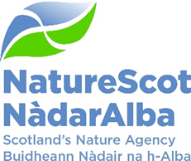

Title: Transforming agriculture to deliver outcomes for nature
Date: 5 October 2022
Purpose: | Decision
How does this link with our corporate priorities | Ensuring nature is fully integrated into the future legislative framework for agricultural payments will be essential in delivering the aims of our Corporate Plan, the ambition of the draft Scottish Biodiversity Strategy, and Scotland’s Environment Strategy and Climate Change targets.
Summary: | This paper sets out our ambition for supporting nature within the future framework of agricultural support. Urgent action is needed to address the climate and nature crises. With agriculture covering over 70% of Scotland’s land, how it is managed has one of the most signfiicant impacts on nature and climate.  Our vision of nature-rich low-carbon Scottish farms is not a choice between nature and food production, but supporting farmers and crofters to be at the forefront of restoring nature and meeting climate change targets alongside sustainable food production.
Actions: | The Board are asked to give a strategic steer on how hard and fast we should push for nature in response to the consultation on the Agriculture Bill including deciding on specific questions raised in the paper:  - Agree to the overarching principles (para 14) to frame our response to the consultation on the Agriculture Bill  - Decide on the timescale for implementing transformative change that puts us on target to reduce biodiversity loss by 2030. Recognising opportunities and challenges (paras 17 – 25), what pace and scale do the Board recommend, bearing in mind Just Transition and biodiversity needs?  - Framing our position on the nature climate crisis, where do the Board want to position us in terms of a climate change focus? (para 27 – 28) Do they agree with the suggestion that our primary focus is on improving nature outcomes?  - Agree to the proposal to discuss detail with a sub set of Board members.
Recommendations: | - Recognise the challenges of transforming land use  - Recognise good practice and progress being made but need for scaling up action across all farmers and crofters  - Endorse an ambitious approach for embedding nature in all levels of future agriculture support
Report Author(s): | Claudia Rowse and Ross Lilley
Sponsor: | Robbie Kernahan
Annexes: | Annex 1: Illustration of relationship between agriculture and biodiversity;  Annex 2: Our ambitions for nature in future agricultural framework

Purpose
- To seek the Board’s direction on our ambition for nature within the future framework of agricultural support so that we deliver on the corporate plan objective of transforming agriculture to deliver outcomes for nature.

Context
- Agriculture is the largest single use of land in Scotland, accounting for over 70% of Scottish land. As such, the way agricultural land is managed has a significant impact on nature and has been recognised as one of the key drivers impacting biodiversity (see Annex 1 for a diagram of the relationship between simplified farm systems and biodiversity).

- Scottish Government’s Vision for Agriculture is to transform support for farming so that Scotland becomes a global leader in sustainable and regenerative agriculture. It sets out the direction for a future support framework that delivers high quality food production, climate mitigation and adaptation, and nature restoration.

- The first step in making the transition to a new support framework has been the establishment of a National Test Programme through a twin track approach of Preparing for Sustainable Farming (Track 1) and Testing for Sustainable Farming (Track 2).

- The consultation on the new Agriculture Bill sets out Scottish Government’s detailed plans for implementing that Vision through the proposed legislative approach for an Agriculture Bill. The aim is to introduce a new support payment system in 2025-26.

- It proposes the future support framework has three tiers of support payments (basic, enhanced and elective) along with a fourth tier of complementary support (including advisory services).The diagram below illustrates how future support will be structured:

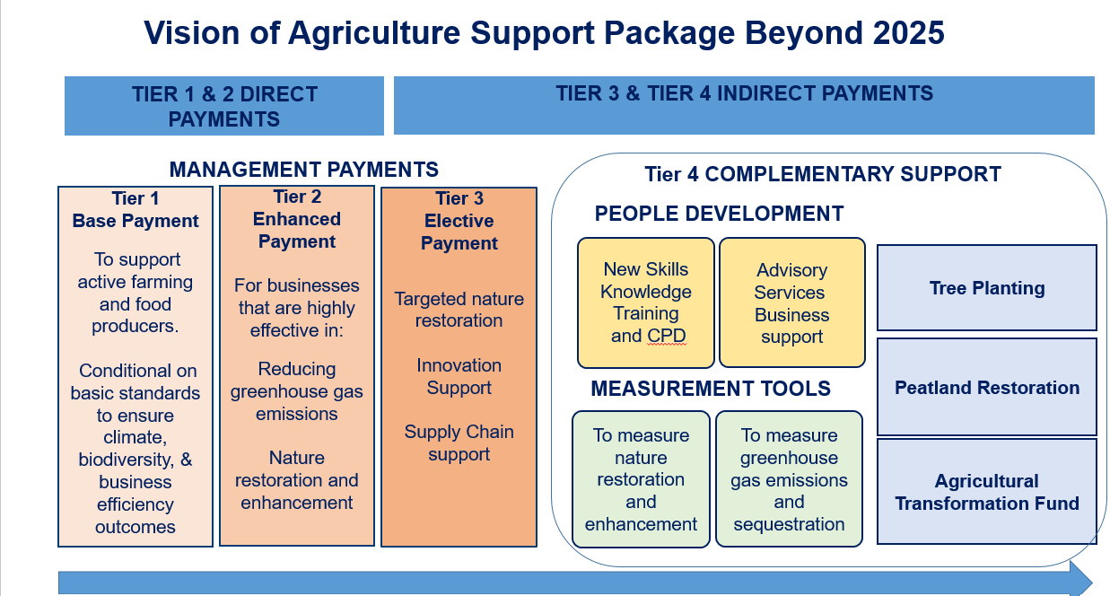

- The current model of Common Agricultural Policy (CAP) payments sees the overwhelming majority of payments delivered through direct payments to farmers (roughly £450m per annum), compared to indirect support for agri-environment schemes of about £50m pa. This system provides a disproportionate incentive in support of the current model of production and its ongoing negative impact on biodiversity and the wider environment. One of the major challenges ahead is to help farmers change from a relatively high input system (with high costs) to a systems change to low emission production based on reduced inputs (and improved profitability).

- There are many good examples of farmers and crofters already farming with nature, who have ‘gone green to get out of the red’ and who run their farms either as low carbon or as net zero enterprises. These illustrate that it is feasible to produce food sustainably and deliver for climate and nature, but transformational change is required to support the wider industry to adopt these changes.
What is NatureScot’s role?

- We mainly have a dual role in terms of our input on agriculture policy. Firstly, as Government’s advisors on nature; and secondly, as a delivery partner for the current agri-environment scheme.

- In terms of advice, we are inputting at all levels of Scottish Government governance arrangements for transformative land use and agriculture reform. We are playing a key role in supporting the National Test Programme, and in leading the Farming with Nature Programme (previously NCAPP – Natural Capital Pilot Programme) to test innovative approaches to future support.
- Our staff expertise is highly valued by Scottish Government in providing a link between translating research and policy into practical implementation of outcomes to benefit nature. Our specialist role focuses on providing tools and expert environmental advice to help farmers and crofters improve nature alongside sustainable food production; testing and demonstrating how biodiversity can be integrated with sustainable food production and climate outcomes as part of the National Test Programme; and identifying practical actions that all farmers and crofters can implement to benefit nature.

- Our leadership and development of the Biodiversity Assessment and App will be available for testing alongside carbon and soil audits as part of the Preparing for Sustainable Farming (Track 1 National Test Programme) actions, and for wider roll-out to all farmers and crofters in following years. Our leadership of POBAS (Piloting an Outcomes Based Approach in Scotland) has the potential to influence new approaches to elective support that moves away from prescribing what land managers must do to a more flexible outcomes based approach that can lead to improved outcomes for nature, and underpin wider behaviour change.

- We also act as a partner with SG’s Rural Payments Inspections Division to deliver the Agri Environment Climate Scheme.

Setting the parameters of our response to the Agriculture Bill consultation
- The Agriculture Bill consultation runs to over 50 pages seeking detailed comments on the future payment framework, delivery of outcomes for food, nature, climate and wider rural development as well as addressing issues such as skills, data, agricultural tenancies and wages. We propose that our response is guided by the ambition in the Global Biodiversity Framework being developed for COP15 to ‘redirect, reallocate, reform or eliminate incentives harmful to biodiversity.’ In order to set our strategic position, we recommend that the following broad principles inform our response:

- Embed Biodiversity – in all levels of future support framework, driving down delivery as far as possible.
- Redirect funding to nature - Ensure the majority of funding for farmers and crofters is re-directed to support positive environmental outcomes, significantly changing the current model.
- Enhance environmental conditionality - Set robust environmental conditions which can be incorporated into the Agriculture Bill as part of the evolving framework of conditionality of basic income support to farmers and crofters.
- Integrate support for food, nature and climate – base our vision for nature-rich low-carbon Scottish farms not as a choice between nature and food production, but where farmers and crofters are at the forefront of restoring nature, meeting climate change targets alongside sustainable food production.
- Evidence based advice – base our advice on robust analysis of evidence.

- In setting out these principles to steer the focus of our work on transforming land use, we are making strategic choices not to engage in some associated areas of work. This includes a strategic choice not to focus efforts on the wider debate around food and consumption, focusing instead on land use and production where we can have greater impact. We will also not focus on the wider debate around agricultural productivity and yields (as raised for example by George Monbiot and others). Instead seek to demonstrate where adoption of nature based farming helps to make businesses more resilient and adaptive to climate change such as increased frequency of droughts.
- Do the Board agree that these overarching principles should shape our response to the Agriculture Bill consultation? Are there additional principles we should follow?

Opportunities
- Funding - Reforming agricultural policy is one of the most significant opportunities in a generation to bring about positive change in restoring biodiversity. With a current budget of approximately £450m per annum, it provides a significant driver in shaping land use decisions. The proposal is that at least half of all that funding is directed to delivering targeted outcomes for biodiversity and climate so that all land managers in receipt of public money will be expected to show how their land benefits nature and cuts greenhouse gas emissions.

- In addition to public funding, there is growing evidence that agricultural management can attract, and will need to attract, private finance through payments for ecosystem services and high integrity carbon markets. It will be important to help farmers and crofters access these net positive nature markets where and when they are developed as transformative land use may need more public funding than may be available in future.

- Legislation - The new Agriculture Bill, proposed to be laid before Parliament by the end of 2024, needs to be based upon a justifiable rationale for public expenditure clearly linked to environmental outcomes. The scale and ambition of conditionality for the basic tier of support needs to be clearly signalled in the Agriculture Bill, even if the detail will follow under secondary legislation.

- Policy design and practice - Continuing input to the National Test Programme provides another important opportunity to test and demonstrate how biodiversity can be mainstreamed into wider farm management and support.

- Wider policy framework of NSET (National Strategy for Economic Transformation) – NSET sets the overarching framework to realise Scotland’s economic potential and achieve a wellbeing economy. There are strong hooks in NSET around natural capital, and we can demonstrate how transformative land use is an essential part of realising the vision for NSET.

- Staff expertise - We are in a strong position to design and advise how this enhanced environmental conditionality could be met with our staff expertise highly valued by Scottish Government.

Challenges

- Resource pressures - Reforming the Common Agricultural Policy is an extremely complex public policy challenge. It has been in place for over 50 years with accompanying institutions and ways of working. Changing this policy places huge demands on Scottish Government resources to design and implement a new approach along with an accompanying payment system. There is a risk that these pressures mean that Scottish Government cannot direct attention in the short-term to supporting elective schemes, including targeted support for nature, or to consider a future integrated approach to supporting wildlife management (such as deer, geese, sea eagles and beaver).

- Status quo - The constraints of the significant public investment (estimated to be in excess of £150m) in the current audit and payment system may limit Scottish Government’s ability for change away from the status quo.
- Cultural and behavioural - There are also significant behavioural and cultural challenges associated with bringing about transformative land use change. This relates to farmers, crofters and land managers as well as to delivery partners including NatureScot and Scottish Government officials who have a strong culture based on complying with EU rules, audit and inspection; and to necessary changes in upskilling the wider advisory services to embrace regenerative agriculture and agro-ecological approaches alongside more traditional agricultural performance advice. For our own staff, it will require a change away from being administrators of AECS with a focus on protected areas to a wider role advising on and assessing the nature outcomes regenerative agriculture and agro-ecological approaches deliver.

- Time required for systems change - Agricultural systems and supply chains cannot be changed overnight without significant economic and social impacts. There is a tension in the scale and pace of action required to restore biodiversity, and the amount of time that the agriculture industry need to transition to a new system of support.

- What pace and scale do the Board recommend, bearing in mind Just Transition and biodiversity needs?

- Agriculture emissions - The Climate Change Plan update sets out the need for agriculture to reduce its emissions by 31% from current levels by 2032. It is not on track to meet these reduced emissions targets with particular challenges for the livestock sector which contributes the majority of agricultural emissions. The new Climate Change Plan (in 2023) will provide another important milestone to further set the parameters for the industry to reduce its carbon emissions. Some reports (such as the 1.5 Degrees for Farming)¹3 show pathways that could make this possible if all farmers compulsorily adopted emissions reduction techniques, others suggest reductions in livestock numbers to meet climate targets.

- While climate and nature are intrinsically linked, our primary focus will be on improving nature outcomes across all farm types, reducing emissions from the land, on greenhouse gas sequestration and promoting agro-ecological practices to adapt to a changing climate rather than engaging directly on the size of the livestock sector that might be required.

- Where do the Board want to position us in terms of a climate change focus? Do they agree with the suggestion that our primary focus is on improving nature outcomes alongside promoting nature-based solutions to climate change?

- Policy context and policy dependencies - Embedding nature outcomes across all the new legislation coming forward presents some challenges of ensuring policy coherence across the proposed Land Reform Bill, Agriculture and Environment Bill. In addition, continuing to align with the EU’s Common Agricultural Policy may limit innovative approaches.

Conclusions/recommendations

- Addressing the twin nature and climate crises, alongside sustainable food production will require major changes in how we use and manage land.

- Ensuring that environmental issues are fully integrated into the future legislative framework for agricultural payments is vitally important in achieving the aims of our Corporate Plan and the Scottish Biodiversity Strategy.

- Our recommendations are for the Board to:

- Recognise the challenges of transforming land use
- Recognise that there is much good practice and progress being made but this needs scaling up across all farmers and crofters
- Endorse an ambitious approach for embedding nature in all levels of future agriculture support
- Support the proposal for further detail to be discussed with a sub-set of Board members with particular agricultural expertise.

- To deliver our objective of transforming land use we have significant opportunity to provide leadership, direction and influence in providing clear advice to Scottish Government on the upcoming Agriculture Bill and inputting to the development of the National Test Programme as a first step in that transition.

Annex 1 Illustrative diagram of relationship between simplified farm systems and biodiversity (cf: Biodiversity on Farmland: European Court of Auditors, p7)

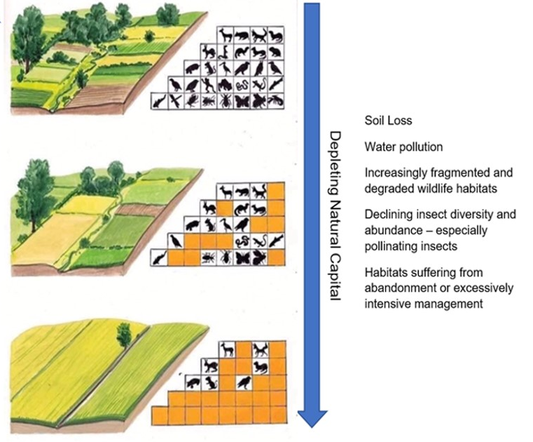
Annex 2 - Our ambitions for nature in future agricultural framework

- We have set out initial actions all farmers and crofters can take, and will need to take, in order to turn around the nature crisis. We have identified five key actions across soil, permanent habitats, linear features and species management that all farms can implement to improve biodiversity.

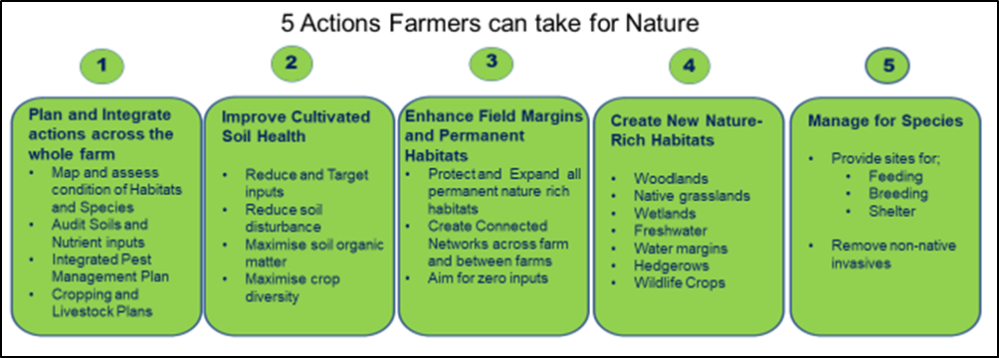
- The actions farmers can take are based on global conservation principles of the 4 Rs which have been established to address both the nature and climate crisis. These can be mapped fairly easily onto the future proposed framework:
Future proposed framework | Conservation hierarchy | Description | Incentive
Basic | Refrain | Stop activities that increase emissions and impact on biodiversity | Regulated minimum stewardship through Cross-compliance and a fresh approach to defining Good Agricultural and Environmental Condition
 | Reduce | Reduce and better target activities that must continue in order to sustain production but contribute to emissions and impact on biodiversity | Part of minimum stewardship/regulation and partly incentivised as condition of receiving basic payment.
Enhanced | Restore | Broad and shallow activities that all farmers can do across all farmland and that have general biodiversity benefits. | Incentivised as a condition of receiving 50% current basic payment. Incorporate wide list of agri-environment type measures that can be broadly implemented
Elective | Renew | Deep and Narrow activities: Create new nature rich habitats and target habitat enhancement activities at specific species and biodiversity outcomes. | A range of targeted nature restoration incentive schemes aimed at biodiversity outcomes (e.g. Future AECS, SFGS, PeatlandAction).

- The illustration below shows in practical terms how biodiversity can be improved across the farmed environment (From the Nature Friendly Farming Network )

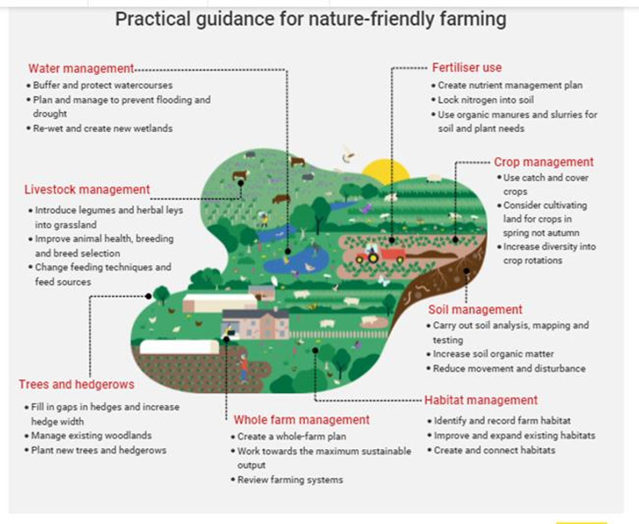

See Nature Farming Friendly Network case studies ; and Scottish Land & Estates case studies.
https://www.gov.scot/publications/securing-green-recovery-path-net-zero-update-climate-change-plan-20182032/
Four steps for the Earth: mainstreaming the post-2020 global biodiversity framework –Milner-Gulland et al, 2021.

