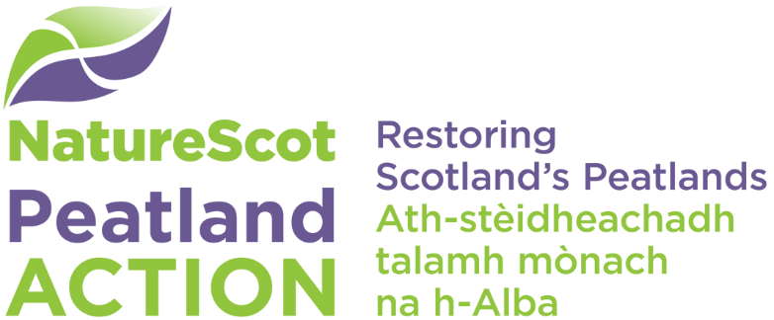

Landlord declaration form
If you are a tenant of the land covered in your funding application, this form must be completed and signed by both you and your landlord.
This form must be completed only where:
- you have a tenancy covering the full duration of the contract and associated monitoring and maintenance periods and a copy of the lease has not been submitted as part of the application (or for official sub-tenants of a croft, a copy of the letter issued by the Crofting Commission confirming the approval of the sub-let and its duration). Sections 1, 2 and 3 of this form must be completed.
Or
- you have a tenancy or licence which does not cover the full duration of the contract and associated monitoring period. Sections 1, 2 and 4 of this form must be completed.

Note – you must provide evidence that the landlord has been notified of the proposal, and is content for the work to proceed and you must sign the landlord notification at Section 5.
NatureScot will collect and hold your details. You should read our Funding Privacy Notice.

Section 1: Application details
Details of Peatland ACTION project
Project Title
Grant ID number (if known)
Year(s) of funding
Grant compliance monitoring period | 10 years

Section 2: Applicant and landlord/main tenant details
Details of applicant (non-croft tenant or official sub-tenant of a croft)
Business name (enter name of sole company or partnership)
Location code of landholding to which this application relates or the name of the property
Main Location Code (enter xxx/xxx)
Business Reference Number (enter xxxxxx)
Date of expiry of lease or contractual licence (if less than 10 years from date of application)

Details of landlord or main tenant
Business name (enter name of sole company or partnership, if appropriate)
Correspondence (enter full address including postcode)

Section 3: Declaration from landlord/main tenant for tenancies with a term of over ten years
I/we declare that:
- I am/we are the outright owner/main tenant (delete as applicable) of all/part of the property referred to in Section 2
- I confirm that the tenant named above in Section 2 has a lease which will cover the duration of the contract and any associated monitoring and maintenance period as referred to in Section 1
- In the event that the applicant ceases to have management control over this land, I/ we will take responsibility for maintaining the proposed restoration area for the remainder of the contract and any associated monitoring and maintenance period as referred to in Section 1.

Signature of landlord (or landlord’s agent) or main tenant
Name (please print)
Position (please print)
Date

Section 4: Declaration from landlord/main tenant to agree to take over Peatland ACTION obligations if a tenancy or licence does not cover the duration of the contract and any associated monitoring period
I/we declare that:
- I am/we are the outright owner or main tenant of all/part of the property referred to in Section 2
- I am/we are aware of the proposed restoration area included in the Peatland Action application referred to in Section 1 by my tenant/sub-tenant referred to in Section 2 (the applicant)
- I/we have read and understood the Peatland Action application guidance, including the Applying for funding – information for applicants, Terms & Conditions, and Funding Privacy Notice
- In the event that the applicant ceases to have management control over this land, I/ we will take responsibility for maintaining the proposed restoration area for the remainder of the contract and any associated monitoring and maintenance period as referred to in Section 1
– I/we will inform NatureScot within three months of the cessation of the tenancy/licence.

Signature of landlord (or landlord’s agent) or main tenant
Name (please print)
Position (please print)
Date

Section 5: Landlord notification – I confirm that the landlord has been notified of this proposal and is content for the work to proceed
Signature of landlord (or landlord’s agent) or main tenant
Name (please print)
Position (please print)
Date

Please return all 3 (three) pages of this form as one completed and signed document to peatlandactiongrant@nature.scot.

