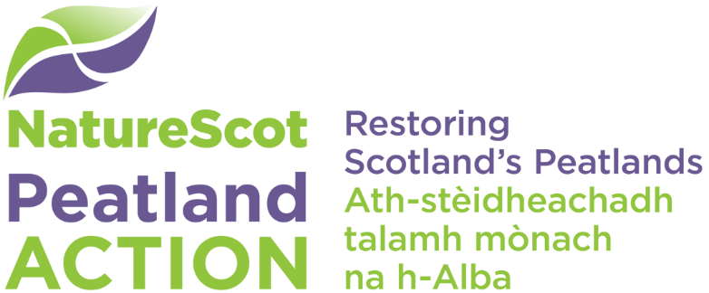

Outcomes and priorities for action

Introduction
Peatland Action is a peatland restoration project run by NatureScot and funded mainly by Scottish Government. Given the extent of Scotland’s peatlands (~2million ha) and the relatively poor condition of much of the resource, it is important that this funding is targeted at areas where it can make a significant difference. The project aims to restore Scottish peatlands whilst also supporting demonstration sites and events to raise standards and encourage innovation for effective peatland restoration.

Project outcomes
- Peatlands restored to maintain carbon stores and encourage carbon sequestration.
- Awareness of peatlands and their restoration raised through demonstration and other forms of communication.
- Peatland ecosystem functions restored.
- Future restoration supported by innovations and lessons learnt.
- Ecosystem resilience to climate change enhanced.
- Benefits of sustainable peatland management promoted.
- The number of land managers and communities actively engaged with peatlands increased.

Definition of ‘peatland’
- ‘Peatland’ is defined as a surface layer or layers more than 50 cm thick and containing more than 60% organic matter.
- Where non-peatland carbon-rich soils support ‘typical’ peatland vegetation, or are an integral part of a peatland project, they will be considered for Peatland Action support.

Peatland Action will fund
- Projects that enhance the capacity of a peatland to deliver one or more long term sustainable environmental benefits.
- Large and small projects, in terms of extent and/or cost. Projects that enhance the public experience, awareness and enjoyment of peatlands.
- Demonstration projects that include the sharing of information and best practice.
- Innovation and trial of new techniques and equipment.
- Existing or planned projects where an enhancement or additional benefit is shown.
- Monitoring associated with peatland restoration projects. This could include the capital costs for long term research projects, relevant to the project aims.
- Preparatory works or equipment. This will include specialist advisory support, site survey, project plan development, and rain and water level recorders. However, these costs must be proportionate to the likely overall benefits of project implementation.

Peatland Action will not fund
- Scrub/woodland removal unless it can be demonstrated that there is an overall benefit to the public purse by doing some minor scrub/woodland removal work as part of a larger Peatland Action restoration project.
- On-going management.
- Replacement of existing committed or anticipated funding.
- Restoration projects which are a condition of planning permission.
- Restoration projects that are subject to discordant conditions of a Scottish Forestry felling permission e.g. for re-stocking.
- Restoration projects where we consider deer and/or sheep densities too high to support effective restoration. In such cases, land managers would be expected to reduce deer/stock numbers to an acceptable level commensurate with peatland restoration requirements.
- Items or capital works that are eligible for funding under the current Forestry Grant Scheme (FGS). However where it can be demonstrated that there is an overall benefit to the public purse by doing some minor FGS eligible works, as part of a larger Peatland Action restoration project, we may exceptionally consider support. For example, if without the activities the project will not gain the wider/total site benefits.

Further advice for applicants
- Where organisations are in receipt of NatureScot funds for delivery of multiple outputs, some of which may also be eligible for Peatland Action funding, they must demonstrate clear additionality.
- Restoration of areas on or adjacent to designated peatland features is considered positive.
- Support from Peatland Action fund for one project neither commits nor precludes Peatland Action funding for any subsequent or related projects.
- This is a competitive process. Although we can, where justified, support up to 100% of cash costs, we encourage contributions in cash or in kind. Such contributions will be looked upon favourably in the assessment process.
- The applicant will need to demonstrate as part of their application that either:
- Any proposed ditch-blocking is carried out in artificial drainage channels or eroded channels AND it is not associated with any water abstraction AND the impoundment is created in a watercourse where the ‘normal’ (baseline) width of water within the active channel is less than 1 metre wide AND the affected artificial drainage channel(s) does not appear on a 1:50000 scale OS map. In this case, no authorisation is required. OR
- In all other cases, i.e. where a licence is required, discussions have been held with SEPA staff on the need for a CAR licence AND there are clear indications that there are NO outstanding matters that would prevent a CAR licence from being issued.
- As a condition of funding, successful applications are expected to ensure that all works are carried out in accordance with the relevant Peatland Action restoration guidance, and any deviations from this must be agreed in writing with Peatland Action staff before works commence.
- As a condition of funding, and before restoration works starts, successful applicants are expected to provide information on peat depths at restoration sites in accordance with Peatland Action peat depth and peatland condition survey guidelines.
- As a condition of funding successful applicants are expected to provide a short before and after photo report and description of practical works.
- All information collected in the project will be shared under an open access agreement unless there is a specific reason not to, for example where the information is personal data.
- Project management costs will only be supported where reasonable, appropriate and justified. Where Peatland Action Officers are supporting the management of the project, we will assess any additional project management activity necessary and may reduce our funding accordingly. We will not cover time to administer the grant.

Our assessment will also consider the extent to which the application supports our wish to deliver
- Excellent value for money and significant impact.
- A wide geographical spread across Scotland.
- A range of peatland types.
- A range of land tenure types.
- A range of land management types.
- A range of objectives in addition to reductions in greenhouse gas emissions. These include: biodiversity, water quality, flood management, awareness, community engagement education and health.
- Cost effective management and collaborative working where it is shown to reduce cost of restoration; particularly opportunities for collaborative working with the private, voluntary or other public bodies.
- High quality restoration to maximise long term benefit.

