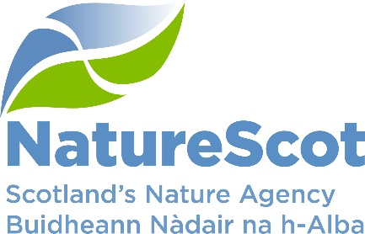

Title: Board Q1 Performance Report

Date: 24th August 2022
Purpose: | Decision
How does this link with our corporate priorities of improving biodiversity or delivering nature-based solutions to climate change: | This paper presents Q1 progress towards delivery of our corporate priorities as laid out in our Business Plan, A Nature-rich future for all: Year 1
Summary: | At the end of Q1, performance for 13 of our 15 Corporate plan objectives are rated as ‘on track’. Corporate risk scores remain as per last quarter with the exception of one which has decreased. One risk was escalated to the corporate risk register and we de-escalated four. Our Operating and Indirect Capital budgets are expected to outturn within tolerance at year end. Awards are currently being agreed for Nature Restoration Fund and Peatlands, with an over-allocation approach to ensure that full budget spend is achieved. Direct Capital is forecasting below tolerance at this stage but a Capital plan is being produced to outline capital expenditure opportunities for 2022/23. In the People Report, nine of ten indicators are green and one remains at amber from last quarter
Actions: | To note the recommendations below
Recommendations: | Board are asked to:  - Note the overall performance of the Corporate Plan objectives  - Note the position of the operating and capital budgets (Finance Report)  - Note the performance of the corporate risks  - Note the overall performance of the People Measures
Report Author(s): | Authors – Directors, Deputy Directors, Outcomes Managers, Finance, Planning & Performance Team, People & OD Team
Sponsors: | Stuart MacQuarrie, Jane Macdonald
Annex | Annex A – National Performance Framework Indicators  Annex B – Corporate Risk Register

Purpose
- This paper presents NatureScot’s performance for the first quarter of 2022/23. It addresses delivery of our corporate priorities by reviewing; the alignment of performance against our Business Plan, a Nature-rich future for all: Year 1; progress towards maximising our available budget; assessing risks for delivery; and reviewing people information supporting the resourcing of our work. These support delivery of our Corporate Plan 2022-23, A Nature-rich future for all.

Summary
- Over the last quarter we are on track to achieve 13 out of the 15 Corporate Plan objectives, the reasons for the slippage is noted below. The two objectives marked as amber are:
- Demonstrate how agriculture can be transformed with new approaches to deliver targeted outcomes for nature and climate
- Scale up Peatland Restoration by delivering Peatland ACTION funding to projects

- An outbreak of avian influenza (AI) has resulted in the diversion of staff resource to establish an internal coordination group, chaired by Eileen Stuart. It has introduced restrictions for a number of island seabird sites some of which are National Nature Reserves. . Activities remain under review, such as visitor management, disinfecting footbaths and managing biosecurity at other reserves. This response attempts to reduce spread and manage the impact where possible.

- Our internal focus has been on the development of Corporate Plan Objective delivery plans to define the scope and the resourcing requirements to deliver the expectations of the Bute House Agreement. These were reviewed by Senior Leadership Team (SLT) at the end of June and feedback will be built into the final iterations by the end of July. These will be used to support the budget scenario planning to begin in Q2.

- The Organisational Development programme continues to review how to evolve the shape of the organisation to set us up for successful delivery of our corporate plan ambitions, with more agile and flexible ways to plan and allocate our resources across the organisation. SLT agree that we need an organisational design that is built around a robust focus on delivery, centred on the Delivery Plans, and ensuring our priorities are clearly communicated and collectively understood. They are also committed to ensuring strong support for learning & development to underpin our knowledge, expertise & skills for the future.

- The table below reflects the Corporate Plan objectives and risks, finance and people metrics.

PRIORITY PERFORMANCE | NUMBER | CORPORATE RISK | NUMBER
Objectives | 15 | Corporate Risks | 15
On Track | 13 | Increased Score | 0
Minor Slippage | 2 | Decreased Score | 1

FINANCIAL METRICS | STATUS | PEOPLE METRICS | STATUS
Operating | MINOR SLIPPAGE | Wellbeing | On Track
Project Allocation | MINOR SLIPPAGE | Capacity | On Track
Paybill | MINOR SLIPPAGE | Development | On Track
Capital | MAJOR SLIPPAGE | Workforce Profile | On Track

- The next page demonstrates our new performance dashboard for our corporate plan measures. These are supported by an update on each of the objectives within the Corporate Plan. With the introduction of our PuMP performance management approach, we have included a new type of graph that you may not be familiar with called an XmR graph:

- These graphs allow us to filter out the noise and focus on the patterns in performance rather than the variation between two data points.
- Grey line - represents our measure data points (current performance being the point furthest to the right).
- Blue line - the Central Line, which is our baseline (calculated from the first 5 data points and then kept constant).
- Shaded light blue area - our Natural Process Limits (tolerances). If a point falls outside the tolerances, then we know that this is out of the ordinary and will be investigated. These types of graphs allow us to identify true signals of changes in performance.

- Where we don’t have five data points, we have used a bar chart. Once we have 5 data points these will change to XmR graphs.

PERFORMANCE DASHBOARD

RAG status will be available once 5 data points are collected. Bar charts are used until this point and initial data is noted without a graph

WE HAVE PROTECTED NATURE
Score | Measure | Performance Overview | Actual | Cause | Response
 | Reducing Deer Numbers | Annual measure
 | Area (ha) of woodlands restored | Annual measure
 | Number of MPAs that we have monitored | Data to be provided in Q2
 | % of licenses issued that comply with the conditions required of them | No data | 0 | No compliance activity has been undertaken during Q1 reflecting a reprioritisation of the resource available to deliver this function. | Recruitment is proposed during Q2 to fill posts to deliver the compliance requirements of this work before the end of the financial year.
 | Are we seeing raptors where we should be? | Annual measure

WE HAVE PROTECTED NATURE
CORPORATE PLAN OBJECTIVE | SLT LEAD | RAG SCORE | Q1 UPDATE
Lead the delivery of 30% of land and sea being protected by 2030 | Nick Halfhide | GREEN | 30x 30 and Nature Networks (NN) Commissions have been finalised with the team recruited and the launch event on 28th June. A first draft of the Highly Protected Marine Areas (HPMA) selection guidelines were shared with officials for early comment and a complete draft by the end of June.  For our National Parks work, input was made to the creation of the successful Scottish Government (SG) public engagement website and preparatory work is underway for the first stakeholder group meeting in July. We have yet to finalise the commission with SG and slippage on agreeing the governance arrangements for the stakeholder group is already threatening the October deadline for our advice to Ministers.
Build stronger collaboration reducing the impacts of deer and modernise our wildlife management and underpinning licencing functions to enable a net zero and nature positive future | Robbie Kernahan | GREEN | All four Strategic Deer Board workstreams had initial meetings in this quarter so progress is as planned. Work on the deer communications plan is under way and operational priorities are well developed in consultation with other public bodies and the Strategic Deer Board (SDB). Recruitment to NatureScot Deer Regional delivery manager posts will be completed in Q2.  Ministers have been briefed on the outline Grouse moor licensing approach and the muirburn research report has been received from the contractor. The licensing approach is therefore developed on the basis of a more regulated approach focusing on areas of known science/impacts and approaches to mitigate risks.
Engage and influence planning and other regulatory systems to ensure they deliver for nature and climate | Robbie Kernahan | GREEN | There has been some slippage which is out of our control as Scottish Government (SG) are likely to carry out another round of consultation on the National Planning Framework (NPF4) as a result of consultation responses. Particular areas for focus likely to be positive effects for biodiversity and facilitating renewables and housing development.  We have worked with the SG planning team to ensure they are aware of our ongoing engagement with biodiversity metrics and to "bring them in to the fold".
Influence the transformation of marine management through new marine planning, protection and fisheries management frameworks, and working with the marine renewable energy sector | Nick Halfhide | GREEN | We have engaged with all ScotWind developers at the pre-scoping stage and provided formal scoping advice for one site. We are also engaging with developers on the newly launched Innovation and Targeted Oil and Gas (INTOG) leasing round to influence outcomes for nature.

WE HAVE RESTORED NATURE
Score | Measure | Performance Overview | Actual | Cause | Response
 | Area (ha) of enhancements through SMEEF | Data to be provided in Q2
 | Ha of land managed under plans supported through agricultural support schemes | 1,211,566 ha | 1,211m (ha) | This data represents the cumulative effort of several organisations, including NatureScot. There is no target at present. | Continue to encourage uptake and administer the funding mechanisms we are responsible for. Note there is a dependency on resource, both scheme budgets and staffing.
 | Area (ha) improved for habitats and species through the nature restoration fund | 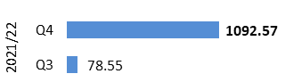 | 1092.57 (ha) | 'Achieving 1000ha of habitats and species restoration in the 8 months from the award of funding is a great outcome and reflects very positive engagement from Stakeholders in project delivery'. | With the Start of NRF 2.0 Q1 is where grant offers are being made to start this project and so this data will be collated in Q2, with improvements.
GREEN | Area (ha) of peatland put on the road to recovery |  | 4256.30 (ha) Q4 | Lower levels of restoration due to a range of issues including uncertainty over carbon credits, design/contractor availability and weather. | Our Project Officers are focused on supporting effective design and earlier decisions to maximise delivery in 2022/23.

WE HAVE RESTORED NATURE
CORPORATE PLAN OBJECTIVE | SLT LEAD | RAG SCORE | Q1 UPDATE
Co-lead the production of the new Scottish Biodiversity Strategy (SBS) and develop targets to include in a new Natural Environment Bill | Nick Halfhide | GREEN | Work in hand, with public consultation on the SBS issued on 20th June, following active work by the Programme Board and Advisory Group in addition to SG/NatureScot team, and good inputs from three stakeholder sessions. The Conference Of Parties (COP15) now confirmed to take place on 5-17 December in Montreal (rather than Kunming) with an extra Open ended Working Group (OWEG) scheduled just before the COP to ensure higher chances of successful agreement on the Convention on Biological Diversity (CBD) 2050 strategy.
Scale up Peatland Restoration by delivering Peatland ACTION funding to projects | Robbie Kernahan | AMBER | Achieving the target of 8,800ha for peatland restoration represents a major challenge given the current levels of demand and design capacity. Some of the main reasons for slippage against last year’s target is the over-ambition from applicants and underestimation of time it takes to build a pipeline of projects coming forward. Considering these issues, our current estimate is that there is a high risk of not realising the 8,800ha target. We are learning lessons from the substantial slippage of 30% last year predominantly due to over-ambition, Covid, supply chain and weather issues. Actions in hand include increased workforce capacity providing more resilience, reduced impact of Covid, as well as applicants being more familiar with the Peatland Code and Permitted Development Rights processes. Progress this quarter includes expanding our network of Project Officers to support project development and delivery; increasing supply and demand by attending events (such as ScotPlant, Scottish Land and Estates Conference; Royal Highland Show); drafting a Peatland Skills Action Plan to lead co-ordinated action across all stakeholders to build an expanded workforce for both design and delivery of peatland restoration; supporting IUCN to speed up their assessment of Peatland Code applications; overcoming operational barriers through new guidance on operating in the Bird Breeding Season. We held a successful training event with all Delivery Partner Project Officers to refine the draft Technical Compendium on peatland restoration techniques. This will outline the standards for peatland restoration in Scotland and will be shared for wider input in Q2 with a view to publishing in September 2022. In addition, we developed a Monitoring Strategy due for consultation in Q2.
Lead, enable and convene others around the development of ambitious and coherent actions to restore nature. Deliver a major Nature Restoration Fund (NRF) targeted at high impact nature recovery projects and seeding greater investment from the private sector | Nick Halfhide | GREEN | All applications to the NRF small value fund have been assessed and the panel met at the end of May, committing £2.95m this year and £2.15m next year to 47 projects. We have a further £1m competitive element for additional Edinburgh Process projects (local delivery of the biodiversity strategy – in Q2), and we have allocated £0.5m to the Scottish Marine Environmental Enhancement Fund (with the possibility of an additional £0.5m, subject to demand). The launch of the high value fund (total £3m) is progressing but will slip to August due to the workload created by the number of applications to the small value fund and final confirmation of governance arrangements from Scottish Government. The high value fund will include funding for the development phase of possible larger projects, creating a pipeline of projects that are more likely to succeed. There is a risk that we may not get enough high value project submissions to spend the £3m but that won’t be known until the end of Q2.
Demonstrate how agriculture can be transformed with new approaches to deliver targeted outcomes for nature and climate | Robbie Kernahan | AMBER | We have started to make progress with SG colleagues on scoping delivery option for the Biodiversity Audit App. This involves dependencies on SG Land Parcel Identification System (LPIS) IT development and governance.  Piloting an Outcomes Based Approach in Scotland (POBAS) Phase 3 testing scoring and App with farmers is underway, and management agreements are being revised. There have been difficulties recruiting and retaining POBAS officers within constraints of Scotland’s Natural Capital Pilot Programme (NCAPP) funding timings.  National Test Programme Track 2 - testing a range of enhanced condition payments planning is moving forward. This has been helped by four 'Funding for Nature' workshops run by ENFOR and Agriculture & Rural Economy Directorate in June which scoped scale and scope of nature delivery that requires public support.

THE VALUE OF NATURE IS RECOGNISED
Score | Measure | Performance Overview | Actual | Cause | Response
GREEN | Hectares of Green infrastructure Restored |  | 15.7 (ha) | 15.7ha is attributed to Clyde Gateway’s Malls Mire project which was officially opened this month | Monitoring and reporting of Ha of Green Infrastructure created/restored will continue.
 | Nature-based jobs and skills opportunities | 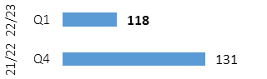 | 117 trained | Programme for Youth Employment static, Working with Rivers placements ended June, CEMVO placements ended April, Peatland Action trainees increasing. | Additional historic data will be added for Q2 report. Action Plan refresh will identify opportunities for new schemes.
 | % of landholdings undertaking a publicly supported Natural Capital approach |  | 50 farms | This is the main set of data for the pilot program. This will be the only set of data for the year as we monitor this Natural Capital approach. | Because of this limited set of data from Q2 onwards we will be expanding this measure to include the biodiversity audit
GREEN | National Nature Reserves online engagement |  | 1.08m  (Reach) | Drop in engagement due to lower number of posts over period, but potentially less contentious issues over period to attract attention. | Review frequency of posts across channels.

THE VALUE OF NATURE IS RECOGNISED
CORPORATE PLAN OBJECTIVE | SLT LEAD | RAG SCORE | Q1 UPDATE
Inspire people to connect with nature, increasing appreciation of nature’s value through impactful delivery and communication of our work | Jason Ormiston | GREEN | An expanded Scottish Outdoor Access Code (SOAC) campaign is in progress and refreshed resources for schools have been launched. A successful Green Health Week was delivered between 14-22 May, including a range of promotional activity and a well-attended webinar in green health partnerships (circa 250 attendees). The impact report on the first three years of the Green Health Partnerships (GHP's) was drafted by Professor Rich Mitchell. The programme has been successful in its application to the UK public health research programme, allowing for more detailed evaluation to be undertaken on health outcomes. The Make Space for Nature Spring campaign activity which took place across social media and local radio in March was supported by the podcast series and an article in The Herald in April. Key messages focused on the link between climate change and biodiversity loss, and the immediate action people need to take.  Scottish Biodiversity Strategy engagement with wider stakeholders has continued to take place and meetings with YoungScot, CEMVO and Muslim Engagement and Development (MEND) have taken place to widen the reach of the consultation. Scoping of next steps for learning in local greenspace has continued with SG, Education Scotland and other partners, with a proposal to pilot further mapping work as part of a UK School NaturePark initiative to commence next quarter.
Influence the regulatory, policy, market and institutional infrastructure needed to stimulate private sector investment into nature | Robbie Kernahan | GREEN | There has been good consensus achieved on the priorities for a new water code and wide support. Work on biodiversity metrics on hold at the request of SG Planning, despite widespread support from elsewhere, including the private sector. Facility for Investment Ready Nature in Scotland (FIRNS) is still 'alive' in the Spending Review process and supported by Kevin Quinlan. Progress more or less on track to launch mini-FIRNS at the start of Q2. Challenges arising from SG desire to inject cash this year making the landscape more complicated. Workstream 2: Project Pipeline of the SG programme is being 'commissioned' in June. NatureScot resources have been allocated to support this. Also continuing to develop our working relationship with Hampden & Co, defining our role and the spatial priorities for initial investment. Scottish Marine Environmental Enhancement Fund (SMEEF) launched by the Minister and considering first round of applications.
Drive the establishment of Natural Capital as an integral part of public and private business planning and investment decisions at national, landscape and landholding/business scales | Robbie Kernahan | GREEN | Public land heat mapping exercise has been completed. Natural Capital Assessment Index (NCAI) update published. Project to refresh the basis for NCAI has been scoped and steering group has been formed to take it forward. Natural Capital Tools Manager recruited and has begun scoping landscape scale NCAP tools project. Training for staff on natural capital was delivered by external contractors (circa 60+ staff involved).
Promote understanding and awareness of skills and capacity needs for the nature based sector | Nick Halfhide | GREEN | The Working with Rivers project has seen 20 people taking up 19 training places, spread across the country. Each trainee has undertaken the 12 week training programme with their host organisation. Evaluation will be completed in early July, for discussion with Skills Development Scotland.  Following evaluation of the Ethnicity in Nature (EiN) project which ran in Q4 of last year, an application was submitted to the Workplace Equality Fund (joint effort between the Skills Team and People and Organisational Development (POD). This would see a 2 year post created, focused on improving the engagement of Minority Ethnic (ME) communities in nature-based jobs. No response has yet been received on this funding bid.  The Green Finance Guidance is live and actively seeking feedback. Two seminars are planned – an internal session for staff and an external session targeted at key sectors. First revisions will be made in September/October for a November update. (This project is being managed within the Wildlife Management Activity). A set of careers videos are live on our YouTube channel.

WE HAVE TRANSFORMED HOW WE WORK
Score | Measure | Performance Overview | Actual | Cause | Response
N/A | Workforce diversity - Age | 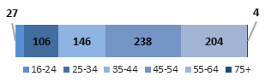 | - | 16-24 increased last year, but now slowing; 55-64 increasing | Funding for PYE static this year, so creativity needed to meet Scottish Government target of 5%.
RED | Workforce diversity - Disability | 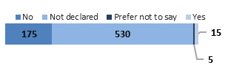 | 15 | This is red-rated because based on current disclosure rates our workforce is not currently representative of wider Scottish society’ | Work on increasing disclosure; continue visible support for the DAWNN network to identify opportunities for improvement in policy & practice
RED | Workforce diversity - Ethnicity | 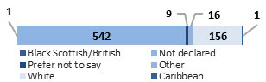 | 18 | Cultural norms are the cause, but increased applications from a wider range of ethnicities in the last three years | Advertise on ethnic jobs website as standard; continue work with CEMVO to increase opportunities
GREEN | Total emissions |  | 372,124  (kgCo2) | Ongoing issues with Rum Hydro resulted in prolonged period of down time. Island power supplied by diesel generators increasing our reported carbon total. | Work been ongoing to rectify issue and hydro has now been brought back online with upgraded batteries now installed. Remaining issues being worked though.
GREEN | Reach in mainstream media |  | 346m | The large increase in media reach is likely because of increased interest and media coverage of climate change issues, as well increased awareness of NatureScot as experts. | Continued proactive and reactive work with the media.
GREEN | Impact of public facing campaigns (social media impressions) |  | 1.3m | Spring activity targeted minority ethnic groups (MEG) and young people (not families). | Summer 6 week campaign, fresh creative mid-way, targeting families, young people and MEG.

WE HAVE TRANSFORMED HOW WE WORK
CORPORATE PLAN OBJECTIVE | SLT LEAD | RAG SCORE | Q1 UPDATE
Deliver new ways of working to stimulate achievement of our ambitions | Jane Macdonald | GREEN | SLT and colleagues continue to work on the new operating model via organisation design work. Significant effort is ongoing to develop our digital workspace, including migration to Exchange Online, procurement of the new telephone contract (to replace Cisco), implementation of Mobile Device Management for mobiles and laptops, alongside the final steps in the development of the new Intranet and Yammer.
Transform our individual and collective leadership capability | Jane Macdonald | GREEN | Building on the Organisational Development framework, NatureScot Way (NSW) groups are working on development of actions flowing from Objective delivery plans to feed in to our Transformation programme.
Sustain our focus on developing a happy and resilient workforce | Jane Macdonald | GREEN | P&OD continue to lead on the production and promotion of the wellbeing calendar of events. P&OD continue to design, monitor and respond (via engagement) to people pulse surveys.

FINANCE
Financial Metrics (£m) | Measure | Budget | Forecast | Variance | Rating
Resource Budget | Outturn within 1% of final budget | 57.5 | 58.1 | (0.6) | MINOR SLIPPAGE
Capital | Outturn within 5% of final budget | 1.8 | 1.4 | 0.4 | MAJOR SLIPPAGE
Indirect Capital | Outturn within 5% of final budget | 15.4 | 15.1 | 0.3 | ON TRACK
Paybill | Outturn within 1% of final budget | 30.5 | 31.2 | (0.7) | MINOR SLIPPAGE
Project Allocation | Outturn within target allocation range | 14.2 | 15.4 | (1.2) | MINOR SLIPPAGE
Peatlands | Outturn within 1% of final budget | 12.9 | 13.2 | (0.3) | ON TRACK
NCAPP | Outturn within 1% of final budget | 3.5 | 3.2 | 0.3 | MINOR SLIPPAGE
Better Places Fund | Outturn within 1% of final budget | 1.5 | 1.4 | 0.1 | MINOR SLIPPAGE
Nature Restoration Fund / BCF | Outturn within 1% of final budget | 7.0 | 6.7 | 0.3 | ON TRACK
*Operating under 1% - on track, up to 10% minor slippage, over 10% major slippage (** Capital under 5% / up to 10%)
Financial graphs | f performance
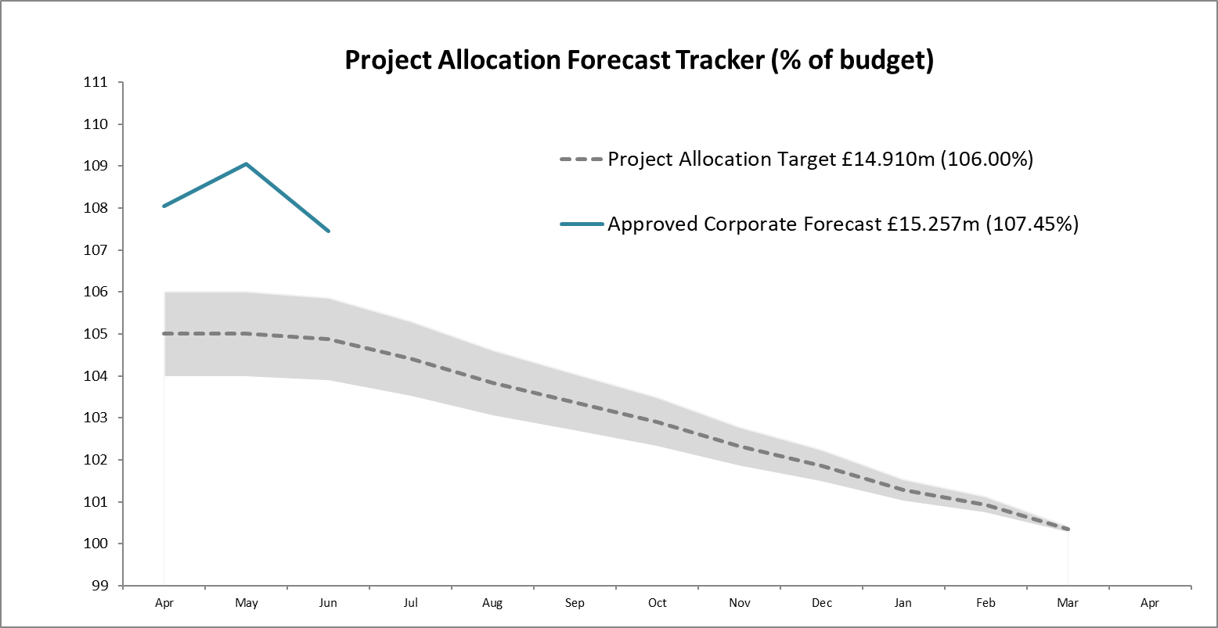  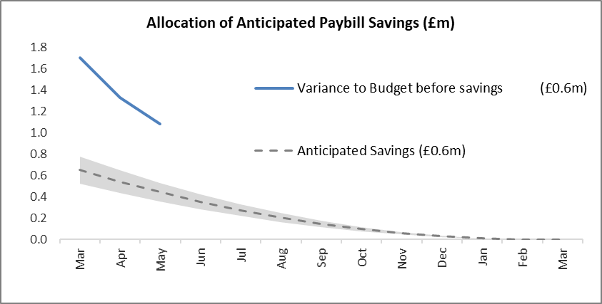 | The Project Allocation Forecast Tracker does not include any ring-fenced funds so NRF/BCF, BPF, Peatlands and ‘Farming with Nature’ are stripped out. There is a significant value (> £3.3m) of built up demand not included in the forecast tracker until surrenders have been made. The rating of the resource budget has been set at minor slippage due to the pressure from this demand and as SG continues to seek budget savings  The payroll budget figure was set £0.520m below the starting forecast in anticipation of savings to be realised through leavers and vacancy gaps. The forecast is currently £0.643m above budget but it is anticipated that additional savings will be achieved throughout the year.

Finance

Resource Budget Performance
- An overspend of £0.550m is currently forecast on the Operating budget, however it is anticipated that we will end the year within our target outturn. At the same point in 2021/22 an overspend of £3.022m was forecast.
- Additional budget for Farming with Nature has now been confirmed by SG, part of which will be allocated against current staffing costs. We are forecasting £1.5m against a £1.5m paybill budget. We have allocated the additional £2m to the overall programme, of which we are forecasting £1.655m. The total budget for NCAPP is £3.5m, with likely hand back of £345k due to late confirmation of allocation. This will be confirmed by the Autumn Budget Review deadline.
- SG have advised that there are significant pressures on resource funding and are currently targeting savings with further spending controls likely to be introduced.
- We will continue to monitor project surrenders throughout the year, using our knowledge and experience of previous slippage patterns to ensure that appropriate demand is ready to allocate when funds become available.
- The paybill outturn is currently projected to exceed the budget by £0.643m. This follows the early approval of staffing requirements for 2022/23 in response to identified resourcing pressures. This proactive approach ensures that we can respond to the developing needs of the organisation in the right timeframe. It is anticipated that additional savings will be achieved throughout the year.

Indirect Capital Funding Programmes (including Peatlands)
- We are forecasting an underspend on Indirect Capital of £0.224m. However, awards are currently being agreed for Nature Restoration Fund (NRF) and Peatlands, with an over-allocation approach planned to ensure that full budget spend is achieved.
- Slippage from 2021/22 Biodiversity Challenge Fund (BCF) grants is being funded from the Nature Restoration Fund Indirect Capital budget (£0.309m).
- The impact of slippage on large value programmes such as NRF presents a risk to spend levels. The anticipated slippage is 4% of the forecast outturn (£0.280m). This is split against NRF Indirect Capital (£0.224m) and Resource (£0.056m) budgets.
- Slippage from 2021/22 for GovTech has now been approved by SG and we have allocated £0.150m to the project for 2022/23.

Structural Funds Programmes
- The current Green Infrastructure claim of £0.848m remains unpaid 21 months after submission.
- The current NCHF claim of £0.214m remains unpaid 8 months after submission.
- The potential NatureScot liability for advance payments at the end of May was £1.543m (this is the maximum exposure should there be disallowance on all of the payments made).
- Cash flow arrangements to enable payment of delivery body claims ahead of ERDF drawdown is now agreed with Sponsor division. Provision for Sponsor Division to manage risk of de-commitment is still in development

Capital Budget Performance
- An underspend of £0.396m is forecast on the capital budget.
- This is after including the sale of Glencripesdale in the NBV figures which increases our ability to spend on Capital projects by £0.750m.
- Funding of £0.051m has been secured from Hermaness Hill Path and Welcome Area.
- The potential proceeds of the sale of Kinloch Castle are not currently reflected in the numbers but will also be considered in any additional capital expenditure plans.

RISK
Corporate Risks |  | Risk Changes
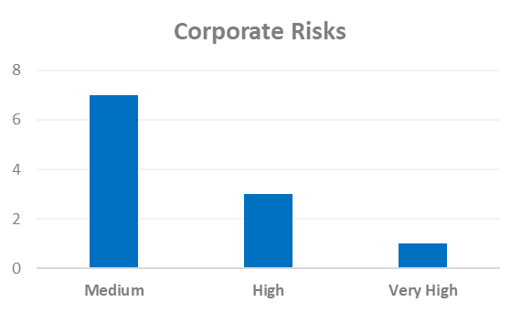 | Changes to Corporate Risk Scores  ↑0 Gone Up  ↓ 1 Gone Down  Change to Corporate Risk Register  ↗ 1 New Corporate Risk  ↘ 4 De-Escalated (approved)

Risk

- Annex B – Corporate Risk Register shows the current high rated corporate risks for NatureScot. Activity and project risks are managed within the risk management system, which underpins the corporate risk register. All risks are managed in line with the Risk Management policy and monitored regularly for compliance and visibility of impact.
- There are currently 11 approved Corporate Risks, 7 medium, 3 high and 1 very high. The risk rating has decreased from high to medium for “NatureScot’s responsibilities for delivery of Agri-Environment Climate Change Scheme (AECS) under the Service Level Agreement (SLA) with Scottish Government”. This is due to the risk owner feeling that the controls in place suitably manage the risk, but it will be kept under review as the work progresses in year.

- One risk has been agreed by SLT to be escalated to the corporate risk register. The risk is included in the register with the proposed controls pending confirmation of their escalation:
- 691 - Lack of support for Fusion Financial and Procurement Modules - Due to the specialised nature of Oracle Fusion and the interface with NatureScot’s Business Planning System, as a result of key system support staff leaving the organisation, there is a risk that there will be insufficient knowledge and ability to operate key financial processes or to develop the system and reports. This may result in an inability to adapt the system to changing business needs, reporting delays or to operational inefficiencies and payment challenges that could affect all users of the system

- During Q1, the Corporate Risks have been reviewed to ensure that they still require to be managed at the corporate level. As a result four risks were approved by Senior Leadership Team to be de-escalated from the register to be managed at the Activity level. These risks are:
  - 84 - Joint Working – As a result of reductions in public expenditure and the government's drive for more integrated public services there is an opportunity to increase joint working and collaboration. This could reduce our overhead costs through shared services, increase the proportion of our resources which is directly invested in nature recovery, increase our influence and provide better public services.
  - 283 - Wildlife Management - Our Ability to Influence Stakeholders – As a result of deeply held and polarised views amongst stakeholders there is a risk that we are unable to secure their compliance and co-operation on the management of wildlife. This could result in the failure to achieve planned outcomes for wildlife and nature.
  - 583 - Covid-19 Pandemic - Business Impact – As a result of the current Covid-19 pandemic, there is a risk that planned business activities and outputs may be significantly impacted due to: reduced productivity levels (move to working from home and the potential for significant staff absences); the potential for a reduced capacity by stakeholders and partners to undertake joint-work; and, due to the potential for reduced public sector funding in the future. This could result in a failure to complete or maintain progress on a range of existing and planned work activities and consequently limit delivery of our business plan priorities.
  - 679 – Strategic Management and Integrity of Land Parcel Ownership/Management Contract Data – This risk was initially escalated due to the threat from a lack of oversight of the management and quality of data. There was a concern this could comprise our ability to deliver nature-based solutions and potentially result in a failure to meet legal requirements. Whilst the exposure to the risk is still deemed to be high, new governance arrangements are now in place to provide oversight and a project established to address the issues raised. As a result, it is proposed that this risk is de-escalated from the Corporate Risk Register and supervised at the Activity/Project level.

PEOPLE
People Metrics | Status

Wellbeing
Accidents & Near Misses – target: to stay within variations around the mean  Q1: Accidents=5, Near Misses=3 (these continue the low trend of the past two years) | Green
Work-life balance – target: 75% of employees feeling that their work-life balance is good  Q1: 69% of employees who utilised Work Happy rated their work-life balance as good (same as last few months, so no real change) | Green
Capacity
Sickness – Target: under 2 days per person per quarter.  Q1: 1.15 days (early indications that the pre-pandemic autumn/winter highs-spring/summer lows are returning) | Green
Holiday Leave  Q1: 19.72% of holiday leave taken | Green

Development
Formal Casework - target <=50% of informal casework  Q1: 22.7% (5 cases), well within normal range for this type of casework | Green
Informal Casework  Q1: 25 cases, well with normal range for this type of casework | Green
Access to L&D for role  Q1: 69% agree | Green

Workforce Profile
Turnover – target: increase  Q1: last 12 months of turnover is 11.06%, a steady increase in the last five quarters (statistically valid increase apparent now), and entirely normal for government bodies. | Green
Internal Movement – target: increase  Q1: a fraction lower than average, but, notably, most coming from promotions or level moves (rather than other types of movement) | Green
Retirement Profile  Q1: 134 employees are aged 57+ currently, predicted to rise to 153 in 2024/25 (19.9% of current headcount), and adjusted for average number of retirements. Position/RAG rating has not changed in the last three quarters so no new information to present. | Amber

Annex A – National Performance Framework Indicators
NPF Indicator (NatureScot lead reporting on) | Status | Next Update Due
Improve the condition of protected nature sites | Maintaining | May 2023
Biodiversity | Maintaining | November 2022
Increase natural capital | Maintaining | April 2023

NPF Indicator (NatureScot contribute towards) | Status | Next Update Due
Increase people’s use of Scotland’s outdoors | To be confirmed | September 2022
Improve access to local green and blue space | To be confirmed | September 2022
Reduce Scotland’s carbon footprint | Maintaining | December 2022
Progress on each Indicator is undertaken annually and where an update occurs we shall provide a report below. Where the status states to be confirmed, this is because, as a result of the Covid-19 pandemic, the approach to gathering the data has changed and it is therefore not directly comparable with previous years.
Protected nature sites
This indicator reports the percentage of natural features on protected nature sites found to be in favourable condition.
By the end of March 2022, 77.9% of natural features were assessed as being in a favourable condition, 0.4 percentage points lower than recorded in March 2021 and 1.9 percentage points higher than recorded in 2007.

Biodiversity
This indicator is a combination of trends for three measures of Scottish species (increased from 1 previously), index of abundance of marine species (based on seabirds), index of abundance of terrestrial species and index of occupancy of terrestrial species.
All three measures were stable over the period 2015 to 2016. The index of abundance of marine species rose by 2.7%, the index of abundance of terrestrial species fell by 4.8% and the index of occupancy of terrestrial species rose by 0.8%.
Over the longer term, between 1994 and 2016, the index of abundance of marine species fell by 36%, the index of abundance of terrestrial species fell by 31% and the index of occupancy of terrestrial species rose by 24%. The marine elements of the indicator continue to be under development as new species data becomes available. Breakdowns for the three measures are available for the main taxonomic groups.

Natural Capital
The Natural Capital Asset Index (NCAI) monitors the quality and quantity of terrestrial habitats in Scotland, and tracks their potential to deliver ecosystem services now and into the future. It is a composite index, based (i.e. equal to 100) in the year 2000. The NCAI in 2020 at 102.8 is the highest since detailed monitoring began in 2000.
It is recognised that at this point in time, the NCAI still requires further development and refinement to produce a fully satisfactory measure. Despite this it is seen as a valuable addition to the indicator set. We will continue to work closely with key stakeholders over time to develop the NCAI and other potential future measures.

Annex B – Corporate Risk Register (High Risks)
Risk Title | DESCRIPTION | CONTROLS | IMPACT | LIKLE-HOOD | RISK LEVEL | Comment
47 - Computer Virus/Malware | As a result of inadequate protection, or inappropriate system use, including accidental activation of email links by that lead to malware downloads, there is a risk that NatureScot systems becoming infected with a malware or virus agent, resulting in NatureScot systems and data become unavailable, encrypted or corrupted, significant system downtime and huge operational impacts | *All file servers are protected by Sophos anti-virus protection. Upgrades are performed automatically and can also be applied in an ad-hoc manner  *All PCs are protected by Sophos anti-virus protection. Upgrades are received on a daily basis but can be applied ad-hoc  *All incoming emails are scanned for viruses.  *All internet access, where possible, is scanned for viruses (not https sessions).  *Raise staff awareness of potential risks relating to email links and infected documents through regular communications.  *Sandbox controls/ environment implemented  *Control of USB devices  *Awareness raising with staff via Blogs and update articles  *Incident Management Group in place  *Shared Service with Scottish Government that takes forward Network Scanning for unusual activity in place. | 4 | 3 | High | Although there have been no recent significant incidents or alerts for the Scottish public we continue to be on high alert due to Ukraine/Russia conflict. We are receiving many updates from National Cyber Security Centre (NCSC) with the constant requirement to check patching or install updates leading to additional work for Infrastructure and Cyber-Security team. Infrastructure team have purchased an additional mail filtering device and are scheduling implementation. We continue with the phishing email testing and with the E-learning for Cyber. Our completion rates remain high.
253 - Peatland restoration target and budget. | As a result of the immature and complex operating environment, there is a risk to: meeting the annual Peatland ACTION restoration hectare target; and spending the annual budget. | • Realistic planning  • Invigorating demand  • Real-time monitoring  • Increasing resilience to change in projections  • Regular and robust review and control | 4 | 4 | High | Whilst we have a pipeline of almost 10,000 ha, there is an ongoing risk of not meeting the hectare target because experience suggests contractors and project officers are over-ambitious. This has an implication on the capital element of the budget, There is less risk on the resource budget due to: - more rigorous programme/business planning; - expanded staff capacity. Thus, the focus of our controls are on: 2. Invigorating demand. We are introducing targeted promotion at events of the multiple benefits of restoration, the open application system, the scope for multi-year offers and a new grant for coordinating delivery of large scale restoration projects. 3. Real-time monitoring - we are monitoring our pipeline of restoration projects - informed by grant application status and risk to delivery from project complexity; vulnerability to extreme weather conditions; and applicant/agent track record of delivery 4. Increasing resilience to change in projections – we are overcommitting by 10%. 5. Regular and robust review and control - There is quarterly assessment of risk by the Peatland ACTION Governance Board, with a remit to provide assurance on the likelihood of risk and recommend [to the Programme Manager] additional controls to reduce the likelihood to 2. 6. Using new Guidance on operating during nesting season to allow risk based approach to operations during that period.
691 - Lack of support for Fusion Financial and Procurement Modules  *New escalated risk* | Due to the specialised nature of Oracle Fusion and the interface with NatureScot’s Business Planning System, as a result of key system support staff leaving the organisation, there is a risk that there will be insufficient knowledge and ability to operate key financial processes or to develop the system and reports. This may result in an inability to adapt the system to changing business needs, reporting delays or to operational inefficiencies and payment challenges that could affect all users of the system | • Engage in a shared service arrangement with other organisations using Fusion e.g. HES, SLAB  • Make use of the support arrangement from Inoapps currently utilised by POD. There may not be sufficient knowledge from Inoapps to initially support some finance and procurement processes.  • Recruit to the two vacant functional analyst positions.  • Draw on finance staff with an awareness of Fusion and the interface with Business Planning as well as the functional analysts who support the POD elements of Fusion, in order to support the finance elements of Fusion. It should be noted that this will not provide all of the specialist knowledge required.  • Implement a networked team approach to involve staff from a wider group to share knowledge and provide resilience in future. | 4 | 4 | High | Interim support for 1 day/wk is continuing to be provided by HES but there are a number of actions being advanced to strengthen this area in the longer term. The current support contract is to be expanded to ensure coverage of finance, procurement and related system administration. Once secured, we will engage in a procurement exercise to revisit this support contract and also invite proposals from others. Recruitment to the NatureScot positions is proving challenging due to high market demand for individuals with these skills. We are in the process of agreeing retention allowances to make the functional analyst positions more attractive to candidates. For the Fusion Manager position, we are engaging with recruitment agencies and have a couple of options being actively progressed. Training up the new employees will also prove challenging given the lack of a handover, but we are also revisiting current support networks and the potential in future for a shared service arrangement with other public bodies. Colleagues within FPP have taken on certain tasks which will also help with induction when transferred back. This remains a high risk, in particular given the likelihood of HES wishing to end the current arrangement shortly.

