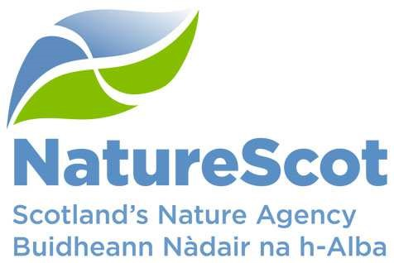

By email
Scottish Ministers
per Natural Resources Division
Victoria Quay
Leith
Edinburgh
EH6 6QQ
25 August 2022 Dear Scottish Ministers

Enlargement of 10 SSSIs under section 5(1) of the Nature Conservation (Scotland) Act 2004

Ben Griams Site of Special Scientific Interest (SSSI)
East Halladale SSSI
Forsinard Bogs SSSI
Loch Caluim Flows SSSI
Rumsdale Peatlands SSSI
Shielton Peatlands SSSI
Sletill Peatlands SSSI
Strathmore Peatlands SSSI
West Halladale SSSI
West Strathnaver SSSI

I write to notify you that Scottish Natural Heritage (hereinafter referred to as NatureScot) considers that the land shown within the solid black lines on the maps referred to in this letter is of special interest because of its natural features. These features are specified in the SSSI citations.

The combined land consists of the land notified by Scottish Natural Heritage (and predecessor bodies) as set out in the table below and the extra land (shown hatched on the boundary maps) which is adjacent to the original SSSIs.

SSSI name | Date notified
Ben Griams SSSI | 13 July 1984, 20 December 1994
East Halladale SSSI | 22 May 1996
Forsinard Bogs SSSI | 13 July 1984
Loch Caluim Flows SSSI | 11 October 1984, 12 March 1993
Rumsdale Peatlands SSSI | 17 September 1984, 24 September 1992
Shielton Peatlands SSSI | 22 March 1984, 31 January 1990
Sletill Peatlands SSSI | 14 November 1991
Strathmore Peatlands SSSI | 10 April 1985, 18 December 1992
West Halladale SSSI | 27 September 1989
West Strathnaver SSSI | 31 May 1994
The Links, Golspie Business Park, Golspie KW10 6UB
A’ Mhachair, Raon Gnothachais Ghoillspidh, Goillspidh KW10 6UB
01463 701608 nature.scot
NatureScot is the operating name of Scottish Natural Heritage

I have also enclosed a link to the list of operations requiring consent for each SSSI. These are lists of acts that are likely to damage the natural features described.

While the notification remains in force, you as a public body must not carry out any operation likely to damage any of the natural features specified in the notification without written consent from NatureScot unless any of the exemptions described in section 14(1) of the Nature Conservation (Scotland) Act 2004 apply. This applies whether or not the operation is on the lists of operations requiring consent and whether or not it would take place within the SSSIs.

In addition, as a designated relevant regulatory authority, before deciding whether to permit any operation likely to damage any of the natural features specified in the notification, you must notify NatureScot of the proposal and wait 28 days before making a decision on the proposal, unless NatureScot notifies you that you need not wait. This also applies whether or not the operation is on the lists of operations requiring consent and whether or not it would take place within the SSSIs.

We have also prepared a revised site management statement for each SSSI. This is a public statement that provides guidance to the owners and occupiers of each SSSI on how each site’s natural features should be conserved or enhanced.

The only changes to the citations are to update the site area and to add the sentence ‘Parts of the site are being restored to blanket bog from conifer plantation’. There are no changes to the features of the SSSIs or lists of operations requiring consent. We have updated the site management statements with the results of our most recent monitoring, any new information that we have on site management and advice on how to continue restoration of the land that is being added to the SSSIs.

All the documentation detailing the proposed extensions to the protected area can be downloaded from https://www.nature.scot/professional-advice/protected-areas-andspecies/protected-areas/protected-area-notices together with an explanation of why we are proposing to extend the protected area now.

If you wish to make representations about the notification of the extra land, please write to me at the address below by 29 November 2022. Representations cannot be made in respect of the original SSSI notifications during this consultation.

The notification will cease to have effect if it is withdrawn or is not confirmed by NatureScot by 25 August 2023.

Yours faithfully
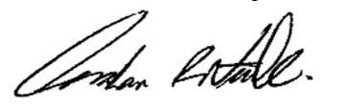
Graham Neville
Head of Operations – North
north@nature.scot

