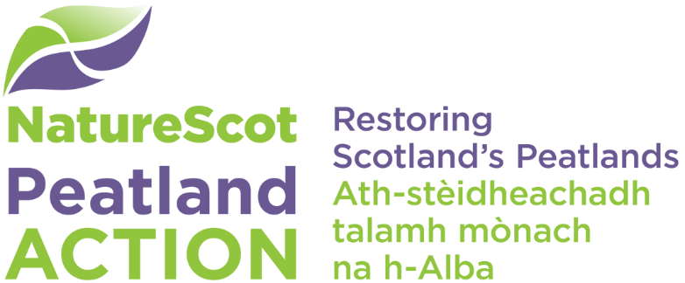

Restoration footprints
  - What are they and how do I draw them?

Definitions
Version 2.0 of the Peatland Action spatial data model includes changes to the terminology around peatland restoration sites. These changes were made to give a better distinction between areas where restoration is proposed or has been undertaken (sites) and the subsequent outcome of restoration (restoration footprint). The two terms are defined below:

Site outline (“Sites”):
- Recorded as the site_outline in the spatial data template.
- Sites are areas where the peatland restoration activity is planned (i.e. the area to be restored), is taking place or has been completed.
- Defined at the convenience of the user – may represent a particular phase of work, a specific geographic area or one year of a multi-year funded project.
- At least one site must be recorded with an application or final report.
- Sites should encompass all site-based restoration features (hags, gullies, peat dams etc.) for a given area.

Restoration footprint:
- Recorded as the restoration_footprint in the spatial data template. Previously referred to as subsite.
- Area around site-based restoration features - up to a maximum of 50m
- Used to calculate the areas of peatland “put on the road to recovery” under a given project for subsequent reporting to Scottish Government
- Should omit areas of non-peatland or other unsuitable areas.
- Should be associated with a Site.

Why does Peatland Action need this information?
The restoration footprint is used to calculate the area (in hectares) included within the project. These areas are used by Peatland Action to report to the Scottish Government on the total area of peatlands “put on the road to recovery” in a financial year. It is therefore very important that all applicants are therefore providing this boundary consistently so we can be confident in our evidence.

Steps for drawing restoration footprints
- Map your Site boundary and features that you are going to restore/have been restored. For more information see associated software specific guidance and spatial data template documentation.
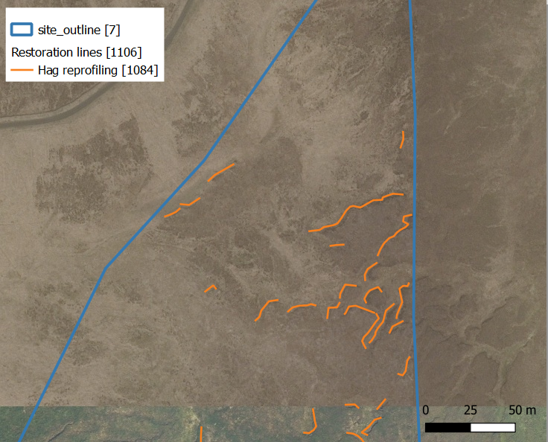
Figure 1. Example of digitised restoration features and site outline.
- Draw the restoration footprint around the site-based restoration features (hags, gullies, peat dams etc). The restoration footprint must not be more than 50 metres away from these restoration features. It may be appropriate to use the buffer tool included with your GIS software.
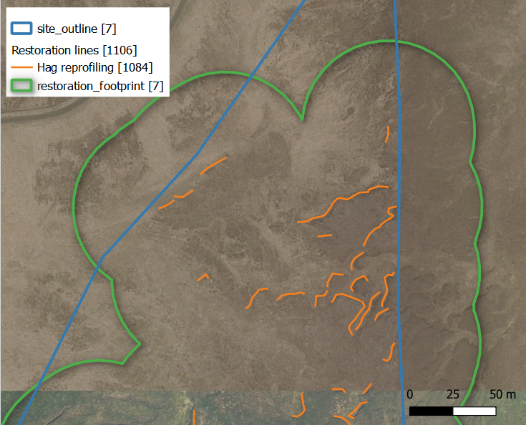
Figure 2. Example of a restoration footprint applied to digitised restoration features.
- All non-peatland areas (such as rocky outcrops) should be excluded from restoration footprints. For more information of what should and should not be included see FAQ section.
- The subsequent polygons indicate the extent of the restoration footprint, group the restoration features by the relevant Site. Be sure not to double count areas by overlapping restoration footprints.
- Calculate the area in hectares of the restoration footprint for each Site to two decimal places. Calculate the area within each Site, and the total hectares for your project will be the sum of hectares for all Sites. Note if you are using the QGIS spatial data template this calculation will be completed for you in the Restoration area measurement table.
- Repeat the above steps for the final report starting at 1 and editing the Site based restoration features based on the actual work done. Make sure you use the same Site ID as the application form in final report unless you have a completely different Site due to changes to the project scope.

If you require clarification or help with mapping please contact peatlandactiondata@nature.scot

FAQ’s

What features should or shouldn’t be included in the restoration footprint?
The following include some examples of areas that shouldn’t be included within the “area put on the road to recovery”, note this list is not exhaustive.
- Roads and/or areas falling on the opposite side of the road from site-based restoration features
- Rivers/lakes and/or areas falling on the opposite side of the river/lake from site-based restoration features.
- Areas of non-peatland habitat, for example bare rock, shoreline or non-peatland soils.
- Areas adjacent or within sites that are to remain under forest cover.
- Adjacent areas of excessively degraded peatland

Where present, the above areas should be removed from restoration footprints.

Can I use a smaller restoration footprint?
The 50m rule is an upper limit, it may be appropriate in areas to use a smaller buffer, for example areas on an uphill gradient from the restored features. Similarly, if the site lies in proximity to areas such as those listed above, a smaller buffer will likely be required.

If you have a reason for a distance of more than 50 metres (for example the whole hydrological unit will be affected) then the details of the slope, flow and terrain must be mapped and explained in the application form and final report.

