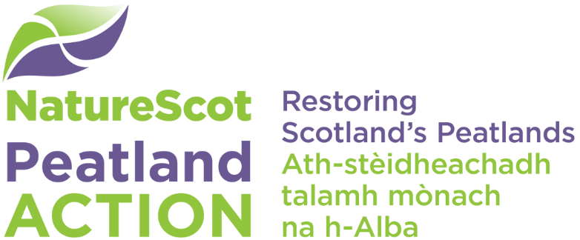

Application process quick guide

Step 1 – Contact us to discuss your plans before you submit your application
You must get in touch with one of our Project Officers as early as possible before you submit your application. Our Project Officers will support you to develop your project, help you understand the Peatland ACTION Fund and assist you with completing your application and supporting information. You must contact us at peatlandaction@nature.scot.
If your project is located within either of Scotland’s National Parks, you should contact the relevant national park Peatland ACTION team to discuss your proposals:
- Cairngorms National Park
stephencorcoran@cairngorms.co.uk or emmastewart@cairngorms.co.uk
- Loch Lomond and the Trossachs National Park
Peatland@lochlomond-trossachs.org

Step 2 - Read our application guidance
Please read our guidance on the Peatland ACTION website and note your responsibilities. You must read the following:
- Peatland ACTION - Frequently asked questions
- Peatland ACTION - Outcomes and priorities for action
- Peatland ACTION - Fund eligibility criteria
- Peatland ACTION - Applying for funding – information for applicants
- Peatland restoration and The Construction (Design and Management) Regulations 2015 - Information for applicants
- Peat depth and peatland condition survey guidance and recording templates
- Spatial data guidance and templates (including Site boundaries - what are they and how do I draw them?)
- Peatland ACTION - Final report template
- NatureScot Standard Terms and Conditions of Funding
- How to acknowledge our support for your project
- Guidance for grant applicants – financial information and records

Step 3 - Complete the Peatland ACTION application form
Once you’ve completed your application form, please email a word version to us at peatlandactiongrant@nature.scot. Make sure you send us the required supporting information including copies of your Construction (Design and Management) Regulations 2015 (CDM) client and designer letters, landowner permission, landlord declaration (if applicable), spatial data, map image/pdf, peat depth and peatland condition survey, quotes or tenders, single tender justification (if applicable), monitoring information questionnaire.

What happens next?

When we receive your application
We’ll email you to confirm we’ve received it. One of our Funding Officers will assess your application. We’ll prioritise assessments based on their potential contribution to Peatland ACTION outcomes, timescales for delivery as well as your track record for delivering previous works with our funding, where applicable. Timescales for a decision will vary depending on demand and the complexity of your proposal. If you haven’t provided all the information we need to complete our assessment it will take longer to reach a decision. In some cases, we will return your application to you for re-submission.

If your application is successful
If your application is successful, you’ll receive a Funding Offer. This is our contract with you and must be read carefully. You’ll have 30 days to accept it. Once it’s accepted, we’ll agree a start date with you.

Before your project starts
We recommend that you set-up an agreement with your agent (if you have one) and your contractor(s). You’ll need to send us a copy of your letter of appointment for the contractor. You’ll need to send us evidence that all relevant licences, permissions or consents are in place.

Project updates and claims for payment
We’ll ask for a short monthly report about progress with the restoration works, which includes photos and a map. We’ll provide you with a claim template so you can request payment for the activities completed. We’ll ask for receipted invoices for the items claimed.

When your project completes, before your final claim can be paid
You’ll need to arrange a site inspection visit from your Project Officer before contractors leave the site. Send us your final report and spatial data for the completed restoration; we’ll provide templates. Send us a copy of The Post Construction Phase Health and Safety file if more than one contractor has been working on the project.

Your compliance requirements – from the date your final payment has been made
You must provide a report on the management success and failures of the project 5 years after your final payment. Site improvements must be maintained for 10 years from the date of your final grant payment. This includes no muirburn on restoration sites for the period.

Project resources and case studies
There’s more information at Peatland ACTION project resources and case studies.

