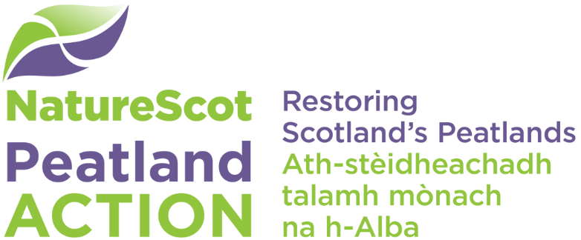

Peatland Restoration and the Construction (Design & Management) Regulations 2015
  - Information for applicants

Purpose of this document
- The document provides a summary of the Construction (Design & Management) Regulations (2015) – hereafter CDM (2015) - and how they apply to peatland restoration carried out through the Peatland ACTION project.
- If you are applying for Peatland ACTION funding to restore a bog, you must familiarise yourself with the Regulations and their relevance to peatland restoration. This document serves as a broad overview. All of the required documentation to guide you through the CDM (2015) process for Peatland ACTION is available on our CDM (2015) web page.
- All applicants are encouraged to liaise directly with one of our project officers prior to submitting an application. This will allow us to help you in developing a safe and legally compliant restoration project.

These regulations are for the construction industry: is peatland restoration construction?
- Yes, it is. The Health and Safety Executive (HSE) provided some guidance on this matter which says that construction work is almost any work relating to a structure, and further includes the definition of structure:
“river works, drainage works, earthworks, lagoon, dam….. structure designed to preserve or alter any natural feature…”
Health and Safety guidance book 153 (HSG153), Guidance on Regulation 2, UK HSE
- In the past others have tried, largely unsuccessfully, to claim that other rural construction projects were in fact activities related to farming or forestry and thus were not covered by the regulations, but the general response from the HSE has been that if it looks like construction, involves construction equipment and construction materials, then it is construction even if the end use is agricultural, silvicultural or something else.
- Peatland ACTION takes health and safety very seriously. Much of our work is carried out in remote upland areas, with machinery on difficult terrain. Achieving programme-wide compliance with the CDM (2015) regulations helps us to ensure the safe working of all involved.

The duty holders
- Everyone involved in the development, design and delivery of a Peatland Action restoration project has a responsibility to ensure compliance with the Regulations. This includes applicants and their agents, and anyone supporting the design of projects, including Peatland Action project officers.
- A typical CDM (2015) Project structure is shown in Figure 1. Each character in the flow diagram has defined responsibilities.
- The roles defined in CDM (2015) do not need to be fulfilled by individuals, they can be taken by corporate bodies or even teams within an organisation (such as Peatland ACTION). There is no restriction on the number of roles a person, or corporate body, can take on. As long as all are clear on the split of responsibilities from the outset, the process is flexible. In many cases, with early pre-application consultation, Peatland ACTION project officers can assist with roles and duties.
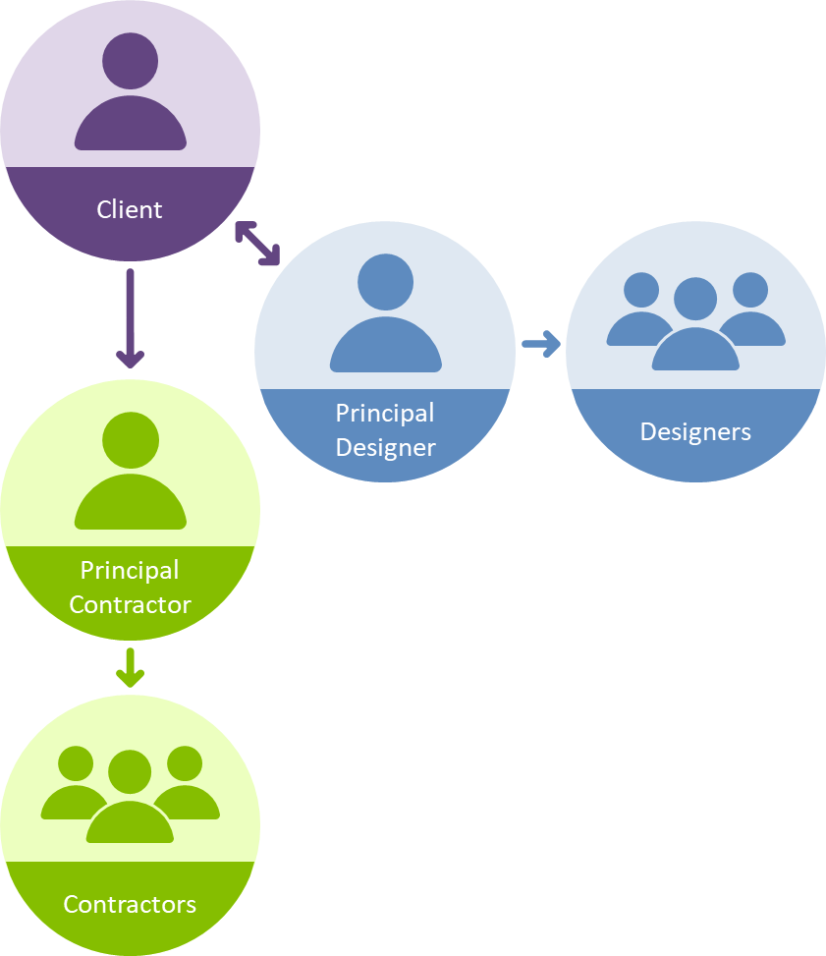
Figure 1. CDM (2015) Duty holder flow diagram

- All the roles noted in the Figure 1 flow diagram have specific duties under the regulations; summarised in Table 1.

Table 1. CDM (2015) Key duty holder roles and responsibilities
Holder | Duties
Client | - Make sure other duty holders are appointed and competent  - Allow sufficient time and resource to carry out the project  - Make sure that the relevant information is provided to other duty holders  - Make sure the Principal Contractor and Principal Designer carry out their duties  - Ensure welfare facilities are provided  - Create the Pre Construction information document
Designer | - Plan, monitor and control the pre-construction phase of the project  - Identify and control foreseeable risks within project at design stage  - Follow the principles of prevention in developing the design  - Ensure other designers carry out their duties  - Provide information to the principal contractor help them carry out their duties in the construction phase  - Create the design documents
Contractor | - Plan, monitor and control the construction phase of the project  - Liaise with client and principal designer  - Follow the principles of prevention in constructing the project  - Organise co-operation between the contractors  - Ensure that reasonable steps are taken to manage safe access  - Create the Construction Phase Plan document

Competency
- You will note that the Client has duties with respect to appointing competent people to carry out roles on the project. This infers that the client must do a degree of assessment of the competence of these various people. Peatland ACTION project officers will in most cases, take on a shared client role with the applicant, using our experience and knowledge of the restoration sector to ensure that an appropriately competent contractor is selected.
- Peatland ACTION project officers may also lead on the design of the restoration work to be carried out. Our competency framework will ensure our officers are capable of designing safe and effective restoration.

The CDM (2015) process and key documents
- CDM (2015) projects are split into three stages:
- Stage 1: Pre Construction
- Stage 2: Construction
- Stage 3: Post Construction
Annex 1 shows how these flow together.

Stage 1: The Pre Consultation Stage
- The first step in any CDM (2015) project is to ensure early pre-application communication between the applicant / agent and a Peatland ACTION project officer (or other competent restoration designer). These early discussions will result in the assigning of Client and Designer duty holder roles and the tasks associated with them. Completed letters of appointment for these two duty holders must be submitted with the grant application form. Template letters for the shared Client role and the Designer role are available on our website.
- The Pre Construction phase starts when the Client decides to bring forward the project and appoints a Principal Designer. The Principal Designer is then tasked with administering this phase of the project, ensuring that design work is carried out in a compliant way and that the project can be brought forwards to construction in a safe manner. The main CDM document from this phase is the Pre Construction Information (PCI) document.

The Pre Construction Information document (PCI)
- This Pre Construction Information document is the Client’s responsibility. The purpose is to give the Designer and Contractor as much information as possible about the project, the site and constraints or hazards identified. The Principal Designer’s work will take account of this document, as will the Construction Phase Plan (CPP). This PCI document should be developed as soon as possible in the project to allow the designer(s) and contractor(s) to take the information into account when forming their plans.
- The PCI document will contain key information about the site, in order to assist the Contractor(s) and Designer(s) in planning for the hazards presented by the project. For further information about what is included in the PCI, see our ‘PCI: What to Consider’ guide.
- The law is structured so that most of the legal risk lies with the Contractor. The Client’s interest is limited to seeing that a sensible plan is in place, not the minutiae of how it is achieved. Once the PCI document and the Principal Designer’s work are complete, an application for funding can be finalised and submitted.
- A Pre Construction information document is required for all projects. The diagram in Annex 2 shows the various steps in this stage.

Stage 2: The Construction Phase
- The construction phase starts when a Contractor (or Principal Contractor where more than one contractor is required) is appointed, following completion of the tendering process and after a Funding Offer has been accepted. The letter of Appointment for the Contractor should be completed, filed and must be submitted to the Funding Officer at this stage. The Principal Contractor will be given the Pre Construction information as soon as possible (usually during the tendering process), and will use this information to develop the Construction Phase health and safety plan. This document is then returned to the Client.

Notification
- In certain circumstances CDM projects must be notified to the Health and Safety Executive by the Client (or their representatives) prior to the commencement of the construction phase. This cannot be done until all duty holder roles are filled which will, in most cases, be after a Funding Offer has been accepted and a contractor appointed. The notification criteria are shown in Figure 2. Even if your project does not meet the threshold for notification to the HSE, the rest of the CDM regulations still apply.
- A construction project is notifiable if the construction work is expected to:
- last longer than 30 working days and have more than 20 workers working at the same time at any point on the project, or;
- exceed 500 person days.

- Every day where there is construction work planned should be counted when considering these thresholds. This includes where the work planned on that day is of a short duration. It also includes holidays and weekends. Our advice is that if a project looks like it could be notifiable as the construction planning gets underway – just notify it. Equally, if a project does not meet the notification criteria in the planning stages, but subsequently grows arms and legs there is no penalty for notifying mid project. It is the Client’s duty to notify a construction project. In practice however, the Client may ask someone else to notify on their behalf. Details on how to notify the HSE are in Annex 3.

The Construction Phase Plan (CPP)
- The Construction Phase Plan is produced by the Contractor to tell the Client how they intend to manage health and safety through the construction phase of the project. It should contain details on how hazards like public access and contractor management will be dealt with, and also any measures taken in response to information which has been delivered in the PCI document. It should also discuss sub-contractor management (if appropriate), induction and site rules. Our CPP ‘best practice’ guide gives further information on what to include.
- This document should be supplied to the Client / Peatland Action project officer prior to starting work on site, and should satisfy them and the Designer that the Contractor has taken account of the information supplied in the PCI document.
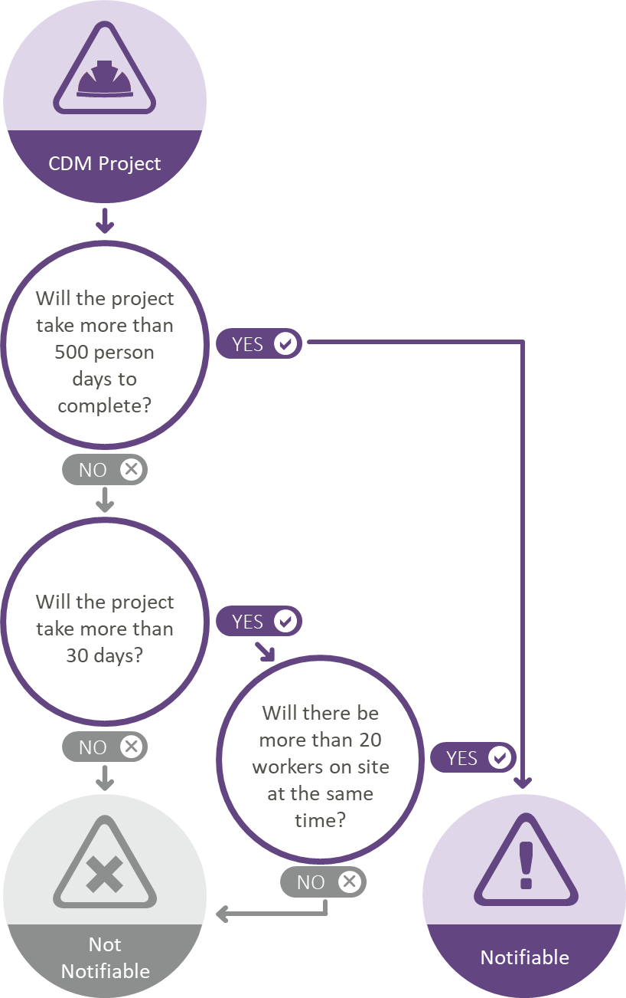
Figure 2. Flow Chart showing notification thresholds

Stage 3: The Post Construction Phase
- This phase starts when the construction work is complete (see Annex 4). The project is then passed back to the control of the Principal Designer, who must pull together the information required for the development of a Health and Safety file. This is a document which details any residual risk which exists in the project, including in any inspection or maintenance tasks which are foreseen.

The Post Construction Phase Health and Safety file
- The Post Construction Phase Health and Safety file is only required where there has been more than one contractor working on the restoration project. It is the responsibility of the Principal Designer. The purpose of the file is to record any latent hazards which remain in the completed project, either because they have not been removed from prior to the project, or because the design team were not able to completely design them out of the new structure (in this case restored peatland). The file might include reference to newly formed very wet areas, standing water, large dams.
- The file should only contain information relevant to a future occupier wishing to carry out maintenance or construction work on the restored site. It should be finalised as soon as the project is complete and passed to the Client for the attention of the restored site’s future users. A copy must be submitted to your Funding Officer.

Annex 1. CDM (2015) top-level process summary
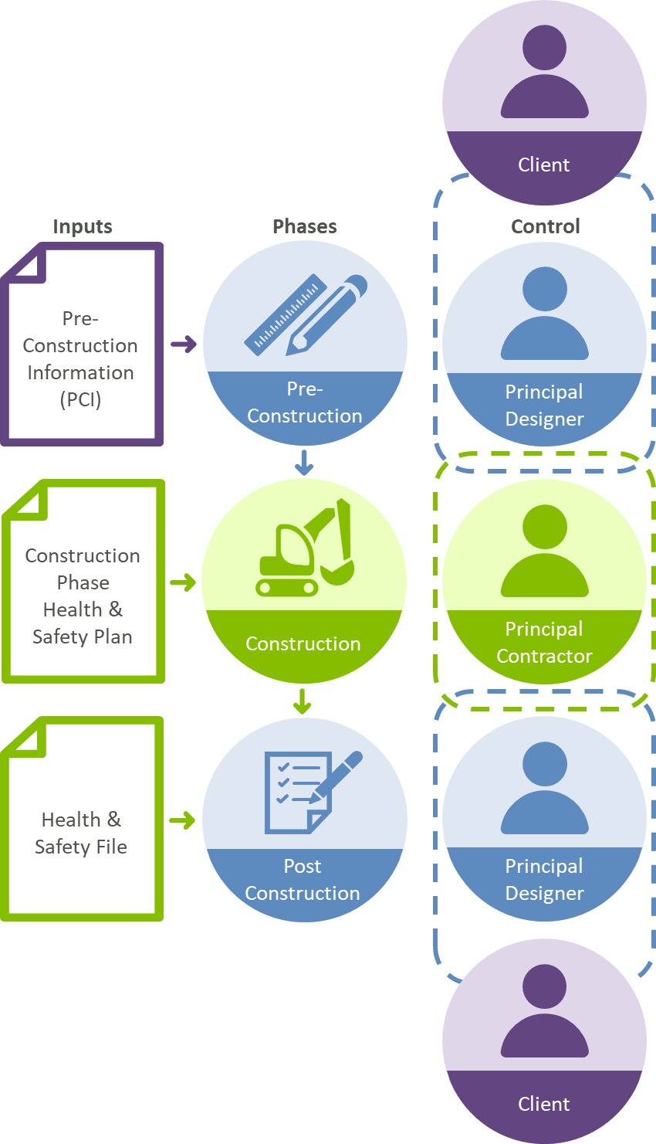

Annex 2. Process overview showing key documents
In Peatland ACTION projects, the Contractor won’t be appointed until the grant is awarded to the applicant, following a successful grant application process.
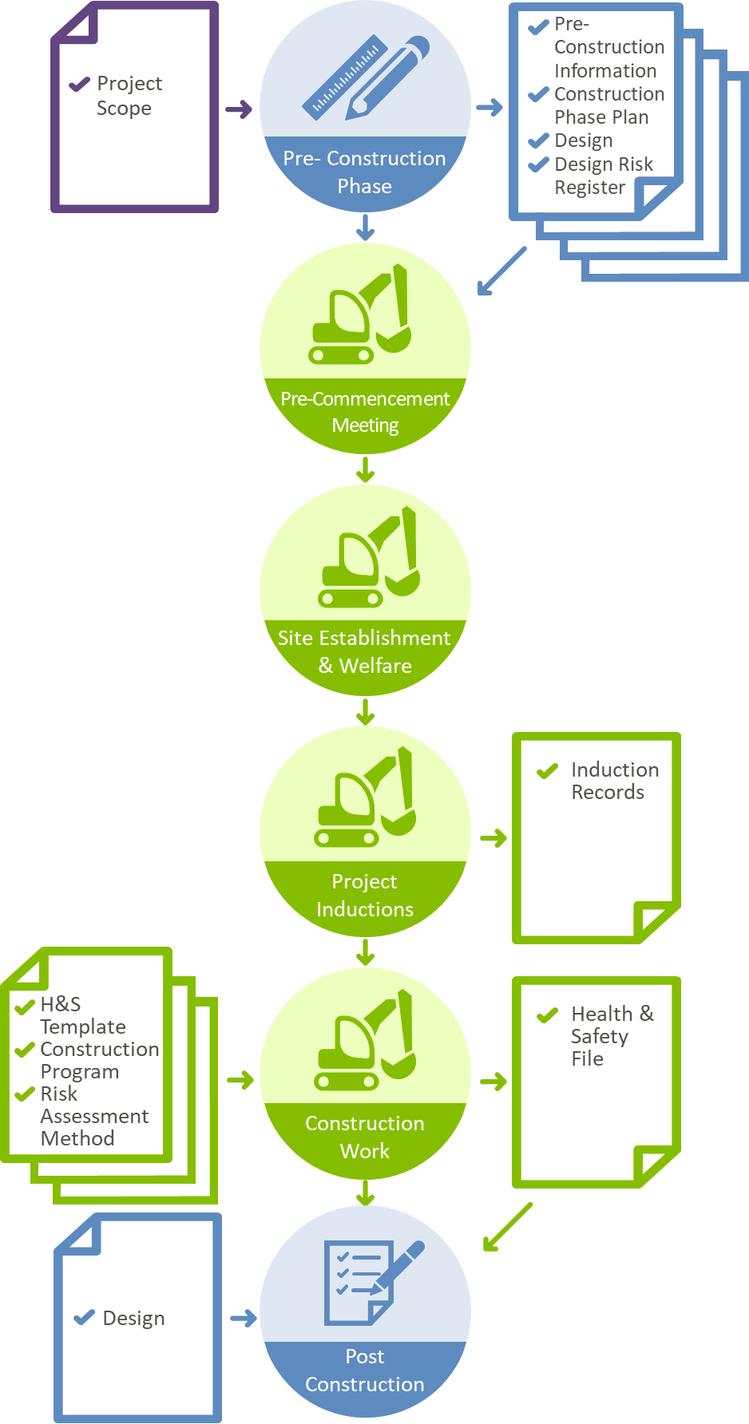

Annex 3. Notification
You can notify the Health and Safety Executive (HSE) of a notifiable construction project using online form F10 or by post. Once all duty holders are appointed, this is a 10-minute job.
The online form is accessible at: https://form.hse.gov.uk/f10
If you cannot use the online form, notify HSE in writing. Make sure you include all required information and send to:
F10 Scanning Centre
Health and Safety Executive
c/o Central Despatch
Redgrave Court
Merton Road
Bootle
Merseyside
L20 7HS

You must know the contact details for the Client, Principal Designer and Principal Contractor, the HSE will not accept ‘To be confirmed’ or ‘TBC’ where appointments are unknown.
Once you have submitted a notification, you will receive a unique serial number that you can use to access or edit your notification.

Annex 4. The Post Construction Phase
Note that a Health and Safety file is only required in larger projects where there have been multiple contractors working on site.
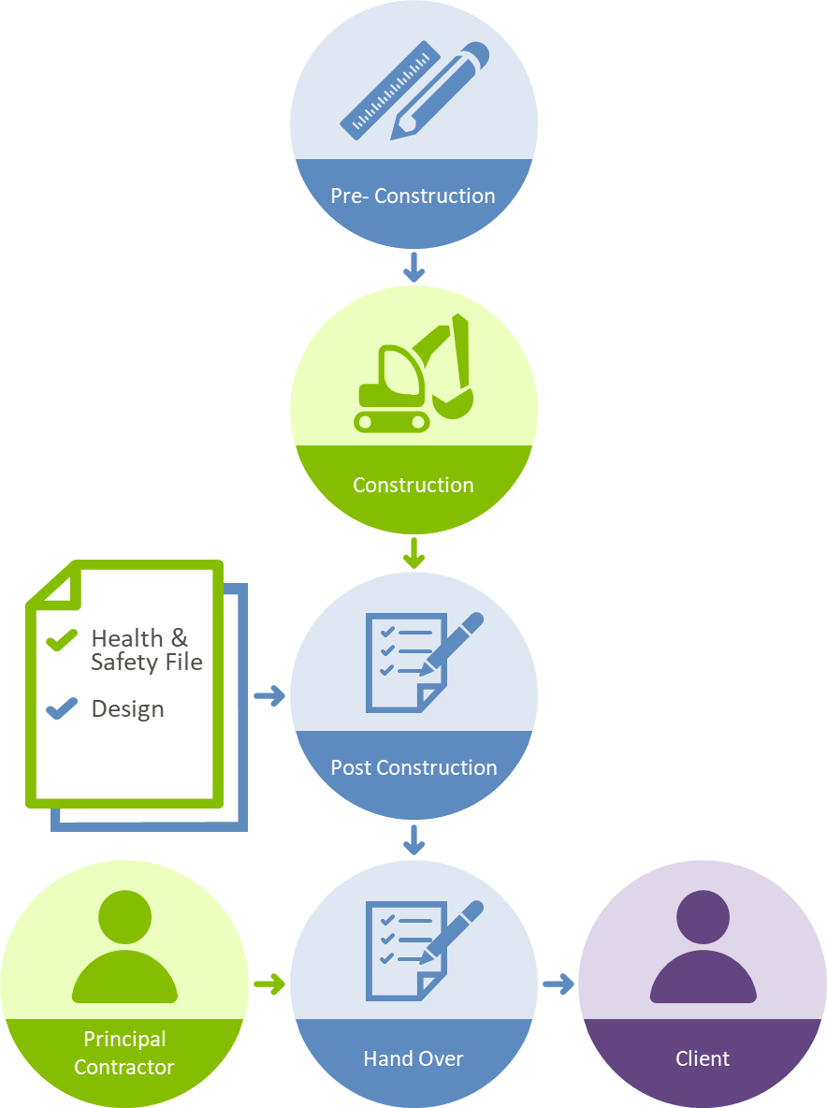

Welfare facilities are a legal requirement on all CDM sites. It is possible that these could be provided locally by giving access to an estate property or by hiring a mobile welfare unit in some cases, but where sites are remote and access difficult, it may be problematic to attempt to get mobile units into these locations. In these instances the pre-construction information document should highlight potential difficulties, and suggest how legal requirements will be met as far as is reasonably practicable.
The principles of prevention provide a framework to identify and implement measures to control risks on a construction project. They can be summarised as (a) avoid risks where possible; (b) evaluate those risks that cannot be avoided; and (c) put in place proportionate measures that control them at source.

