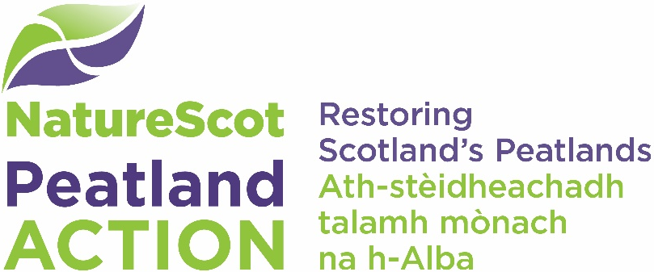

Feasibility Study enquiry form

Submit your completed form to: peatlandfeasibility@nature.scot

FEASIBILITY STUDY ENQUIRY
Date of Enquiry.
Name of Enquirer.
Organisation.
Position in Organisation.
Site Name.
Contact Telephone.
Contact Email Address.
Site Location (6-figure central grid reference)
Land ownership boundary. Please forward shapefiles (preferred) and/or a PDF map showing the full land ownership boundary.
Total area of site (hectares).
Number of Landowners involved with site.
Contact details of Landowners.
Is land tenanted? If so, how many tenants and have they been consulted?
Confirmation that area is likely to contain deep peat (based on ‘Scotland soils and carbon 2016’ online map).
Attach landowner(s) permissions to proceed with Feasibility Study request
Details of any previous landowner engagement/liaison.
Historical and current land use(s) of proposed area(s).
Stocking/deer densities relative to management units (if known).
Have you already discussed this enquiry with a Peatland ACTION Project Officer or NatureScot Staff? Please give contact details.
Please confirm that your intention is to apply for Peatland ACTION grant funding following the completion of a successful Feasibility Study.
Are you intending to proceed through Peatland Code?

