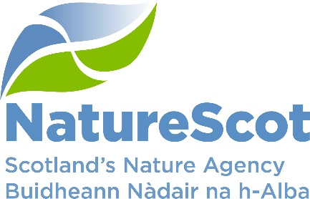

Title: Board Q4 Performance Report

Date: 18th May 2022
Purpose: | Decision
How does this link with our corporate priorities of improving biodiversity or delivering nature-based solutions to climate change: | This paper presents Q4 progress towards delivery of our corporate priorities as laid out in our Business Plan, Connecting People and Nature: Year 4.
Summary: | Performance for 10 of our 10 priorities is rated as ‘on track’ against the Q4 90 day plan. Two corporate risks have increased their risk score in the last quarter. Our operating budget is expected to outturn below tolerance due to the reduction to the annual leave accrual following the adjustment period. Capital is expected to outturn marginally below tolerance. For large additional in-year budget allocations (mainly Peatlands and NRF), there have been challenges in committing the full 2021/22 budget. In the People Report, seven of ten indicators are green, and three are amber.
Actions: | To note the recommendations below
Recommendations: | Board are asked to:  - Note the overall performance of the priorities  - Note the position of the operating and capital budgets (Finance Report)  - Note the performance of the corporate risks  - Note the overall performance of the People Measures
Report Author(s): | Authors – Directors, Deputy Directors, Outcomes Managers, Finance, Planning & Performance Team, People & OD Team
Sponsors: | Stuart MacQuarrie, Jane Macdonald
Annex: | Annex A – Corporate Risk Register

Purpose
- This paper presents NatureScot’s performance for the fourth quarter of 2021/22. It addresses delivery of our corporate priorities by reviewing the alignment of outcome performance against our Business Plan, Connecting People and Nature: Year 4; progress towards maximising our available budget; assessing risks for delivery; and reviewing people information supporting the resourcing of our work. These Outcomes support delivery of our Corporate Plan 2018-22, Connecting People and Nature.

Summary
- The Corporate Plan for 2022-2026, A Nature-rich Future for All, was approved by Scottish Government on the 31st of March and published on the 5th of April along with the Year 1 Business Plan. Ongoing engagement with Scottish Government has supported us to re-prioritise our efforts towards delivering our Corporate Plan priorities to Protect, Restore and Value Nature.
- Lifting of the remaining Covid-19 restrictions means that further changes to our working arrangements took place towards the end of April. The Business Continuity Group (BCG) Incident Team had their final meeting on 21st April. Unless the situation with Covid-19 deteriorates again we will now manage any on-going elements as part of routine business continuity monitoring. This will also be a significant step towards normalising new, hybrid working arrangements.
PRIORITY PERFORMANCE | NUMBER | CORPORATE RISK | NUMBER
Priorities | 10 | Corporate Risks | 14
On Track | 10 | Increased Score | 1
Minor Slippage | 0 | Decreased Score | 0

FINANCIAL METRICS | STATUS | PEOPLE METRICS | STATUS
Operating | Minor Slippage | Wellbeing | On Track
Project Allocation | Minor Slippage | Capacity | Minor Slippage
Paybill | Minor Slippage | Development | On Track
Capital | On Track | Workforce Profile | On Track

- More People Benefitting from Nature (Nick Halfhide, Director Nature & Climate Change)
- NatureScot will facilitate the role of nature in transforming places where people live
Delivery of our Green Infrastructure projects, which create multifunctional nature-based solutions in deprived urban areas, continues despite considerable challenges created by COVID-related delays and increasing construction costs. The Phase 1 projects are all now complete or close to completion. The biggest and most complex of the Phase 2 projects – GUARD (Glasgow Avenues led by Glasgow City Council) – has withdrawn as their main contractor was unable to deliver the project to budget or to time. Whilst it is disappointing to lose this project and the considerable outcomes it would have achieved, we have been able to reallocate some of the GUARD funding to other projects which are experiencing similar issues but are still deliverable. This has avoided the need to consider requesting further ERDF from the Scottish Government to deliver the programme which would have been time-consuming and risky at this stage of delivery. Queens Cross Housing Association, Southside Housing Association and East Dunbartonshire Council are all aiming to sign contracts and start delivery in Q1 22/23 which will allow them to deliver their projects by the deadline of June 2023. Nevertheless, it will not be possible to reallocate all of the GUARD funds, and it is still possible that other projects will withdraw, reducing the overall outputs of the programme. Clyde Gateway’s Cuningar Loop project is progressing on site and their other Phase 2 project, Mall’s Mire is complete and will be officially opened in June 2022.
The Winter Make Space for Nature campaign activity took place across social media. Key messages focussed on the link between climate change and biodiversity loss, and the immediate action people need to take. Twenty “Wee Forests” are established with support from a range of delivery partners, generating good engagement with schools and communities and generating significant press interest. We published the evaluation of the successful Learning in Local Greenspace project which worked with over 115 schools in some of the most deprived parts of Scotland to support regular outdoor learning in local greenspaces.

- NatureScot will support and encourage access to and enjoyment of nature
The Improving Public Access (IPA) scheme was prepared and launched and a successful webinar was held which attracted over 80 applicants. £3.9 million Scottish Government (SG) funding was also confirmed for additional "boots on the ground" for NatureScot and other public bodies and to support a third round of the Better Places Fund (BPF), which we successfully launched at the end of March. The Visitor Management Strategy (VMS) governance arrangements were refreshed, with three working groups established to look at longer-term action required on provision for camping/campervans, traffic management and use of digital technology. The Scottish Outdoor Access Code (SOAC) material for schools is being finalised for publication. Discussions with SG over the National Park commission are in progress with a Ministerial announcement on the first stage of work expected in May. The NNR resilience strategy is in place and recruitment is underway for 2022/23 seasonal staff.
- The Health & Resilience of Scotland’s Nature is Improved (Nick Halfhide, Director Nature & Climate Change)
- NatureScot will invest in action to reverse biodiversity loss and jointly lead the Scottish Biodiversity Programme (SBP)
We continue to work closely with Scottish Government (SG) and Rural and Environment Science and Analytical Services (RESAS) on the Scottish Biodiversity Strategy (SBS), drafting Vision and Outcomes for each land and seascape, developing priority actions and preliminary ideas on biodiversity targets for the forthcoming Natural Environment Bill. This will inform the materials for the consultation in June. NatureScot’s proposed approach to developing the SBS Delivery Plan will be considered by the SBP Board meeting 10 May. The final phase of COP15 has been postponed to September, and the ensuing Global Biodiversity Framework will inform the SBS, due to be published in late autumn.
The Expressions of Interest (EoI) phase for the Nature Restoration Fund has just closed with over 100 EoI’s received and following feedback we have extended the application window to 1st April.
The commission on 30x30 should be finalised by the end of this quarter. The proposal is to combine Nature Networks and 30x30 into a single commission and we are now finalising resourcing requirements. The 30x30 project is anticipated to subsume the majority of the Protected Areas review work and the Monitoring and Surveillance programme. Delays in agreeing the commission on 30x30 has therefore impacted on this work with a paper to the Protected Area Committee to be submitted in Q1 to outline where and how the various strands of these pieces of work will be taken forward within or alongside the commissioned work.
Work on identifying marine monitoring gaps and priorities has been pushed back to Q1 2022/23. This means that it will delay the completion of the recommendations from the Marine Monitoring Panel on our future approach to monitoring Marine Protected Areas, likely to the end of Q2 2022/23.

- NatureScot will support a step-change in use of Nature-based Solutions to climate change and other problems
Discussions are ongoing with Local Authorities (LAs) to ensure use and integration of Dynamic Coast outputs. Also in support of this, progress is being made with drafting of Guidance for Coastal Change Adaptation Plans. Analysis is complete for initial allocation of Coastal Change Adaptation funds with letters recently sent to all LAs. Year 3-onwards is yet to be established. The Vegetation Satellite (VegSat) analysis is continuing and groundwork is ongoing for the Coastal Monitoring Strategy, which will lead to open source data being generated that we (along with other parts of SG) can access to inform our work on the coast, in designated sites, for coastal adaptation and to inform nature based solutions (NbS) deployment.
We have engaged with UK Blue Carbon Forum and Evidence Partnership and provided comments on Scottish contract work on saltmarsh restoration to underpin a potential saltmarsh code. Work on a wider marine and coastal climate change strategy has been delayed by Marine Scotland to next year. We will shortly publish a comprehensive literature review and evidence map on blue carbon which will help steer future Scottish work.

- More Investment in the Management of Scotland’s Natural Capital (Robbie Kernahan, Director of Sustainable Growth)
- NatureScot will help to transform use of land and sea so that it contributes even more to the future wellbeing economy
AECS 2022 has been launched and NatureScot provided guidance. 18 posts were advertised, attracting over 60 applicants. We are currently developing training plans for these posts.
Scoping of the Biodiversity Audit project has been agreed, the project is to be delivered in 2022/23. A version of the Natural Capital Assessment Template has been tested with over 30 farmers. The extension of the contract with the application developer to help build the app is about to be concluded. SG formally commissioned NatureScot to develop Biodiversity Audit for Track 1 by Q1 2023/24.
We have engaged with all farmer clusters under Phase 3 (to test outcome score cards for a range of farmland habitats including the use of a mobile app to do the scoring on the farm) with agreements nearly all concluded. Some management actions underway but most now expected in 2023/24.
We are close to finalising our response to the Fourth National Planning Framework (NPF4) consultation and the closely linked Local Development Plan Regulations. Consultation period for "developing with nature" is on track. The parliamentary committee process for NPF4 is streamlined and we have not been asked to give evidence to the committee but we have submitted questionnaire responses to relevant ones, and have been engaging in ongoing discussion with contacts which have been positive.
ScotWind leases have been announced (up to 25GW rather than 10GW, so staff capacity is under review). ScotWind recruitment is proceeding well and good liaison progressing with Marine Scotland (MS) on wider work priorities to support their Blue Economy aims and Programme for Government (PfG) commitments.
Approach has been agreed by Scottish Biodiversity Strategy (SBS) Board, with Strategic Deer Board (SDB) meeting in early March to populate work stream contributions, agree vision and messaging on deer management. There is a need to go beyond Deer Working Group (DWG) recommendations for delivery of SBS work streams plans outlining priorities being developed and prepared for next SDB meet in Q1. Ongoing programme of NatureScot work to develop non- legislative recommendations and approval for increased resourcing which is being progressed through 2022/23 recruitment.
The licensing approach for grouse (based on right to shoot grouse) is well developed with work ongoing with SG legal to refine framing and mechanics. We have developed an outline for SLT / Ministers in April. Muirburn evidence base is being progressed with a wider scope in terms of agricultural land use aspects being considered in terms of refining purposes.
Initial scoping work of the statutory fisheries measures has been completed and shared with Marine Scotland (MS). This has allowed for further discussions with MS about resourcing and timescales, and enables MS to start work on the Strategic Environmental Assessment. Both of which are key next steps in the process of implementing the required statutory fisheries measures for MPA’s.
- NatureScot will focus effort on mainstreaming natural capital approaches/accounting in decision-making
We advertised a new National Capital Approach Pilot Programme (NCAPP) Landscape Tool developer and the NCAPP Natural Capital (NC) assessment template has been trialled with 50 farmers, crofters and estates. Results and feedback due in 2022/23 Q1 for next phase of testing, we are expecting the results to help us refine the NCAPP Assessment Template and then do some more user testing before completing the project in 2022/23. The Q4 target of testing with a sufficient range of farmers has mostly been met by our contractors.
The public land owner group (sub-group of the Scottish Forum for Natural Capital, comprising public sector partners seeking to test natural capital approaches on their land/assets) is up and running and is making progress. Heat mapping is underway to identify best locations for public land natural capital approaches. New national environmental data service development is underway but not yet operational.

- NatureScot will help to grow and diversify environmental green finance
To grow private investment in natural capital, the Carbon Price Guarantee contract has been let and is underway. There has been no further progress on developing a new approach to blend private investment through the Peatland Code with Peatland Action this quarter, which means there is delayed promotion of use of private finance to supplement Peatland Action investment.
The Scottish Marine Environmental Enhancement Fund (SMEEF) launch is planned for the 9th May and Ministerial input is sought. We are awaiting the outcome of an external bid for Crown Estate Scotland and Marine Scotland resources. Due diligence contract work is proceeding well and membership of the Ethical Contributions Board and Grants Panel are being finalised. We have had positive discussions with some potential funders which will add value to SMEEF.

- NatureScot will accelerate peatland restoration through our Peatland Action Programme and collaboration with others
Pipeline indicates that over 5,600 ha of peatland will be put on the road to recovery - meeting our target for a 40% increase. Budget for 2022/23 agreed with SG to allow for step change with a focus on increasing demand for and design of restoration to support delivery. Action plan for transformation in preparation with focus on location of and obligation for restoration, along with attracted funding from wider sources.

- We have transformed how we work (Jane Macdonald, Director Business Services & Transformation)
- NatureScot will invest in skills for a nature-rich future, especially in youth employment
All Programme for Youth Employment (PYE) posts from the 2021/22 cohort are now active with the Technology and Digital Services modern apprenticeships at the recruitment stage. A number of the apprentices and young employees took part in the winter carnival human library session, sharing their journeys to working for NatureScot, which was well received. An apprentice away day was held on 10th March in Battleby as part of our engagement with our modern apprentices and CEMVO Placements during apprenticeship week. The programme included a talk from Francesca on how apprenticeships fit into NatureScot’s future priorities and for developing skills.
The funding package for a training and employment programme for nature-based skills is being considered. Meantime, Working for Rivers project launched with six employers recruited and interns have been recruited and started in post. 0.5 FTE Peatland Action Skills post was recruited and has started and online peatland restoration training was organised for NatureScot staff to develop skills and capabilities.

- NatureScot will transform as an organisation to meet the demands of the future, including accelerating its transition to a net zero emissions organisation
All projects and programmes under the auspices of our Transformation Portfolio are on track with some minor reprioritisation of the M365 Programme in order to facilitate essential work on network connectivity. The sign-off of the Corporate Plan reflects the hard work from across the organisation that went into our Action Learning Sets to establish our ambition. The NatureScot Way groups are now working on the structures, skills, systems and processes that will bring that ambition to life. Engagement on this Organisational Design piece took place through our "Glimpse of the Future" sessions as part of the Winter Carnival, which were very well attended, and we received positive feedback. During the Winter Carnival we held approximately 150 different sessions with around 3000 attendees across the programme (equal to around 3000 hours of engagement). Informal feedback is that the social sessions are a fun way to connect with others, and that all sessions are particularly helpful for new employees to have a chance to meet people from across the organisation that they don't work with directly. This helps in building relationships, collaboration, integration, wellbeing and inclusion.
Climate Change Duties Report has been submitted and we are awaiting verification before publishing on intranet, with a higher than planned reduction in carbon being reported. Electric vehicle charge points has progressed with some slippage into the next year due to connection issues. The planned renewable technology programme for 2021/22 was completed on time and on budget including batteries and inverters on Rum and a new Photo-voltaic array on the Isle of May. A paper on the future investment needed for Renewable Energy Technology has been delayed. Plans are being revised in response to early indications that our initial proposals do not go far enough in reducing carbon emissions to meet our Net Zero target. Ongoing review of the return to the offices, work preferences, office demand, locations and hub development are continuing and will contribute to Net Zero progress. Continual decarbonisation of grid electricity will also reduce carbon totals for NatureScot.

PERFORMANCE
Business Plan Measures | Status
NatureScot will invest in action to reverse biodiversity loss and jointly lead the Scottish Biodiversity Programme | GREEN
- We will develop a suite of draft biodiversity targets for Scotland following Global Biodiversity Monitoring Framework (for COP15) | GREEN
- We will fund at least £1m of Biodiversity Challenge Fund grants through Phase 3 during 2021/22 | GREEN
- Advise Government on options to achieve 30x30 protected area targets | GREEN
- Take forward Protected Area Committee recommendations for enhancing our special nature sites | GREEN
- Implement priority recommendations in the surveillance and monitoring strategy to better inform management | GREEN
- Develop a new approach to delivering the Scottish Marine Protected Area monitoring strategy | AMBER
NatureScot will help to transform use of land and sea so that it contributes even more to the future wellbeing economy | GREEN
- We will help to deliver Agri-Environment and Climate Scheme | GREEN
- We will advise SG on Biodiversity and Climate outcomes across all future farm support schemes | AMBER
- We will deliver Phase 3 of Piloting Outcomes Based Approaches in Scotland (POBAS) | AMBER
- We will secure strengthened policy and spatial direction in the Fourth NPF that delivers positive effects for biodiversity | GREEN
- We will support Marine Scotland in developing and implementing a Blue Economy Action Plan | GREEN
- We will develop and deliver actions arising from the Scottish Government responses to the Werrity and Deer Working Group reports. | GREEN
- The number of Marine Protected Areas with management measures will be increased | GREEN
NatureScot will support a step-change in use of Nature-based Solutions to climate change and other problems | GREEN
- Implement phase 2 of the National Coastal Change Assessment to support Local Authorities planning | GREEN
- We will be part of developing and delivering a strong new vision and work plan for the Scottish Blue Carbon Forum. | GREEN
NatureScot will focus effort on mainstreaming natural capital approaches/accounting in decision-making | GREEN
- We will provide evidence to support SG to embed applying a natural capital approach in policy and investment | GREEN
- We will provide evidence and tools to enable the uptake of natural capital assessment of the public estate | GREEN

Business Plan Measures | Status
NatureScot will help to grow and diversify environmental green finance | GREEN
- We will develop new approaches to grow private investment in natural capital | GREEN
- We will develop a new approach to blend private investment through the Peatland Code with Peatland Action. | AMBER
- We will develop and launch the Scottish Marine Environmental Enhancement Fund (to support recovery and resilience of our coasts and seas) | GREEN
NatureScot will invest in skills for a nature-rich future, especially in youth employment | GREEN
- We will employ up to 37 posts through the Programme for Youth Employment | GREEN
- We will develop and secure funding for a training and employment programme for nature-based skills. | GREEN
NatureScot will facilitate the role of nature in transforming places where people live | GREEN
- We will fund up to £3.4m of Green Infrastructure projects using ERDF funding. | AMBER
- We will support up to 300 communities across Scotland to improve local green and blue spaces for people and nature as part of our Making Space for Nature campaign | GREEN
NatureScot will support and encourage access to and enjoyment of nature | GREEN
- Fund up to £3m of new paths through the AECS – Improving public access scheme | GREEN
- We will co-ordinate delivery and amplify responsible access communication as our contribution to the national visitor management strategy | GREEN
- We will implement a resilience strategy on our NNRs | GREEN
NatureScot will accelerate peatland restoration through our Peatland Action Programme and collaboration with others | GREEN
- We will increase Peatland Action’s delivery of restored peatland by 40% | GREEN
NatureScot will transform as an organisation to meet the demands of the future, including accelerating its transition to a net zero emissions organisation | GREEN
- We will deliver the Organisation Development Framework actions | GREEN
- We will deliver the NatureScot Net Zero plan which will aim to deliver a 7% carbon saving in line with our stretch target (or 63.3 tonnes of CO2). | GREEN

Performance
- Of the 30 measures that we planned to achieve over the full year, 25 (83%) are rated on track, and five (17%) have experienced minor slippage. All Business Plan priorities are green. The five measures with slippage, and the actions to recover this, are summarised below. It is anticipated that all slippage is recoverable.
  - Develop a new approach to delivering the Scottish Marine Protected Area monitoring strategy
Work on identifying marine monitoring gaps and priorities has been pushed back to next quarter. This means that it will delay the completion of the recommendations from the Marine Monitoring Panel on our future approach to MPA related monitoring, likely to the end of Q2 2022/23.
  - We will advise SG on Biodiversity and Climate outcomes across all future farm support schemes
Scoping of the Biodiversity Audit project has been agreed, the project is to be delivered in 2022/23. A version (Natural Capital Assessment Template) tested with over 30 farmers. App developer contract extension to help build the app about to be concluded. SG formally commissioned NatureScot to develop Biodiversity Audit for Track 1 by Q1 2023/24.
  - We will deliver Phase 3 of Piloting Outcomes Based Approaches in Scotland (POBAS)
We have engaged with all farmer clusters under Phase 3 (to test outcome score cards for a range of farmland habitats including the use of a mobile app to do the scoring on the farm) with agreements nearly all concluded. Not all 1-2-1 due to Covid/weather restrictions but sufficient for App testing. Some management actions underway but most now expected in 2023/24.
  - We will develop a new approach to blend private investment through the Peatland Code with Peatland Action
There has been no further progress on developing a new approach to blend private investment through the Peatland Code with Peatland Action this quarter, which means there is delayed promotion of use of private finance to supplement Peatland Action investment.
  - We will fund up to £3.4m of Green Infrastructure projects using ERDF funding
For the Green Infrastructure projects, which deliver solutions to people in urban areas, the biggest and most complex project – GUARD (Glasgow Avenues) – has withdrawn as a result of contractor withdrawal with some of the funding being reallocated. Other projects experiencing similar issues. Queens Cross, Scottish Housing Association and East Dunbartonshire Council are retendering. Nevertheless, it will not be possible to reallocate all of the GUARD funds, and it is likely that other projects will withdraw. So the overall outputs of the programme will be reduced. Cuningar Loop is progressing on site and all other Phase 2 projects are underway and on target.

FINANCE
Financial Metrics (£m) | Measure | Budget | Forecast | Variance | Rating
Resource Budget | Outturn within 1% of final budget | 52.5 | 51.7 | 0.8 | MINOR SLIPPAGE
Capital | Outturn within 5% of final budget | 2.4 | 2.4 | 0.0 | ON TRACK
Indirect Capital | Outturn within 1% of final budget | 14.6 | 12.7 | 1.9 | MAJOR SLIPPAGE
Paybill | Outturn within 1% of final budget | 30.6 | 28.9 | 1.7 | MINOR SLIPPAGE
Project Allocation | Outturn within target allocation range | 18.3 | 17.8 | 0.5 | MINOR SLIPPAGE
Peatlands | Outturn within 1% of final budget | 9.4 | 8.1 | 1.3 | MAJOR SLIPPAGE
Biodiversity Challenge Fund | Outturn within 1% of final budget | 2.0 | 1.9 | 0.1 | MINOR SLIPPAGE
Better Places Fund | Outturn within 1% of final budget | 2.0 | 2.1 | (0.1) | MINOR SLIPPAGE
Nature Recovery Fund | Outturn within 1% of final budget | 5.0 | 4.5 | 0.5 | MAJOR SLIPPAGE
*Operating under 1% - on track, up to 10% minor slippage, over 10% major slippage (** Capital under 5% / up to 10%)
Financial graphs | summary of performance
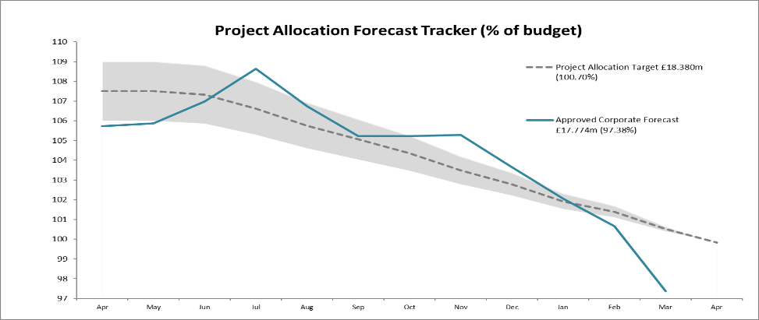  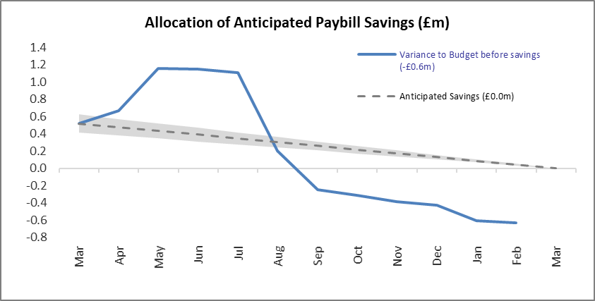 | Due to a change in the annual leave policy (carry forward reduced from 10 to 5 days for full time staff), the accrued amount has lowered by £1m. This has reduced our operating costs for 2021/22 by the same amount. Inclusion of this non-cash movement in Q4 has brought us from above tolerance to below budget as we factor in paybill savings when setting our controllable projects budget.  The variances on the larger funds reflect the most recent forecasts. Underspends are expected for Peatlands (£1.3m) and NRF (£0.5m) although there is scope for these to vary as final claims are received. Although the ratings reflect slippage on each of the larger funds, it should be highlighted that over £16m of activity has been delivered in less than a year since confirmation (with NRF only advised in August).

Finance
Resource Budget Performance
- An underspend of £0.765m is currently forecast on the Resource budget. This does not reflect the final year-end position as we now enter the 2021/22 adjustment period when technical accounting adjustments will be processed. At the same point in 2020/21, an under-spend of £0.257m was forecast.
- The estimated operating cost reduction arising from the restriction in the maximum annual leave carry-over to 5 days is £1.041m. This is now reflected within the paybill budget resulting in a projected underspend on paybill of £1.755m. These savings are taken in to account when setting the controllable projects budget, with further project allocations approved to ensure that the budget is as near to fully utilised as possible.
- A higher level of budget surrenders were experienced in Q4 in respect of previously planned work compared to the 4-year average. Project surrenders for the year are considerably higher than the 4-year average (29% of budget (£5.2m) compared with 22% (£3.7m) for the 4-year average). Allocations have also increased during 2021-22 (£7.1m) compared to the 4-year average (£4.7m) following the re-allocation of the additional budget surrenders.
- We continue to monitor project surrenders throughout the year, using our knowledge and experience of previous slippage levels to ensure that appropriate demand is ready to allocate when surrenders are received.
- The business partnering work has helped to ensure that budgets are fully committed or surrendered at the earliest opportunity. This began in Q2, engaging with project managers to ensure good progress is being made with their projects during the latter part of the year.

Indirect Capital Funding Programmes (including Peatlands)
- An underspend of £1.877m is currently forecast on the Indirect Capital budget.
- The budget for Peatland Action restoration, conservation, management and associated employee costs for 2021/22 remains at £9.390m following the £0.5m savings on Resource and a handback of £1m on Indirect Capital.
- We are forecasting £8.057m and therefore reporting an underspend of £1.333m on Peatlands (£1.032m on Indirect Capital and £0.301m on Resource).
- The impact of slippage on the other large value programmes (BCF, BPF, NRF) also presents a heightened risk of underspend given the size of the funds, their capital nature and late confirmation during the year. Estimated slippage has been reflected in the forecast.
- The Biodiversity Challenge Fund (BCF) is forecasting an underspend of £0.133m (£1.867m against a budget of £2m). This includes the estimated slippage of £0.300m (£0.235m on Indirect Capital and £0.065m on Resource).
- The Better Places fund (BPF) is forecasting an overspend of £0.117m (£2.067m against a budget of £1.950m).
- The Nature Recovery Fund is forecasting an underspend of £0.546m (£4.454m against a budget of £5m). This includes the estimated slippage of £0.186m (all of this funding is Indirect Capital for this financial year).

Structural Funds Programmes
- The current Green Infrastructure claim of £0.848m remains unpaid 20 months after submission (previously £1.14m - £286k to be resubmitted in next claim). The current NCHF claim for £214k has now been delayed by 3 months. Following discussions with SG Sponsor, a further £1m of payments are being processed, increasing the potential NatureScot liability for advance payments to approximately £1.25m (this is the maximum exposure in the unlikely event of de-commitment on all of the payments).
- Discussions are ongoing around the cash flow mechanism needed to make further advance payments and the increased risk of de-commitment that would result.

Capital Budget Performance
- An underspend of £0.023m is forecast on the capital budget.
- We received confirmation that the Glencripesdale sale will now not proceed until 22/23.
- Funding of £0.571m has been secured from various sources towards the cost of new charging points, NNR car parking, path work and a replacement hide.
- The Net Book Value – Asset Disposals value of £0.209m has been included, this increases our ability to spend on Capital projects by this amount.
- We have reported an underspend on GovTech ring-fenced funding of £0.150m to Scottish Government. Permission to underspend has been granted and will be confirmed in the final budget monitoring letter for 2021/22.

RISK
Corporate Risks |  | Risk Changes
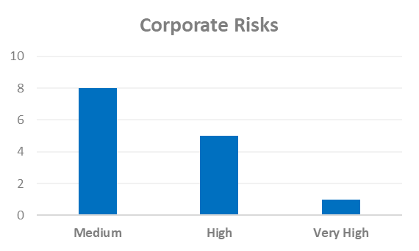 | Changes to Corporate Risk Scores  ↑1 Gone Up  ↓ 0 Gone Down  Change to Corporate Risk Register  ↗ 0 New Corporate Risks  ↘ 0 De-Escalated (proposed)

Risk

- Annex A shows the current high rated corporate risks for NatureScot. Activity and project risks are managed within the risk management system, which underpins the corporate risk register. All risks are managed in line with the Risk Management policy and monitored regularly for compliance and visibility of impact. All risks currently active on the Corporate Risk Register are recommended to be retained.
- There are currently 14 approved Corporate Risks, 8 medium, 5 high and 1 very high. The risk rating has increased from high to very high for “Structural Funds – failure of programme delivery and/or funding mechanism”, this is due to SG now requiring NatureScot to pay approved claims in advance of ERDF draw-down (as soon as they have been assessed), contrary to our original agreement (but in accordance with other Lead Agencies). This would mean that NatureScot could have a cash flow exposure of up to £20m+ at some points, and be exposed to de-commitment across the whole £26m of both programmes. The likelihood of “Covid-19 Pandemic - Business Impact” has reduced but there has been no change to the score.

- No new risks have been proposed for escalation or de-escalation this quarter.

PEOPLE
People Metrics | Status

Wellbeing
Accidents & Near Misses – target: to stay within variations around the mean  Q4: Accidents=11, Near Misses=0 (these continue the low trend of the past two years) | Green
Work-life balance – target: 75% of employees feeling that their work-life balance is good  Q4: 69% of employees who utilised Work Happy rated their work-life balance as good (same as last few months, so no real change) | Amber
Capacity
Sickness – Target: under 2 days per person per quarter.  Q4: 1.84 days (a rise from previous quarters, but returning to pre-pandemic levels) | Green
Holiday Leave  Q4: 85.4% of holiday leave taken | Amber

Development
Formal Casework - target <=50% of informal casework  Q4: 27% (6 cases), well within normal range for this type of casework | Green
Informal Casework  Q4: 22 cases, well with normal range for this type of casework | Green
Access to L&D for role  Q4: 69% agree (Q2 data – question has not been asked in Q3 or Q4) | Green

Workforce Profile
Turnover – target: increase  Q4: last 12 months of turnover is 11.55%, a steady increase in the last three quarters, but entirely normal for government bodies | Green
Internal Movement – target: increase  Q4: after a slight decrease in Q3, the number of internal moves has returned to normal, as predicted | Green
Retirement Profile  Q4: 134 employees are aged 57+ for 21/22, predicted to rise to 159 in 24/25, adjusted for average number of retirements. | Amber

People
- Sick absence – As the graph below shows, the sick days per person rate has increased to 1.84, which is now outside the normal range in statistical terms, but continues to be below our target of 2 days per person per quarter and therefore still remains as a green rating. While in the context of the last two years this is an increase, it could be considered as a return to more normal patterns, and most likely what we will see continuing for the foreseeable future as society returns to behaviours more akin to pre-pandemic. For context, Scottish Government (in the year to September 2021) had a rate of 5.9.
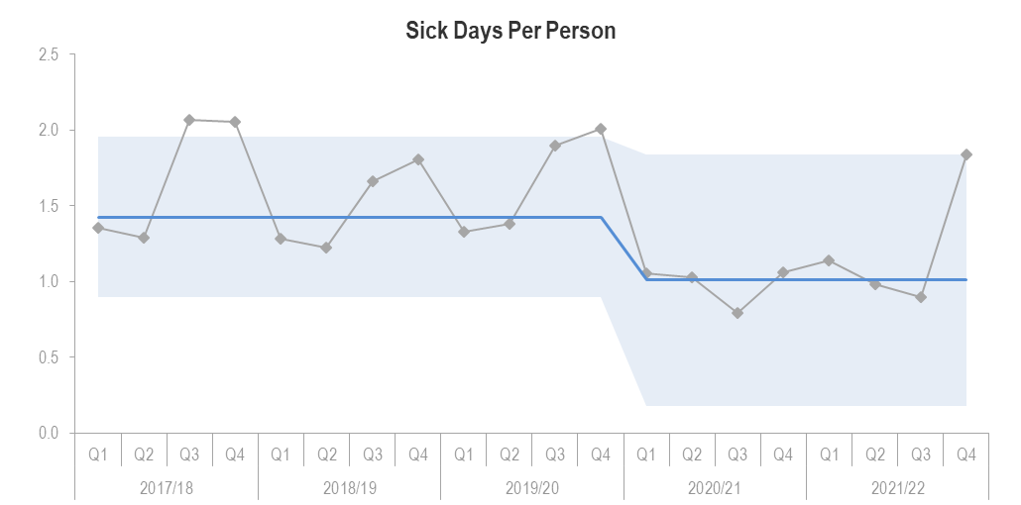

Perhaps unsurprisingly, given the current transmission rates in the country, the highest number of days lost to sick absence this quarter are down to Coronavirus, and affect all our employees rather than a particular age range. Days lost to poor mental health have gone up and are higher than the last five quarters, but are still within normal range at 0.39 days lost per person (and the numbers of individuals are entirely normal too, so it is not indicative of anything the organisation is doing or not doing). Days lost to cancer are by a small number of people, generally in the older age ranges. There is nothing of note in relation to all other sick absence reasons.
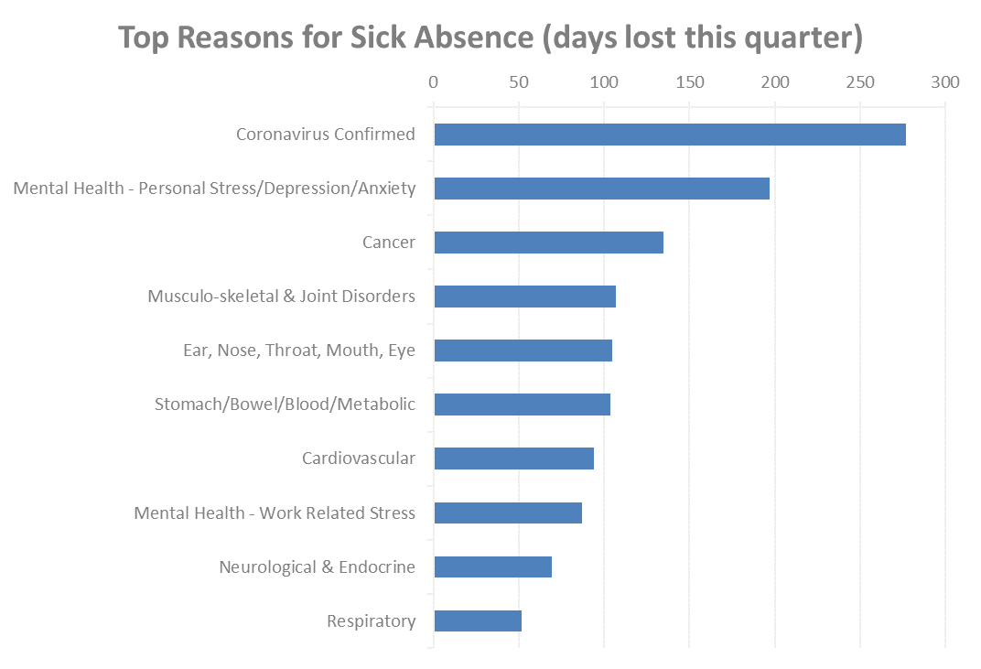
Days lost to coronavirus, and the numbers affected are predictably higher, but concurrent with what is happening across the country, the new variants with higher transmission and removal of restrictions, which has allowed more person to person interaction, which can also be seen within NatureScot as we have reopened offices from 21 February 2022.
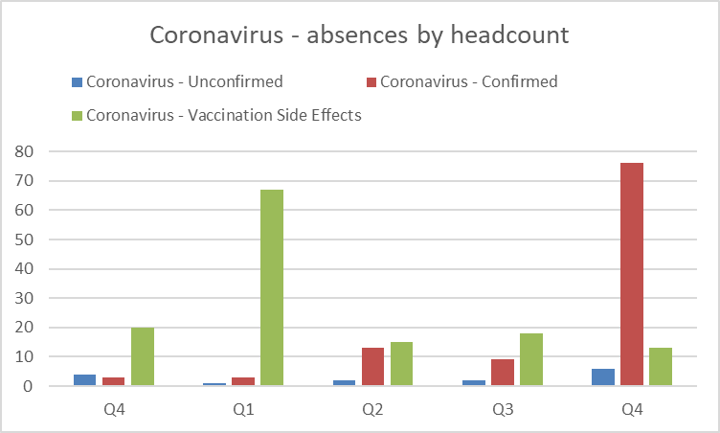
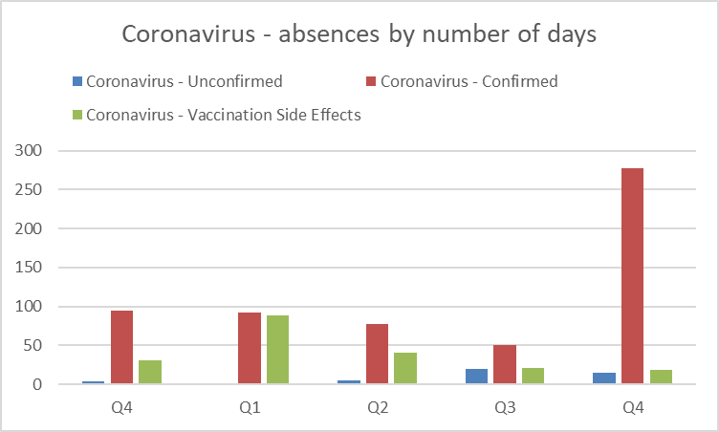

- Holiday Leave – While 100% is a notional target for the end of the leave year, as we allow a 5 day carry-over of leave, a more realistic target is that 88% of leave to be taken by the end of Q4. In addition, there will always be factors outside our control that affect our workforce’s ability to take their leave, (such as secondments, maternity, long term sickness, who can carry over their leave accrual in full).

- It should also be noted that notice was given at the start of 2021/22 that we would be reducing carry over to 5 days (from 10), and we have seen 85.4% of leave has been taken for the year by the end of Q4. Although taking time off during the pandemic has been challenging (lack of incentive because travel has been restricted), it is still important for our employees to have a suitable work-life balance. While the % of leave taken (at time of reporting) is lower than it should be, (hence the amber rating), there aren’t any other tracked measures that suggest we have a particularly poor work-life balance in general. The increase in sickness absence and increased numbers of employees taking leave during Q4 to reduce their balance, has resulted in workload pressures being reported during this quarter.

- Retirement Profile – Although amber, there is no change in the data from last period, and therefore no further action in addition to what is already being done. We have seen a number of requests come forward for partial retirement and this may affect the profile going forward.

Annex A – Corporate Risk Register (High Risks)
Risk Title | DESCRIPTION | CONTROLS | IMPACT | LIKLE-HOOD | RISK LEVEL | Comment
47 - Computer Virus/Malware | As a result of inadequate protection, or inappropriate system use, including accidental activation of email links by that lead to malware downloads, there is a risk that NatureScot systems becoming infected with a malware or virus agent, resulting in NatureScot systems and data become unavailable, encrypted or corrupted, significant system downtime and huge operational impacts | *All file servers are protected by Sophos anti virus protection. Upgrades are performed automatically and can also be applied in an ad-hoc manner  *All PCs are protected by Sophos anti virus protection. Upgrades are received on a daily basis but can be applied ad-hoc  *All incoming emails are scanned for viruses.  *All internet access, where possible, is scanned for viruses (not https sessions).  *Raise staff awareness of potential risks relating to email links and infected documents through regular communications.  *Sandbox controls/ environment implemented  *Control of USB devices  *Awareness raising with staff via Blogs and update articles  *Incident Management Group in place  *Shared Service with Scottish Government that takes forward Network Scanning for unusual activity in place. | 4 | 3 | High | Continue to make good progress with E-learning, published new policy on how to deal with staff who fail the phishing tests on a regular basis, or don't complete cyber training will help all round. Completed work with external contractors on testing our defenses against linked email and result was very positive. We have good controls, however, a determined staff member could still cause a significant incident. We are looking at additional controls with Infrastructure team on email gateway and the potential in the future for 24/7 support from vendor to deal with email related threats and risks. At present, with the Russia/Ukraine incident going on, we must and should be extra vigilant, although at this time there has been no identified threat (however, Toyota in Japan, British Airways and a few other large Euro based companies have all had significant cyber incidents in the last week).
71 - NatureScot’s responsibilities for delivery of Agri-Environment Climate Change Scheme (AECS) under the Service Level Agreement (SLA) with Scottish Government | As a result of failure to meet requirements under the SLA, NatureScot opens itself to significant financial risk consequent to audit findings and, as a result, reputational risk relating to its competence | 1. Business planning to ensure that SLA delivery is adequately resourced, with in year adjustment where necessary to account for planning uncertainties;  2. Work closely with Scottish Government in its governance of the delivery of the AECS programme to actively management of delivery management and associated risks;  3. Secure support of internal audit to provide early warning of weakness in business procedures linked to delivery of the SLA;  4. Deliver training to staff with respect to scheme requirements and guidance; and, have management systems in place to deliver adequate support and quality assurance on a case by case basis – this management to be led through clear delegated authority and overseen through the SRDP Delivery Team  5. Regular (at least quarterly) meetings with Scottish Government to review progress and issues around delivery of the SLA  6. Keep under review key issues that relate to the delivery of the SLA, in particular (but not limited to) the relative Government IS, NatureScot’s reliance on it and any surrounding risk – and take such action as required utilising our engagement in governance and in the scheduled SLA meetings to address concerns  7. Regular reports within NatureScot to the Agriculture, Land Use and Rural Economy Group with escalation to SLT. | 4 | 4 | High | Ability to deliver – we are actively recruiting 18 time limited posts to have in place in time to help with the assessment of the 2022 application round. Additional E grade capacity has been put in place. If the exercise is not successful we will need to re-advertise and/or scrape NatureScot.  The budget available for Improving Public Access (IPA) – from the 2021 round it is clear that a significantly bigger budget required to service demand.  Due to Rural Payments and Inspections Division (RPID) Information Services Division (ISD) capacity it is not possible to update the Agri-Environment Climate Scheme (AECS) casework system to e.g. revise the payment rates  Highlights  Currently issuing 245 contract offers to successful applicants form the 2021 restricted round (on track thanks to hard work of staff)  Guidance for applicants for the 2022 round is complete, (although due to tight timelines and resource this was later than we would have liked) and the application window is open to applications.  A review and revision of the guidance, processes and training for staff assessing 2022 applications is now underway.  There are a number of compliance audits scheduled on AECS in Q2 and Q3 with 6 of them directly involving NatureScot.  Quarterly meeting with SG to discuss SLA took place on 22 Feb.
253 - Peatland restoration target and budget. | As a result of the immature and complex operating environment, there is a risk to: meeting the annual Peatland ACTION restoration hectare target; and spending the annual budget. | • Realistic planning  • Invigorating demand  • Real-time monitoring  • Increasing resilience to change in projections  • Regular and robust review and control | 4 | 4 | High | This is the report for March 2022. For Q4, the likelihood of the risk remains 4 (high). Whilst there is reduced risk of not meeting the ha target, there is continued risk of underspend on the annual budget because of: - Very ambitious plans for 2021/22 that didn’t factor in staff changes; - Unexpected snow in early December; - The uncertainty created by the new PDR/Peatland Code processes; - The implications of Brexit on the supply chain; - Covid related staff absences; and - Reduced staff capacity whilst expanding the Team. However, robust controls have been put in place to reduce the risk in Q1 of 22/23, namely: 1. Realistic planning - We have expanded our number of POs to support the new target and proposed an annual budget that will be framed by a Peatland ACTION Programme Plan that has clear and sized tasks, and assigned responsibilities. 2. Invigorating demand. We are introducing targeted promotion of the multoiple benefits of restoration, the open application system, the scope for multi-year offers and a new grant for coordinating delivery of large scale restoration projects. 3. Real-time monitoring - we have developed a pipeline of restoration projects that is informed by grant application status and risk to delivery from project complexity; vulnerability to extreme weather conditions; and applicant/agent track record of delivery 4. Increasing resilience to change in projections – we have reduced our budget ask by 10% to reflect the propensity for slippage. However, we we continue to develop a reserve projects that amount to 10% of the budget that can be brought forward if further slippage is identified. 5. Regular and robust review and control - There is quarterly assessment of risk by the Peatland ACTION Governance Board, with a remit to provide assurance on the likelihood of risk and recommend [to the Programme Manager] additional controls to reduce the likelihood to 2. 6. We plan to issue new Guidance on operating during nesting season being update to allow risk based approach to operations during that period.
283 - Wildlife Management - Our Ability to Influence Stakeholders | As a result of deeply held and polarised views amongst stakeholders there is a risk that we are unable to secure their compliance and co-operation on the management of wildlife. This could result in the failure to achieve planned outcomes for wildlife and nature. | 1. Undertake work aimed at breaking down barriers to cooperation including through the Working for Waders project, stakeholder work around Sea Eagle scheme and strategy, stakeholder work around goose management, work on feral pigs and other non-natives, the application of conflict management principles and our work on deer.  Communications and engagement plans developed for key species issues on deer, beaver, sea eagle, Geese, with broader comms around our approach to licensing and the shared approach underpinning our work.  2. Maintain close working relationships with key stakeholders and monitored in line with the new approach NatureScot develops for monitoring the health of its relationships with external stakeholders .  3. Ensure all predictably contentious projects have well thought through communications plans attached to them which are implemented.  4. Application of principles within the wildlife management framework and development of the shared approach.  5. Through the Activity Resource Plan ensure that skills in practical wildlife management are retained in our staff complement. | 3 | 4 | High | Bilateral discussions have continued with marginally increased contact across the stakeholder range. This in part has been driven by interest in what a grouse licence and muirburn licence is going to look like. The range of views across interests is very wide and we need to continue to manage expectations in line with SG direction. Of note in terms of managing engagement was the series of online session to develop the Scottish National Beaver Strategy. The sessions provided an insight into the varied tools, developed though the IUCN SSC Conservation Planning Specialist Group, and skills that can be further applied to wider wildlife management issues.
679 - Strategic Management and Integrity of Land Parcel Ownership/ Management Contact Data | As a result of the lack of oversight of the management and quality of this data, there is a risk that this data is not adequate for our purposes. This may compromise the delivery of nature based solutions; fail to meet legal requirements; and limit NatureScot's ability to leverage this data for partnership working and innovative digital solutions | Controls will be proposed following an investigation of the current management, storage and use of this data. | 3 | 4 | High | Audit and Risk Committee (ARC) attended. Meetings planned to discuss options for taking work to address this risk forward.

