Future Routes Fund

Guidance

2022
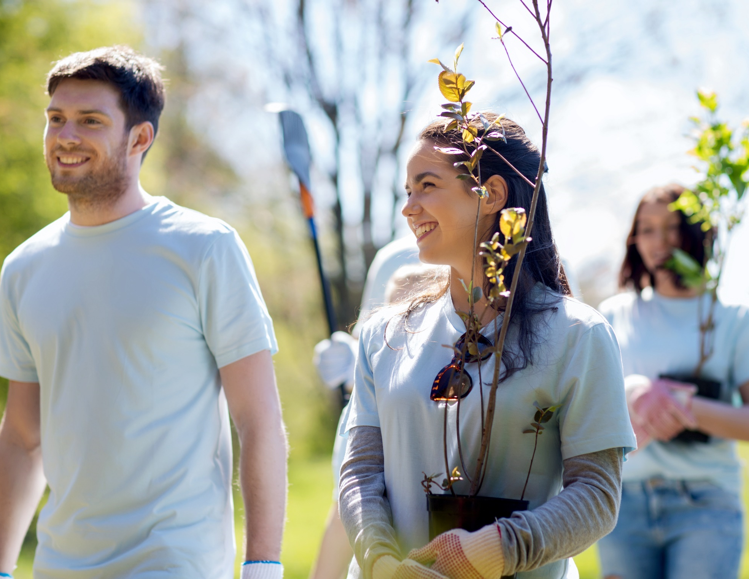

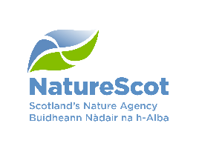
#FutureRoutesFund

The Future Routes Fund
ReRoute, NatureScot and Young Scot are excited to share this information about The Future Routes Fund. The fund is open to groups and individuals aged 11 – 26 from across Scotland who have an idea which would help young people to connect with nature and make a positive impact on the nature and climate in Scotland.
These guidance notes will give you information about the Future Routes Fund. We suggest you read this whole document before you fill out the form because it may answer your questions and will help make your submission as great as it can be!
If you need more information or if you need copies of this guide in a different format, then please contact us using the details at the bottom of this page.

I’m interested – how do I get started?
Excellent, you are in the right place! The first step is to read these guidance notes before completing your Idea Submission.
The Idea Submission form can be found online at www.nature.scot/funding-and-projects/future-routes-fund.
If you need support or have any questions, you can contact us using the contact details at the bottom of this page. You can also request these documents as paper copies or in a different format, such as in another language.

Part One: About the Future Routes Fund
What is the purpose of the fund?
The purpose of the fund is to help young people to connect with nature and make a positive impact on Scotland’s nature and climate. ReRoute, NatureScot and Young Scot have tried to make this fund as easy and accessible as possible for young people because we think young people have some amazing and inspiring ideas! If young people can turn their ideas into a reality with this fund, hopefully even more young people will be aware of Scotland’s nature and will be inspired to enjoy and protect it!

Who can apply?
Any individuals or teams (2+) of young people living in Scotland who are aged between 11-26 can apply.

How much money can you apply for?
An individual can apply for £500 to £2000.
A team (2+) can apply for £1000 to £5000.

What information do you need to provide?
The Idea Submission Form asks for details about the individual or team members who are submitting their idea, a summary of the idea, how it meets the fund’s criteria and an outline of the budget to explain how the funding would be spent.

What if you have an idea but you’re not sure about it?
We want to support all young people who are interested in submitting an idea to the Future Routes Fund. If you have an exciting idea but you aren’t sure how it would work or what it would involve, you should still submit your idea with as much information as possible. Share your thoughts, questions, ideas and vision and we will be happy to support you to develop this if your idea is successful. If you have any questions at any point, then just contact us.

Part Two: Criteria
This page is really important – it tells you what the aims, outcomes and criteria of the fund are. The judging panel will use the information on this page to judge submitted ideas and choose the strongest ideas to award funding to!

The aim of the fund is (what we want the Future Routes Fund to achieve overall):
To support young people to connect with nature and make a positive impact for nature and climate in Scotland

The outcomes (what we want the funded ideas to achieve) are that young people:
- Have access to improving their local environment
- Are encouraged to be engaged in their community through nature
- Are supported to increase their knowledge and understanding of Scottish nature
- Are empowered through opportunities to connect to nature and take action for nature and climate

The criteria for the fund are:
- Ideas must meet the aim of the fund
- Ideas must meet at least two of the outcomes of the fund
- Ideas must take place in Scotland before end of November 2022
- Ideas must be designed, planned and delivered by young people

Your ideas could be anything that connects young people to Scotland’s nature or provides opportunities for young people to take action for nature and climate, from short films or theatre performances to art exhibitions, conservation projects, discussion days or nature trails. It really is up to you!

We welcome ideas which would:
- Provide a platform for young people’s opinions about the environment to be heard
- Encourage young people who have little experience or interest in nature to get involved
- Show how nature can help tackle climate change and promote a healthy lifestyle
- Highlight equality issues and celebrate diversity
- Showcase the skills of young people

Part Three: What will Future Routes not fund?

Ideas will not be considered if:
- Submitted ideas are closed/ private events and are therefore not open to other people in your community to attend

- The funding would be used to buy equipment that would be for your own personal use or gain, or to buy products or services for projects which are not related to your idea. (Applications to fund equipment as part of a broader project may be considered in some circumstances)

- Applications are looking for replacement funding or to use this fund to fill budget gaps created by the withdrawal of another funder

- Ideas align with any partners or sponsors which would be viewed as inappropriate for the age-range of the people who may benefit from your idea

- Ideas which demonstrate any form of political bias.

Part Four: The Team Leader & The Project Support

The Team Leader
If a team (two or more young people) is submitting an idea, they must nominate one member of the team to be Team Leader. This person needs to provide their contact details in the Idea Submission Form and will be the main point of contact for the team. If the team leader is over the age of 18 they will also receive the funding into their bank account. If an individual is submitting an idea, they must provide these details for themselves as the Team Leader.

The Project Support
Each individual or team must appoint a Project Support, a trusted adult aged 21 or over who regularly works with young people and agrees to support the individual or team throughout the process. The Project Support is not a member of the team but is someone who can offer support and guidance if needed.

The Project Support must:
- Hold a PVG (Protecting Vulnerable Groups - see details here) certificate if anyone in the team is under the age of 18 (Please get in contact if you are struggling to find a Project Support with a PVG)
- Agree to support the group throughout the process, from idea submission and delivery to final evaluation and reporting
- Provide financial accountability for the grant if all members of the group are under 18 (this means they would receive the money into their account and be responsible for it)
- Ensure all necessary insurances are in place for running your idea
- Ensure all necessary child protection and safeguarding policies (where relevant) and procedures are followed, including ensuring all consents are obtained.

If the members of the group are all over 18 and are no longer in education or members of a youth group, then the Project Support could be an employer (for example your Line Manager) or an adult in a position of responsibility within the community who is aged 21 or over.

Part Five: Funding Agreement & Reporting

We want to make sure that the successful ideas which receive funding are delivered, recorded, shared and celebrated with others.

If your idea is successful, the Team Leader and the Project Support will be required to sign a Future Routes Fund Agreement form before you receive your funding. This will outline the roles and responsibilities of you and your team, the Project Support and ourselves.

Part of this agreement will ask you to agree to keep in touch with us regularly and to keep a record of what you get up to (this could be through photos, videos, blogs etc.) You will be asked to provide information about your idea in an evaluation at the end. You will also be asked to submit a full budget of how the funding was spent and to participate in feedback and follow up conversations with us once your idea has been delivered.

If your idea is successful then more information about this will be provided.

Part Six: Key Dates

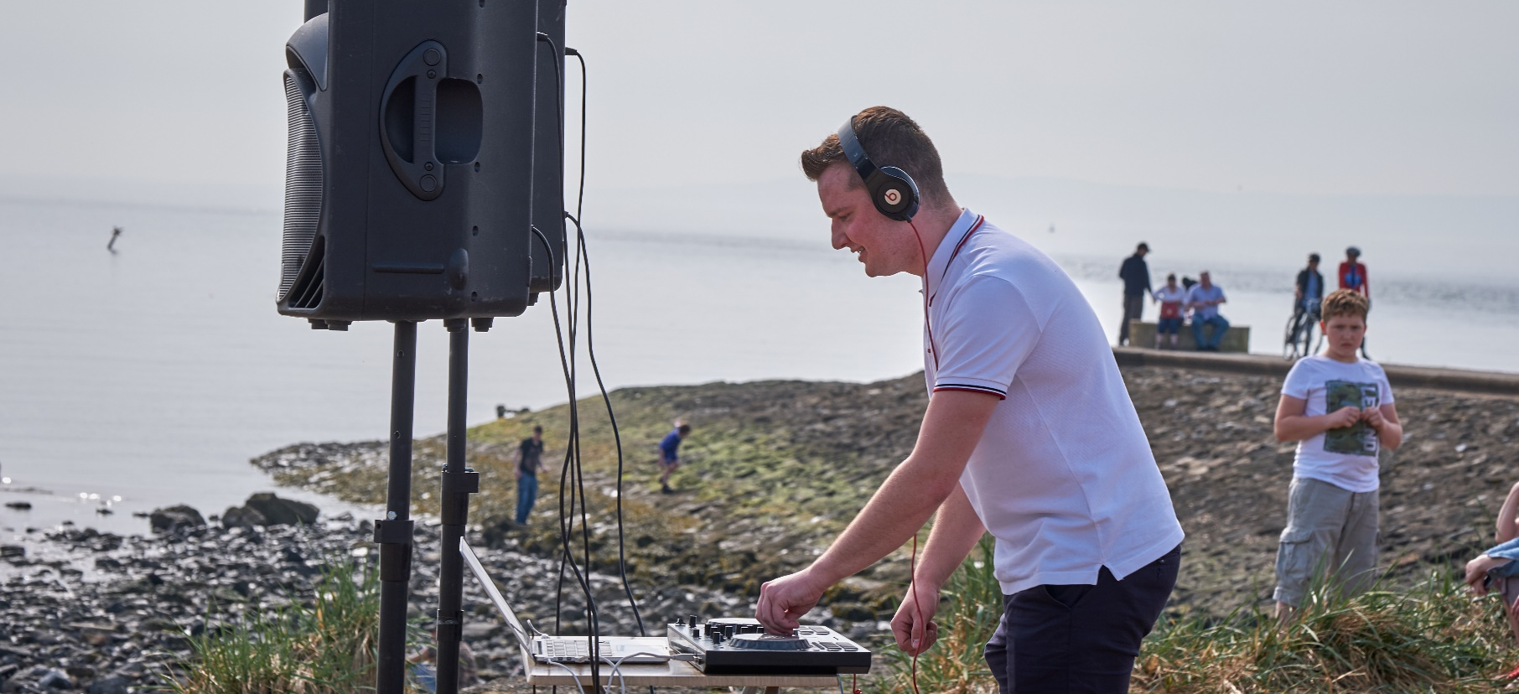
Here are the important dates you need to know if you are interested in submitting an idea.

Idea Submission Deadline Sunday 29th May 2022
If you would like to submit an idea for Future Routes funding, you will need to complete an Idea Submission by Sunday 29th May.

Decision Making Friday 24th June 2022
Idea Submission will be assessed by a decision-making panel made up of young people and NatureScot. They will decide which ideas receive funding and you will hear back from them by Friday 24th June.

Make your Idea a Reality! By November 2022

Successful ideas will need to be delivered by November 2022

Part Seven: Next Steps
Bubbling with ideas? Ready to get started? Great! Here are the next steps you should follow if you would like to submit an idea to the fund.

- Read through the Idea Submission Form so you know what information you need to prepare

- If you are applying as part of a team, discuss your idea and nominate a Team Leader whose contact details will go on the form

- Approach someone to be your Project Support

- Complete an Idea Submission in the best way that suits you. Chose one from the list below;

  - Fill in the Idea Submission Form word document and email to futureroutesfund@nature.scot.
  - Fill in and submit the Idea Submission form Microsoft Form found here.
  - Submit an Idea as a video or voice recording. In your video or recording make sure you answer the same questions that are in the form. Email a link or a copy of the video to futureroutesfund@nature.scot.
  - Submit an Idea over the phone. Please email futureroutesfund@nature.scot and we will arrange a time that suits you to ask you the submission form questions over the phone.

- Check that everyone in your team is happy with it
- Submit your ideas and keep your fingers crossed!
- Tweet using #FutureRoutesFund to join in the excitement online!

Remember, you can contact us at any point if you have a question
Email: futureroutesfund@nature.scot or call Abi Gardner on: 07717 541110

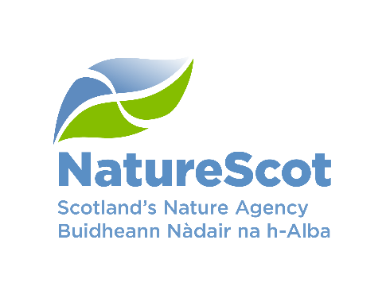
Background Information

Who is NatureScot?
NatureScot is the government funded body that looks after all of Scotland’s nature. For more information visit www.nature.scot

Who is Young Scot?
Young Scot is Scotland’s national youth information and citizenship charity for young people aged 11-26 in Scotland. For more information visit www.youngscot.net

Who is ReRoute?
ReRoute is a group of young people who worked with NatureScot and Young Scot to engage young people in Scotland’s amazing nature and Scotland’s Biodiversity Strategy. ReRoute set up the Future Routes Fund to empower young people to take action for nature. To find out more on ReRoute visit www.young.scot/reroute.

#FutureRoutesFund

