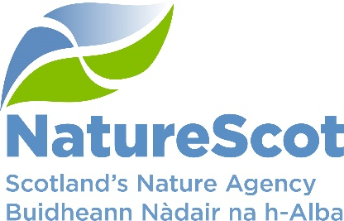

Title: Scottish Biodiversity Strategy and COP15 – update
Date: 16 March 2022
Purpose: | Decision.
How does this link with our corporate priorities of improving biodiversity or delivering nature-based solutions to climate change | The post-2020 Scottish Biodiversity Strategy is a key driver of our new Corporate Plan. The COP15 (CBD, Kunming China, August/September 2022) is the international platform for ratifying the international global biodiversity framework for action.
Summary: | We are working on the new strategy, to be issued for consultation in May 2022. Currently, much of our work focuses on devising the vision and outcomes – for 2030 (halting biodiversity loss), and 2045 (large-scale regeneration of biodiversity). There is significant stakeholder engagement in this work – across government, agencies and wide range of NGOs. The paper outlines significant key themes and choices emerging from the strategy development work.
Actions: | The Board is asked to:  Agree that we have identified the most significant key themes and policy choices, and offer their insights into how we should approach these.
Paper Author(s):  Sponsor: | Des Thompson, Clive Mitchell and Debbie Bassett  Nick Halfhide

The post-2020 Biodiversity Strategy - The Twin Crises
- We need to reverse and repair centuries of unsustainable management of the land and sea. The challenge ahead is daunting. In Scotland, the evidence base on biodiversity decline is strong and growing (e.g. State of Nature Report for Scotland 2019) and demonstrates very clearly that Scotland has seen a dramatic decline in its biodiversity:

- We have one of the lowest biodiversity intactness indexes globally
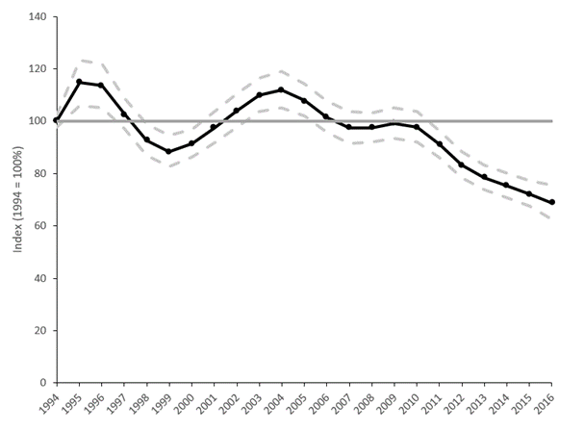
- 11% of species are threatened.
- 24% decline in abundance of recorded species since 1994.
- 14% contraction in species range since 1970.
- Our new biodiversity indicator (right, showing terrestrial species, reflects evidence of decline; the indicator for marine species abundance has shown a statistically significant decrease of 36% from 1994 to 2016).

- Work is well advanced on the post-2020 biodiversity strategy for Scotland. This 25-year strategy will outline a meaningful and transformational response to the intertwined crises of climate change and biodiversity loss. On 28th February 2022 the IPCC released the second report in its 6th Reporting cycle emphasising the close, binding relationship between ecosystem health and climate change. It noted up to 14% of species assessed globally will likely face a very high risk of extinction if the world warms by 1.5 °C (currently we are at 1.1 °C above pre-industrial levels); this will rise to up to 29% of species at risk under 3 °C of warming.

- Biodiversity (the complexity of genetics, species, habitats and ecosystems, both terrestrial and marine) has a huge role to play in cutting Scotland’s GGH emissions. It will take carbon out of the atmosphere, and store it making us more resilient to climate change. Johan Rockström and colleagues make the key point that ocean and land ecosystems remove around 50% of anthropogenic CO2 emissions from the atmosphere each year (i.e. half our ‘climate debt’ is removed, for free, by the biosphere every year – a vast subsidy to the world economy). If habitats, ecosystems and landscapes are not resilient to climate change the evidence points to a tipping point for both nature and climate.

- The Inter-Governmental Science-Policy Platform on Biodiversity and Ecosystem Services (IPBES) 2019 report identified five direct drivers of biodiversity loss. Action to tackle the wider, indirect drivers of biodiversity loss, alongside traditional conservation and restoration activities is also important. We have commissioned the James Hutton Institute to report on the range of indirect IPBES drivers in Scotland.

Work on the post-2020 strategy
- Working very closely with the Scottish Government, we are developing the post-2020 biodiversity strategy, under three steps:
- Step 1 – Devise the vision and outcomes, working closely with a wide range of stakeholders.
- Step 2 – Identify and develop conditions for success, governance outcomes and priority actions. These are the ‘levers necessary to meet the outcomes. This work involves developing targets, and indicators to measure progress. RESAS colleagues are supporting us in developing the evidence base and logic modelling to ensure the sum parts of work meet the whole ambition.
- Step 3 – Bringing the work together in a high level strategy, which will be issued for consultation in May 2022.

- Beyond this, in line with the Programme for Government we shall develop a Delivery Plan to implement the strategy. The Natural Environment Bill, which should be laid before Parliament in 2024, will contain targets underpinning key elements of the strategy and delivery plan.

- The diagram below gives detail on the engagement process which began in September 2021 to develop the biodiversity strategy.
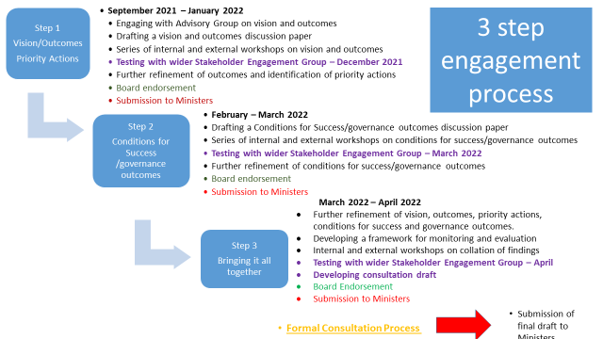

Step 1 - Vision and Outcomes framework
- Drawing from the Bute House agreement and following discussion with Minister Slater we have set two key milestones for the new biodiversity strategy:

- By 2030, halt biodiversity loss; and
- By 2045, biodiversity is regenerated, thriving and resilient, with key restoration targets met.

The draft vision is:
‘By 2045 we have regenerated and enhanced biodiversity across our landscapes and seascapes so it is resilient and able to adapt to climate change and sustain the goods and services on which we depend. We will see a reversal in biodiversity loss across all ecosystems, both on land and at sea; a resurgent, resilient natural environment, is playing a widely acknowledged central role in our response to climate change.’

- The framing of this work chimes closely with the CBD post-2020 framework for managing nature through 2030, for ratification at the Biodiversity COP15 in Kunming in August/September 2022. We work with the four countries and UK government in contributing to the UK position on the CBD framework.

- We have devised outcomes framed broadly by seascapes and landscapes. Essentially, these are depictions of what success for biodiversity should look like in 2030 and 2045. The Biodiversity Programme Scientific Advisory Group helped develop an initial set of these, drawing on a range of recently published works. This framing is considered the most appropriate on the basis that: there is greater accuracy on species abundance, habitat extent and health; there is universal cover across land, coast and seas; it resonates with main stakeholder groups’ interests and key policy drivers; and it cements the transition from halting loss to enhancement, restoration and regeneration of nature.

- These broad sea/landscape types are:
- Agricultural landscape
- Uplands (including peatlands)
- Woodlands / forestry
- Rivers, lochs and wetlands;
- Towns and cities
- Coasts
- Marine
- Soils and geodiversity
- Across ecosystems

Engagement process
- Our work to date has involved close working with stakeholders. Two well-attended events in December were supplemented with a series of one-to-one stakeholder sessions in December-January, and landscape focused sessions in January and February. On 1 March we held a large stakeholder event to develop work on the range of governance outcomes e.g. legislation framework, funding/investment, public engagement, mainstreaming, evidence and data infrastructure.

Outcomes
- A refreshingly broad and exciting range of outcomes is emerging from discussions with stakeholders, with strong consensus on many of them (with some partnerships already in place for delivery). The outcomes already provide important steers for priorities under the recently announced Nature Restoration Fund. This is fast-paced work, and is still in progress as we collate inputs from stakeholders.

Broad consensus
- There is broad agreement across many land and seascape outcomes, including:
- Appetite for regeneration of key habitats and species assemblages, and not restoring simply what we had in the past, but instead establishing a more resilient and viable body of biodiversity which is adapted to the climate ahead
- The need for large scale regeneration work which will address key drivers (e.g. invasive non-native species; intensive land use practices; adapting to climate change)
- The key opportunity offered by Nature-based Solutions to meeting outcomes, covering coastal, river, upland, and urban settings
- A meaningful reduction in deer numbers is a key challenge to the functioning of and resilience of multiple terrestrial ecosystems.

Key themes and policy choices – work in progress
- A number of key themes and policy choices issues are emerging from this work. Many of these relate to the rural environment and in particular the lowland farmland, upland and peatland landscapes. Those emerging for further consideration include:
- Restoration versus regeneration in underpinning resilience. Frequent stakeholder discussions focused on the ‘restoration to which point in time?’ question, posing challenges over the baseline we are working to, and whether looking ahead more emphasis should be placed on resilience and sustainable regeneration of biodiversity adapted to the climate ahead.
- The need for large scale work to address key drivers which affect the functioning and resilience of multiple terrestrial ecosystems (e.g. invasive non-native species; intensive land use practices; water pollution)
- The huge potential of nature based solution – the win-win to address the nature and climate change crisis. But also to address key challenges (such as flooding) in our coastal, urban and riverine landscapes
- The key role for agriculture – 70% of Scotland’s land cover. Fundamental change will be required to deliver biodiversity outcomes. Changes will reduce agricultural productivity but offer opportunities for green jobs from more effective environmental management activities including sustainable deer management, peatland restoration, woodland creation, as well as shifts in farming practices. Specifically we will need to:
- Reconcile multiple objectives for upland and peatland landscapes in particular, reflecting diversity of agricultural, field sport, renewable energy and strictly conservation-orientated measures;
- Find ways to address the emissions and impacts of our dependency on livestock; and
- Take forward changes in arable farming to support biodiversity recovery.
- Sustainable deer management. Deer impacts across both uplands and lowlands pose significant concerns, notably from red and roe deer. Widespread reductions in deer numbers are needed to regenerate biodiversity at landscape scales.
- Invasive non-native Species (INNS). Considerable organisational and community support for large-scale and urgent action to manage INNS, especially in woodland and river environments.
- Peatland restoration. Restoration targets are ambitious, and work is underway within Peatland ACTION on the most effective targeting of restoration work to deliver on both climate and nature ambitions.
- Woodland expansion. In order to meet open upland landscape ambition for species recovery, there are some localised conflicts with woodland expansion in the uplands. In some areas this will effectively prevent woodland expansion, especially where ground nesting waders and large raptors depend on open habitats; this also applies to some key invertebrate species, particularly pollinators, and internationally important heath and grassland communities.
- Predators (meso-predators). In order to meet some of the species recovery ambition (e.g. capercaillie), our wildlife management framework needs to be developed to address the management of some protected species (e.g. some of the predatory mammals and birds). This is highly contentious, but without major landscape regeneration, this management will be necessary.
- Nature networks embedded in 30% target for protected areas. Strong support across the landscapes for this (seascapes target already met in outline), but noting the vital importance of ensuring local communities are both designing and benefiting from the networks.
- Green finance. This offers highly significant opportunities for effecting change, and can provide considerable benefits for local communities and biodiversity.
- Renewable energy developments. Recognising the potential extensive expansion of these on land (and at sea), ensure major benefits for nature and local communities accrue.
- Marine renewables, fisheries and aquaculture. There are formidable issues in agreeing targets to meet biodiversity outcomes. We need to identify the key policies to enable this.
- Recreational disturbance. In some areas seasonal restrictions on access will be needed to sustain recovery of nature (e.g. for some woodland and coastal areas).
- Integrated action across land and sea. We need to look across land and sea in an integrated way – what happens on land affects what happens at sea in terms of biodiversity and vice versa.

Next steps
- We are refining the outcomes and the underlying evidence base to ensure that the sum total of these will meet the 2030 and 2045 vision. Work is underway on Step 2, developing the detail on the governance outcomes and action needed to meet the ambition. Towards the end of March we will develop the draft strategy, to be issued for consultation in May. The strategy will be published in October, and six months after that we will publish the Delivery Plan outlining how the strategy will be implemented.

- The Board is asked to agree that we have identified the most significant key themes and policy choices, and offer their insights into how we should approach these.

