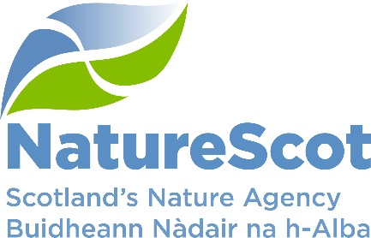

Title: Board Q3 Performance Report

Date: 3rd February 2022
Purpose: | Decision
How does this link with our corporate priorities of improving biodiversity or delivering nature-based solutions to climate change: | This paper presents progress towards delivery of our corporate priorities as laid out in our Business Plan, Connecting People and Nature: Year 4.
Summary: | Performance for 9 of our 10 priorities is rated as ‘on track’ against the Q3 90 day plan. No corporate risks have changed risk score in the last quarter. Operating is expected to outturn at year end within tolerance. Capital is expected to underspend. For large additional in-year budget allocations (Peatlands, BCF, NRF, BPF), there are challenges in committing the full 2021/22 budget. In the People Report, 6 out of the 10 indicators are on track, 2 have experienced minor slippage, and 1 will be updated in Q4.
Actions: | To note the recommendations below
Recommendations: | Board are asked to:  - Note the overall performance of the priorities and the anticipated recovery of any slippage (Performance Report).  - Note the position of the operating and capital budgets (Finance Report)  - Note the de-escalation of corporate risks noted in paragraph 13.  - Note the overall performance of the People Measures and the actions being taken to address slippage (People Report).
Report Author(s): | Authors – Directors, Deputy Directors, Outcomes Managers, Finance, Planning & Performance Team, People & OD Team
Sponsor: | Stuart MacQuarrie, Jane Macdonald
Annex: | Annex A – Q4 90 day plan  Annex B – Corporate Risk Register

Purpose
- This paper presents NatureScot’s performance for the third quarter of 2021/22. It addresses delivery of our corporate priorities by reviewing the alignment of outcome performance against our Business Plan, Connecting People and Nature: Year 4; progress towards maximising our available budget; assessing risks for delivery; and reviewing people information supporting the resourcing of our work. These Outcomes support delivery of our Corporate Plan 2018-22, Connecting People and Nature.

Summary
- During Q3 the Conference of Parties 26 (COP 26) was held in Glasgow. NatureScot played a key role in the run up to and during the event through exhibitions, talks and event attendance. COP 26 put nature firmly on the centre stage and has helped shape the development of our future work. The Corporate Plan as a result will focus on protecting, restoring and valuing nature and our efforts will be delivered, driven by those outcomes.
- Q3 also saw the opportunity for more staff to return to the office. This has been progressing well and positive feedback from staff has been received in response. Sadly, Q3 also saw a mutation in Covid-19 and as a result a new more infectious variant, the Omicron virus, entering the UK.
- Our work to reopen offices may now be impacted by this and the Business Continuity Group are reviewing the position in early January. The progress of this variant and the potential tightening of restrictions applied by Scottish Government may also impact our approach in Q4. Organisations are being warned to expect up to 25% of the workforce to be absent and the message therefore remains to ‘work from home if you can.’
- The Scottish Biodiversity Strategy has been circulated for the first round of stakeholder engagement in December and will go through further refinement during Q4. There will also be wider analysis key drivers and policy content with identification of enabling conditions, priority actions and strategic choices. By April, the key indicators and a framework for monitoring and evaluating successful delivery of the strategy must be in place.
PRIORITY PERFORMANCE | NUMBER | CORPORATE RISK | NUMBER
Priorities | 10 | Corporate Risks | 18
On Track | 9 | Increased Score | 0
Minor Slippage | 1 | Decreased Score | 0

FINANCIAL METRICS | STATUS | PEOPLE METRICS | STATUS
Operating | On Track | Wellbeing | On Track
Project Allocation | On Track | Capacity | On Track
Paybill | On Track | Development | On Track
Capital | Major Slippage | Workforce Profile | Minor Slippage

- More People Benefitting from Nature (Nick Halfhide, Director Nature & Climate Change)
- NatureScot will facilitate the role of nature in transforming places where people live –
- Work on the Malls Mire Green Infrastructure site was completed, is open to the public, and an official opening is planned for Q4.
The Autumn Make Space for Nature Campaign was launched which highlighted the link between climate change and nature loss, and the practical actions people can take to help. Community engagement supporting over 450 communities (300 target) delivered work on marine protected areas, wee forests, raingardens and volunteering with a press release issued to mark World Volunteer day on 5th Dec.
- NatureScot will support and encourage access to and enjoyment of nature –
We completed the assessment of applications under the Agri-Environmental Climate Scheme (AECS) Improving Public Access scheme. Of the 147 applications (£12.3m) received, we assessed that 81 (£6.9m) were eligible for funding, and with the budget available we were able to support 17-20.
A review of the 2021 visitor management strategy (VMS) is in progress, including a successful 3rd stakeholder summit with the Cabinet Secretary. Better Places Fund final reports, claims and payments are being processed and we now expect some underspend. The funding of seasonal rangers and other VMS staff has been widely credited as the key to improving visitor management on the ground, and a more detailed evaluation of the fund is now underway to learn lessons for possible future rounds.
The National Nature Reserves Strategy is being implemented and under continual review - this includes a prioritised list of infrastructure investment priorities. We completed a review of resources and submitted a proposal to SG for additional staffing and capital support for 2023/4 and beyond as part of strategic visitor management proposals.

- The Health & Resilience of Scotland’s Nature is Improved (Nick Halfhide, Director Nature & Climate Change)
- NatureScot will invest in action to reverse biodiversity loss and jointly lead the Scottish Biodiversity Programme –
NatureScot supported SG in the October element of COP 15. NatureScot is supporting the Scottish Government to showcase the ‘Edinburgh Process’, an agreed declaration which seeks to collectively influence the development of the post-2020 global biodiversity framework. Our support continues until the face to face conference, currently scheduled for April 2022.
We developed the criteria for the enhanced Nature Restoration Fund and have launched a competitive element.
We received a first draft of the commission from SG to achieve 30x30 protected area targets and we anticipate finalising the commission early in Q4.
We agreed with Protected Areas Committee that 30x30 will largely subsume the recommendations of the Protected Areas (PA) review work including PA principles. We are reviewing any elements of PA review that will not be taken forward by 30x30 and will update PAC during Q4.
GovTech work has continued to impact on implementing priority recommendations in the surveillance and monitoring strategy. The Ecosystems Health Working group is now due to commence in early Q4 and an implementation plan developed in similar timescale. Whilst this presents some slippage, work across the activity is already progressing at least half of the recommendations of the initial review.
Marine Monitoring Panel members now have a much clearer idea of the legislative and policy framework relating to marine monitoring, and what we can tell from our current work. This provides a good basis for developing recommendations in 2022 to guide future marine monitoring.
- NatureScot will support a step-change in use of Nature-based Solutions to climate change and other problems –
Dynamic coast was an important element of SG's COP26 presence with Alistair Rennie appearing at a parliamentary committee discussing how innovations are critical to the Nature/Climate Emergencies. Work is progressing successfully regarding Coastal Change Adaptation Fund plan prioritisation.
Our blue carbon and coastal adaptation work received good coverage during COP26 with several NatureScot media interviews and significant involvement in the Scottish Blue Carbon Forum international conference with strong Ministerial support.
- More Investment in the Management of Scotland’s Natural Capital (Robbie Kernahan, Director of Sustainable Growth)
- NatureScot will help to transform use of land and sea so that it contributes even more to the future wellbeing economy -
All AECS cases processed and National Project Assessment Committee approvals/rejections confirmed. Ministerial approval for AECS 2022 obtained and scheme launch details to be communicated to stakeholders alongside 2021 results.
Our Natural Capital Pilot (NCAPP) programme now included as part of Track 2 of a new National Test Programme. This includes development and piloting of a biodiversity audit from 2022. Ongoing engagement with SG on future support the high level vision for Agriculture to accompany the National Test Programme.
Nearly all Piloting Outcome Based Approach Scheme (POBAS) farmers have been engaged on a one-to-one basis including use of the POBAS App and testing it on at least one habitat on their farms. There has been less progress on securing some management actions due to delays in farmer engagement following recruitment of enhanced POBAS team. Over 10% now considering options and expect this to grow in Q4 and next year.
The draft National Planning Framework (NPF) 4 consultation was published in late November (closing 31st March 2022) and public consultation on our "developing with nature" draft Guidance was launched late November which aim to strengthen policy and spatial direction delivering positive effects for biodiversity.
ScotWind resourcing was approved (£750k staff funds per yr) and progress made in scoping other workstreams with Marine Scotland to develop and implement the Blue Economy Action Plan.
The Strategic Deer Board (public agencies) met and agreed the basis of a work programme within four workstreams. The Deer Management Round Table met November with focus on Biodiversity and Climate drivers for management. Grouse commission was agreed by SG, and task groups leading licencing approaches are formed and work is underway.
Discussions with stakeholders on management measures for Marine Protected Areas (MPA) have restarted and the first round is expected to be completed by Christmas. This will enable work to develop materials for public consultation for Phase 2 MPAs to begin.
- NatureScot will focus effort on mainstreaming natural capital approaches/accounting in decision-making –
Metrics on biodiversity are now built into the Natural Capital template being trialled with land managers. Other work to test biodiversity metrics for Natural Capital Asset Index are not progressed due to loss of key staff. The Scottish Biodiversity Strategy vision and outcomes paper is providing a useful alternative driver for this work.
Organised and (Francesca) chaired Public Sector Leaders' Natural Capital Roundtable including advance briefing, and presentation and discussion on Dasgupta review and relevance to Scottish economic policy which will support the development of evidence and tools to enable the uptake of natural capital assessment of the public estate.
- NatureScot will help to grow and diversify environmental green finance –
To grow private investment in natural capital a further iteration of the proposal for a Facility for Investment Ready Nature in Scotland (FIRNS) was completed and shared with key contacts in SG for submission to the Spending Review.
A Green Finance Guide for Land Managers final draft has been circulated for input from key external contacts.
Formal fundraising launch of Scottish Marine Environmental Enhancement Fund (SMEEF) delayed due to Marine Scotland (MS) request for further financial due diligence work and contracting this advice. MS and Crown Estate Scotland progressing resource bids to fund NatureScot SMEEF staff.
- NatureScot will accelerate peatland restoration through our Peatland Action Programme and collaboration with others –
The pipeline identifies over 6000 ha to be restored in 2021/22. The next steps in advancing horizontal functions have been shared and discussed with other delivery partners. Recruitment for delivering future Peatlands funding is underway.

- We have transformed how we work (Jane Macdonald, Director Business Services & Transformation)
- NatureScot will invest in skills for a nature-rich future, especially in youth employment –
We have now completed recruitment for our 2021/22 Programme for Youth Employment. In total, we've welcomed 40 new colleagues this year. These range from Modern and Graduate Apprenticeships to a number of Practical and Project Placements. We've also welcomed a number of Trainee Operations Officers, Trainee Rangers and some Internships. All of them will spend up to two years with NatureScot, working on developing their skills and knowledge, and gaining valuable experience to help them in their future careers, either with us or elsewhere. In addition to those that we've recruited through the main Programme, we're also running a pilot project with the Council for Ethnic Minority Voluntary Organisations (CEMVO) as part of the 'Ethnicity in Nature' Programme, to help increase diversity in nature-based sectors. A lot has been going on to promote equality & diversity more generally over the past few months, including the launch of our Race, Diversity and Inclusion Forum as part of a series of Black History Month blogs. We also launched an Islamophobia Awareness Month (IAM) blog and recently held a MEND (Muslim Engagement & Development) session that looked at "How well placed is NatureScot for working with Muslim communities?"
We have secured £140k for a National Transition Training Fund ‘Working with Rivers’ training placement scheme, which has been launched with an invitation for host organisations to bid. In terms of our input to wider green skills initiatives, the nature-based jobs and skills action plan progress report has been prepared for Skills Development Scotland
- NatureScot will transform as an organisation to meet the demands of the future, including accelerating its transition to a net zero emissions organisation –
We've made good progress this quarter across a range of activities that support our Organisational Development framework and help transform how we work. This work is coordinated through the Transformation Steering Group who have responsibility for ensuring that we target our actions to help us achieve three strategic outcomes of new ways of working, a happy and resilient workforce and increased leadership capabilities.
Homeworking is now firmly established as part of our new ways of working and we have made a range of support available to ensure that we continue to feel connected with each other, regardless of where we work from. To help us adapt to our new ways of working as offices start to partially re-open, learning packages were developed and promoted in October. Topics covered include helping with team collaboration, building relationships, time management, leadership etc. Further support is also being rolled out as part of self-awareness sessions. These look at gaining a better understanding of our different working preferences to help us connect and adapt.
Transforming our Workplaces 2 (TWP2) has been set up to take forward our Estate Strategy and to help shape the 10 Year Plan for our future office requirements. Local projects are now underway looking at opportunities to review what sort of workplaces we need in the future to ensure alignment with our new ways of working. Some of this will likely lead to more universal public sector hubs that are shared with our partners. This will form a key component of our wider net zero ambitions.
We've continued to implement a number of other actions as part of our Net Zero Plan and demonstrate our leadership role in this area. This has included projects to upgrade the Photovoltaics (PV) and related battery installations on the Isle of May and Rum NNR's. We've also taken delivery of a further 10 Electric Vehicles (EVs) over the past few months and are working on installing further charging points at a number of our properties.
To ensure we are transparent in the total emissions that we produce we've recently adopted a methodology (developed by Sustainable Scotland Network) for the monitoring of our homeworking emissions, which will be incorporated into our carbon reporting.
We are continuing to develop and mainstream the use of innovative technology to help improve our ways of working, access new data and support delivery of our work. We are developing a number of projects to detect and monitor change, map habitats and make data, including Earth Observation (EO) data, easier to access and use. One such project, in partnership with SSE, has been driven by the need to monitor how offshore windfarms may impact on breeding puffins. The inaccessible nature of their colonies added to the fact that their nest sites are hidden underground, make puffin populations very difficult to monitor. A trial has been running at the Isle of May NNR in the summer of 2021 and has demonstrated that we can use remote cameras and automated image recognition (AIR) systems to continuously monitor puffin numbers in real time. This exciting project highlights the use of innovative technologies to advance the sustainability of developments.
Following the Board's strategic steer for the new Corporate Plan, further work has been taking place to enable us to address the priorities agreed with our Minister to protect, restore and value nature. This includes identifying what sort of skills we might need to develop; how we can deploy these more flexibly and responsively; what sort of organisational culture we need to support our ambition; and what sort of systems and information might be required. These themes will be explored further over Q4 and staff engaged through our Winter Carnival.
PERFORMANCE
Business Plan Measures | Status
NatureScot will invest in action to reverse biodiversity loss and jointly lead the Scottish Biodiversity Programme | ON TRACK
- We will develop a suite of draft biodiversity targets for Scotland following Global Biodiversity Monitoring Framework (for COP15) | ON TRACK
- We will fund at least £1m of Biodiversity Challenge Fund grants through Phase 3 during 2021/22 | ON TRACK
- Advise Government on options to achieve 30x30 protected area targets | ON TRACK
- Take forward Protected Area Committee recommendations for enhancing our special nature sites | ON TRACK
- Implement priority recommendations in the surveillance and monitoring strategy to better inform management | MINOR SLIPPAGE
- Develop a new approach to delivering the Scottish Marine Protected Area monitoring strategy | ON TRACK
NatureScot will help to transform use of land and sea so that it contributes even more to the future wellbeing economy | ON TRACK
- We will help to deliver Agri-Environment and Climate Scheme | ON TRACK
- We will advise SG on Biodiversity and Climate outcomes across all future farm support schemes | ON TRACK
- We will deliver Phase 3 of Piloting Outcomes Based Approaches in Scotland (POBAS) | MINOR SLIPPAGE
- We will secure strengthened policy and spatial direction in the Fourth NPF that delivers positive effects for biodiversity | ON TRACK
- We will support Marine Scotland in developing and implementing a Blue Economy Action Plan | ON TRACK
- We will develop and deliver actions arising from the Scottish Government responses to the Werrity and Deer Working Group reports. | ON TRACK
- The number of Marine Protected Areas with management measures will be increased | ON TRACK
NatureScot will support a step-change in use of Nature-based Solutions to climate change and other problems | ON TRACK
- Implement phase 2 of the National Coastal Change Assessment to support Local Authorities planning | ON TRACK
- We will be part of developing and delivering a strong new vision and work plan for the Scottish Blue Carbon Forum. | ON TRACK
NatureScot will focus effort on mainstreaming natural capital approaches/accounting in decision-making | ON TRACK
- We will provide evidence to support SG to embed applying a natural capital approach in policy and investment | ON TRACK
- We will provide evidence and tools to enable the uptake of natural capital assessment of the public estate | ON TRACK

Business Plan Measures | Status
NatureScot will help to grow and diversify environmental green finance | MINOR SLIPPAGE
- We will develop new approaches to grow private investment in natural capital | ON TRACK
- We will develop a new approach to blend private investment through the Peatland Code with Peatland Action. | MINOR SLIPPAGE
- We will develop and launch the Scottish Marine Environmental Enhancement Fund (to support recovery and resilience of our coasts and seas) | MINOR SLIPPAGE
NatureScot will invest in skills for a nature-rich future, especially in youth employment | ON TRACK
- We will employ up to 37 posts through the Programme for Youth Employment | ON TRACK
- We will develop and secure funding for a training and employment programme for nature-based skills. | ON TRACK
NatureScot will facilitate the role of nature in transforming places where people live | ON TRACK
- We will fund up to £3.4m of Green Infrastructure projects using ERDF funding. | ON TRACK
- We will support up to 300 communities across Scotland to improve local green and blue spaces for people and nature as part of our Making Space for Nature campaign | ON TRACK
NatureScot will support and encourage access to and enjoyment of nature | ON TRACK
- Fund up to £3m of new paths through the AECS – Improving public access scheme | ON TRACK
- We will co-ordinate delivery and amplify responsible access communication as our contribution to the national visitor management strategy | ON TRACK
- We will implement a resilience strategy on our NNRs | ON TRACK
NatureScot will accelerate peatland restoration through our Peatland Action Programme and collaboration with others | ON TRACK
- We will increase Peatland Action’s delivery of restored peatland by 40% | ON TRACK
NatureScot will transform as an organisation to meet the demands of the future, including accelerating its transition to a net zero emissions organisation | ON TRACK
- We will deliver the Organisation Development Framework actions | ON TRACK
- We will deliver the NatureScot Net Zero plan which will aim to deliver a 7% carbon saving in line with our stretch target (or 63.3 tonnes of CO2). | ON TRACK

Performance
- Of the 30 measures that we planned to achieve over the full year, 26 (87%) are rated on track, 4 (23%) have experienced minor slippage. Only one Business Plan priority is amber, ‘NatureScot will help to grow and diversify environmental green finance’. The 4 measures with minor slippage, and the actions to recover this, are summarised below. It is anticipated that all slippage is recoverable.

  - Implement priority recommendations in the surveillance and monitoring strategy to better inform management – GovTech work has continued to impact on implementing priority recommendations in the surveillance and monitoring strategy. The Ecosystems Health Working group now due to commence in early Q4 and implementation plan developed in similar timescale. Whilst this presents some slippage, note that work across the activity is already progressing at least half of the recommendations of the initial review.
  - We will deliver Phase 3 of Piloting Outcomes Based Approaches in Scotland (POBAS) - Nearly all Piloting Outcome Based Approach Scheme (POBAS) farmers have been engaged on a one-to-one basis including use of the POBAS App and testing it on at least one habitat on their farms. There has been less progress on securing some management actions due to delays in farmer engagement following recruitment of enhanced POBAS team. Over 10% now considering options and expect this to grow in Q4 and next year.
  - We will develop a new approach to blend private investment through the Peatland Code with Peatland Action – We will develop a new approach to blend private investment through the Peatland Code with Peatland Action. A number of actions in the plan were agreed in August and planned for implementation in Q3. These are now being taken forward by the Peatland Action Team during Q4.
  - We will develop and launch the Scottish Marine Environmental Enhancement Fund (to support recovery and resilience of our coasts and seas) – Formal fundraising launch delayed due to MS request for further financial due diligence work and contracting this advice. MS/CES progressing resource bids to fund NatureScot SMEEF staff. Meanwhile strong performance by SMEEF project manager in delivering NRF marine fund work.

- The Q4 90 day plan for 2021/22 is now live. This focuses on the priorities and the milestones to be achieved by the end of Q4, which support delivery of the 2021/22 Business Plan.

FINANCE
Financial Metrics (£m) | Measure | Budget | Forecast | Variance | Rating
Resource Budget | Outturn within 1% of final budget | 52.5 | 53.1 | 0.6 | ON TRACK
Capital | Outturn within 5% of final budget | 3.2 | 2.7 | (0.5) | MAJOR SLIPPAGE
Indirect Capital | Outturn within 1% of final budget | 14.6 | 14.1 | (0.5) | MINOR SLIPPAGE
Paybill | Outturn within 1% of final budget | 30.6 | 30.0 | (0.6) | ON TRACK
Project Allocation | Outturn within target allocation range | 17.0 | 17.6 | 0.6 | ON TRACK
Peatlands | Outturn within 1% of final budget | 9.4 | 9.4 | 0.0 | ON TRACK
Biodiversity Challenge Fund | Outturn within 1% of final budget | 2.0 | 1.9 | (0.1) | MINOR SLIPPAGE
Better Places Fund | Outturn within 1% of final budget | 2.0 | 2.1 | (0.1) | MINOR SLIPPAGE
Nature Recovery Fund | Outturn within 1% of final budget | 5.0 | 4.8 | (0.2) | MINOR SLIPPAGE
*Operating under 1% - on track, up to 10% minor slippage, over 10% major slippage (** Capital under 5% / up to 10%)

Financial graphs | Summary of performance
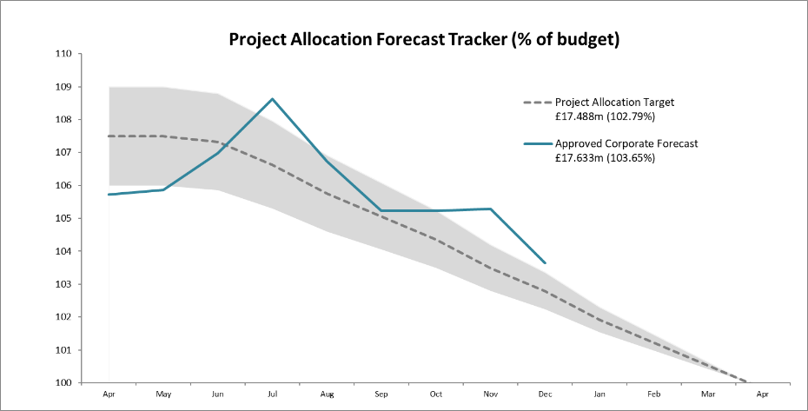  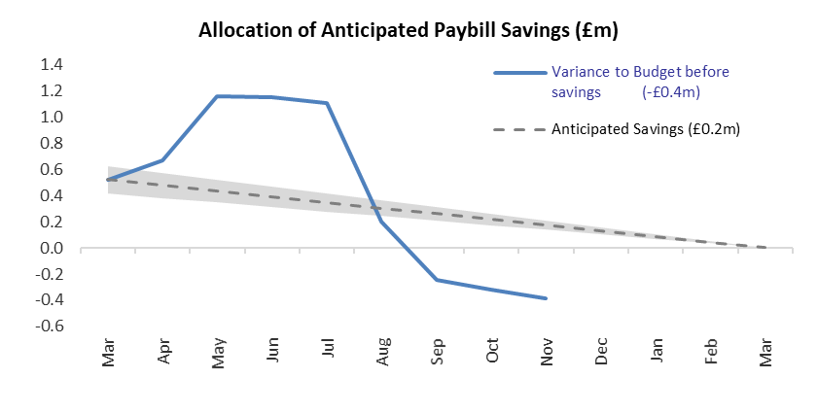 | Additional in-year budget transfers totalling £19m have been confirmed and are reflected within the budget. The indirect capital element of these are forecast to underspend by £0.5m with efforts continuing to minimise this. Proceeds from the sale of land at Glencripesdale will not be fully committed prior to April resulting in the major slippage on capital.  To manage resourcing pressures identified in Q1, additional funding was allocated to paybill (£0.6m). Due to plans varying, the forecast is now below budget (£0.6m). Project expenditure is above upper tolerance level as approved by the Resourcing Group in order to avoid an underspend at year end.

Resource Budget Performance
- At this point of the financial year, an overspend of £0.597m is forecast on the Resource budget. (At the end of Q3 2020/21, an overspend of £0.685m was forecast).
- In response to the savings exercise from SG, £0.7m of savings were identified and communicated to SG (£0.2m visitor management funding and £0.5m Peatlands staffing costs). The budget adjustments have been made.
- Further budget allocations were made following confirmation of SBR – overall an increase of £0.107m.
- We have communicated to SG that we will be handing back £0.539m of the SRDP retention. The main reasons for this relate to POBAS farmers not being in a position to enter into management agreements to support payment for actions on the ground; and secondly, a delay in the Landscape Scale Natural Capital Project (on Islay) due to no tenders being submitted. This has been reflected in the budget.
- The latest forecast for paybill is an underspend of £0.557m for the year. We have increased the project allocation budget as a result.
- We are now reporting the split between Resource and Indirect Capital allocations for the various funding programmes, given the need to treat these separately.
- Based on experience in recent years, the project allocation forecast has been given approval by Resourcing Group to remain above tolerance to help optimise use of our Resource budget before year end.
- We will continue to monitor project surrenders throughout the year, using our knowledge and experience of previous slippage levels to ensure that appropriate demand is ready to allocate when surrenders are received.

Indirect Capital Funding Programmes (including Peatlands)
- An underspend of £0.472m is forecast on the Indirect Capital budget.
- The budget for Peatland Action restoration, conservation, management and associated employee costs for 2021/22 is now £9.390m following the £0.5m savings on Resource and a handback of £1m on Indirect Capital. This closely matches the forecast for Peatland Action of £9.394m.
- The impact of slippage on large value programmes (BCF, BPF, NRF) also presents a heightened risk of underspend given the size of the funds, their capital nature and late confirmation during the year. Estimated slippage has been reflected in the forecast but is likely to be revised in the remaining months.
- The Nature Recovery Fund remains at £5m. It was initially advised late in Q1 (£2m direct fund and a £1m competitive fund) with a further £2m agreed in September for direct funding of marine and coastal projects. All of this funding is Indirect Capital for this financial year.

Structural Funds Programmes
- The current Green Infrastructure claim of £0.848m remains unpaid 19 months after submission (previously £1.14m - £286k to be resubmitted in next claim). An NCHF claim for £214k has been submitted which was due to be paid in November but has not yet been processed. The potential NatureScot liability for advance payments is £239k (this is the maximum exposure should there be disallowance on all of the payments made).

Capital Budget Performance
- An underspend of £0.473m is forecast on the capital budget. We are reporting this as RED – Major Slippage.
- The reason for the large underspend is we increased our budget to £3.2m due to the Glencripesdale sale, where we are expecting £0.750m of proceeds from the sale. We are monitoring all projects funded by these proceeds. Currently there are £0.453m of projects funded by the sale, therefore £0.300m unable to be utilised.
- £0.150m of core underspend relates to 2 projects which have been unable to proceed due to slippage and sourcing issues and one project £0.080m which has been reclassified as Operating. Allocations Group will consider possible purchases which could be brought forward from next year but scope is limited in the timescale available and the capital budget will be underspent at year end assuming the sale of Glencripesdale completes, as anticipated.
- Funding of £0.709m has been secured from various sources towards the cost of new vehicles, charging points, NNR car parking, path work and a replacement hide.
- The Net Book Value – Asset Disposals value of £0.129m has been included, this increases our ability to spend on Capital projects by this amount.

RISK
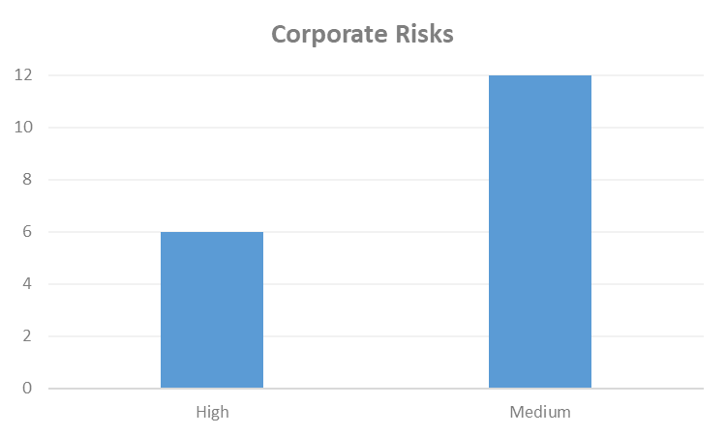 | Changes to Corporate Risk Scores  ↑ 0 Gone Up (medium > high)  ↓ 0 Gone Down (high > medium)  Change to Corporate Risk Register  ↗ 0 New Corporate Risks  ↘ 4 De-Escalated (proposed)

Risk
- The Corporate Risk Register holds the current corporate risks for NatureScot. Activity and project risks are managed within the risk management system, which underpins the corporate risk register. All risks are managed in line with the Risk Management policy and monitored regularly for compliance and visibility of impact. All risks currently active on the Corporate Risk Register are recommended to be retained.

- There are currently 18 approved Corporate Risks, 12 medium and 6 high. There has been no movement in risk scores over Q3 although Risk 72 SRDP - AECS – Outcomes for the Natural Heritage has reduced in likelihood and risk 253 Peatland restoration target and budget has decreased. No new risks are proposed for escalation.

- As a result of the ongoing exposure to disallowance for Risk 583 – Structural funds, an updated position has been provided at the end of the Corporate Risk Register in Annex B. A verbal update was provided to SLT. Audit and Risk Committee have been provided with the text and a profile of future claims.

- During Q3, Internal Audit and the Risk Manager engaged with Outcome groups and Area Managers to determine ‘what keeps them awake at night’. This identified two new Activity risks to address new financing opportunities and measuring and evidencing performance of the corporate plan. A follow up review of the risks on the Corporate Risk Register identified a number which are within the risk appetite tolerance. As a result these were approved by Senior Leadership Team to be de-escalated from the register to be managed at the Activity level. These are:

  - 53 Marine Protected Areas - As a result of insufficient stakeholder engagement and and/or insufficient resources across Team Scotland, there is a risk that new designation and management proposals will be not be supported, which could result in incomplete delivery of Ministerial commitments for an ecologically coherent and well-managed MPA network.
  - 72 SRDP - AECS – Outcomes for the Natural Heritage - As a result of the dependency on the funding available under SRDP, there is a risk that insufficient funding is provided to support natural heritage outcomes which may result in widespread negative impacts on biodiversity, climate mitigation and adaption and improving public access.
  - 87 Provision of balanced advice on European sites - As a result of failing to understand the implications of European sites legislation, there is a risk of NatureScot's advice to Scottish Government, Competent Authorities and developers being either: too precautionary resulting in impediments to development; or insufficiently precautionary, resulting in exposing the Government, competent authorities or NatureScot to Judicial Review or action by Environmental Standards Scotland, with its associated financial and reputational consequences. This encompasses advice from NatureScot on European site conservation objectives, conservation priorities and management measures, together with casework advice.
  - 255 Realising nature's role in addressing Climate Change - As a result of the Climate Emergency placing focus on the key role of nature in helping address climate change, through both emissions-reduction and adaption, there is an opportunity to position nature front and centre in climate change action and help address a key driver of biodiversity loss. If not, we may fail to further promote and sustain biodiversity in a changing climate, fail to support and deliver Government policy, and potentially damage NatureScot’s reputation.

PEOPLE
People Metrics | Status

Wellbeing
Accidents & Near Misses – target: to stay within variations around the mean  Q3: Accidents=2, Near Misses=1 (these continue the low trend of the past two years) | GREEN
Work-life balance – target: 75% of employees feeling that their work-life balance is good  Q3: 69% of employees who utilised Work Happy rated their work-life balance as good | GREEN

Capacity
Sickness – Target: under 2 days per person per quarter.  Q3: 0.90 days (continuing lower than normal trend since Q1 20/21) | GREEN
Holiday Leave  Q3: data delayed following a change to the leave year being implemented – next update in Q4. | No data

Development
Formal Casework - target <=50% of informal casework  Q3: 45.5% (5 cases), well within normal range for this type of casework | GREEN
Informal Casework  Q3: 11 cases, right on average for this type of casework | GREEN
Access to L&D for role  Q3: 69% agree (Q2 data – question has not been asked in Q3) | GREEN

Workforce Profile
Turnover – target: increase  Q3: last 12 months of turnover is 10.71% (a rise from last quarter, though a rise at this time of year is not unusual) | GREEN
Internal Movement – target: increase  Q3: Internal Employee Moves: decreasing | AMBER
Retirement Profile  Q3: 134 employees are age 57+, predicted to rise to 159 in 24/25, adjusted for average number of retirements, but we are forecasting a significant change by 24/25. | AMBER

People
- Sick absence – Both stress-related and cold/flu/respiratory are now showing a statistically significant reduction. While the latter is likely to be down to employees working from home/not socialising as much, the continued low numbers are encouraging for the general health of our employees as well as not losing so many days to sick absences. For the former, it may be due to both our ways of working (preferences for some will be to home-work permanently now) but also our expanding and continued support for wellbeing for our colleagues. Covid-related absences (including vaccination side effects) remain low (118 days in the quarter, compared to 189 for mental health).

- Holiday Leave – unfortunately we still cannot provide an update to holiday leave taken/remaining. The report producing the information is yet to be fixed by our contractors. However, with the change in leave year policy/period, the crucial information for this measure is due in March, not December. Managers can continue to track the leave balances of their direct reports in Fusion and should be encouraged to ensure that leave is taken.

- Internal Moves – Our target is to increase internal movement in order to provide more career development opportunities and make greater use of available skills. Whilst recruitment remained high, it did dip at the end of the summer which has resulted in fewer internal movers this quarter. As a reminder, this measure covers promotion, internal recruitment, reassignment, redeployment, return to substantive post, secondments out and back, and changes in hours.
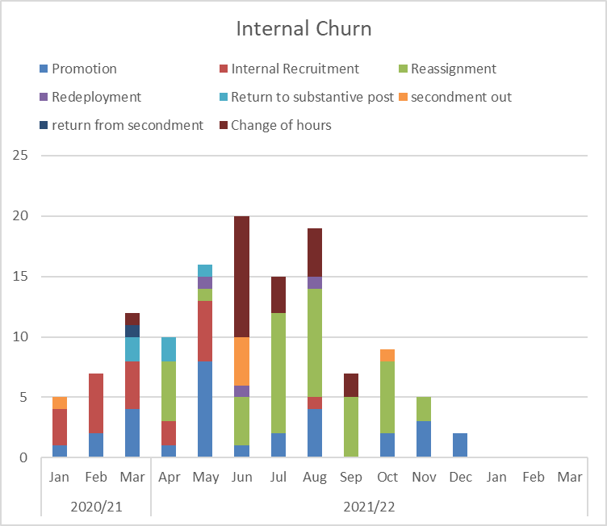
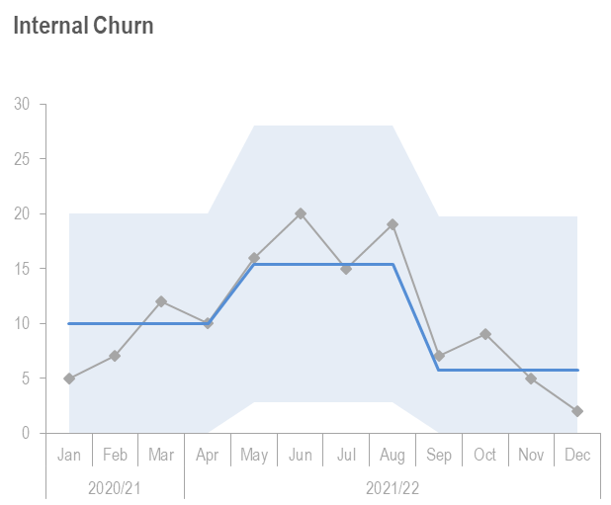

- Retirement Profile – There is an average of 15 retirements a year. As the below graph shows, we can see an increase in the number of employees who are aged 57+, (from 134 employees in 2021/22 to 219 in 2023/24), we can therefore expect to see a higher than usual number of retirements over this time, (our average retirement age has increased to 62, from a previously reported 61). This offers both opportunities (for employee promotion/movements, and the organisation reshaping/paybill reductions) but also risks (loss of knowledge, time spent on increased recruitment activity). Investment in skills/learning and development for our people will help address the loss of knowledge & expertise. Skills will be a key component of the organisational design work (the NatureScot Way). Career MOTs will also enable more informed choices for people, while the McCloud Judgement (pension/age discrimination case) may have an impact on this as well.

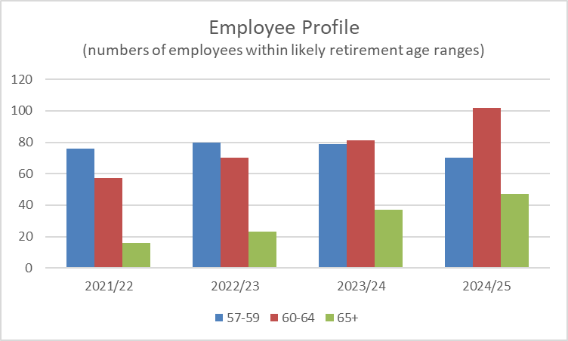

Recommendations
- Board are asked to:
- Note overall performance of the priorities and the anticipated recovery of any slippage (Performance Report).
- Note the positions of the operating and capital budgets (Finance Report)
- Note the de-escalation of corporate risks noted in paragraph 13.
- Note the overall performance of the People Measures and the actions being taken to address slippage (People Report).

Annex A – Q4 – 90 day plan

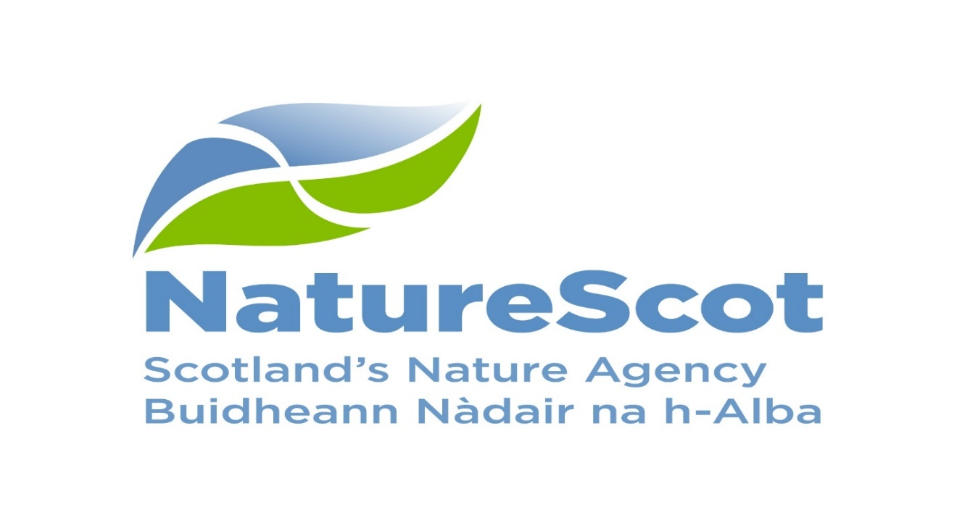
2021/22 Q4 90 day plan
Year Four of Connecting
People and Nature

Delivering our work in Q4 – Moving towards a Nature Rich Future

This is the final quarter of our Business Plan ‘Year 4 Connecting People and Nature’, the final year of our Corporate Plan 2018-2022. A lot has changed since that Corporate Plan was first published but what has become clearer than ever is the importance of our connection with nature.
The ongoing Covid-19 pandemic has demonstrated this, on both a global level, with clear links being identified between the degradation of nature and increasing pandemic risk; and at a local level where the nature on our doorsteps has become so important to our physical and mental wellbeing during lockdowns and restrictions.

As we move through the year we continue to pursue this vision through delivery of the four outcomes and by ensuring our resources are focused on where they can maximise impact. Our efforts are focused on investing in targeted action to deliver our strategic priorities. These are:
- Enriching Biodiversity
- Leading on nature-based solutions to climate change
To deliver the strategic priorities we will focus on the 10 areas of work detailed on the next page. These are the same 10 priorities in our published Business Plan.
The 90 day plan for Quarter 4 sets out the key activities that will significantly advance us towards achieving the outcomes of the business plan. Quarterly plans allow us to adapt quickly to the unknown and take into account the reducing but continuing impact of Covid-19 on staff availability and wellbeing, and on our ability to deliver our priorities.

The Conference of Parties (COP) 26 held in October, cemented the need to act now to tackle the twin climate and nature crises. The role nature plays in mitigating climate change was given greater emphasis, promoting nature-based solutions and their positive impact on climate change and everything living on our planet. Our role in leading the way ourselves, and working with others, has never been more important.

The Programme for Government published in September provides some of our focus for the coming year and to deliver those areas, we need to take action now. The Budget settlement confirmed in December means that Q4 will focus on the organisational development activities, aligning our staffing, systems and finances to be ready to deliver Scottish Government’s (SG) expectations. We will also be starting to develop plans to protect, restore and value nature, our focus for the next Corporate Plan 2022-26.

The message remains to ‘work from home if you can’. Offices are beginning to operate and move to the new normal. We continue to focus on the importance of staff wellbeing through pulse surveys and regular communications from the Business Continuity Group. Q4 will see another Winter Carnival to engage with colleagues on a range of topics including the new Corporate Plan.

This quarter will focus on:
- Preparation for the Conference of Parties (COP) 15 in April
- Development of the next Nature Restoration Fund
- Planning for resourcing the Programme for Government commitments in 2022/23
- Strategy development for land and marine to deliver resilience, surveillance and monitoring
- Progress on our journey towards Net Zero

NatureScot Priorities | What will we achieve during Q4
NatureScot will invest in action to reverse biodiversity loss and jointly lead the Scottish Biodiversity Programme | - Ensuring UK and SG colleagues are fully briefed on the suite of draft biodiversity targets in advance of travelling to Conference of Parties 15 (COP15)  - Assessing applications for the Nature Restoration competitive fund and engage with SG.  - Commission agreed on options to achieve 30x30 protected area targets. Stakeholder engagement will commence during Q4.  - Protected Area Committee (PAC) recommendations for enhancing our special nature sites to be reviewed in light of emerging 30x30. Identify and reassess priority of any elements out with the scope of commission and discuss any findings with PAC.  - Commencing Ecosystem Health working group on implementation of priority recommendations in the surveillance and monitoring strategy. Prepare progress review and project plan.  - Identifying gaps in current approaches to delivering the Scottish Marine Protected Area monitoring strategy and priorities for future marine monitoring programme.
NatureScot will help to transform use of land and sea so that it contributes even more to the future wellbeing economy | - Assisting SG with the launch of Agri-Environmental Climate Scheme (AECS), recruit and train additional staff resource to handle anticipated extra caseload,  - Developing the biodiversity audit to a stage it can be incorporated into an app based approach. Recruit additional Natural Capital Pilot Programme (NCAPP) staff to help deliver the Biodiversity audit pilot under Track 2 National Test programme in 2022/23  - Completing 1-2-1 engagement with Piloting an Outcome Based Approach Scheme (POBAS) farmers on introducing and testing the POBAS App and conclude agreements on management actions to enhance scores  - Managing a National Planning Framework (NPF) 4 virtual team to produce a response to the draft NPF4 which maximises the contribution the planning system makes to combating biodiversity loss and the climate emergency. Manage the consultation process for "developing with nature" and finalise guidance for incorporation into the NPF4 process. Provide evidence to parliamentary committees Feb/March as required.  - Recruiting up to 14 new roles to support ScotWind casework (lease announcements due 17 Jan). Agree priorities and tasks for work with MS on marine fisheries, aquaculture, marine planning and marine natural capital.  - Deer - Taking forward work in four workstreams on legislation, regulation, incentives and operational delivery - develop a joint working approach to deer across public agencies and work for wider stakeholder delivery through the Wild Deer National Approach. Complete and report on Firearms projects. Deer Management Round Table meet April 2022. Grouse - Focus on developing licencing approaches for grouse moor and Muirburn - commission and receive review of Muirburn evidence base.  - Agreeing scope of statutory fisheries measures required for Marine Protects Areas (MPAs) for mobile species (Phase 3 MPAs).
NatureScot will support a step-change in use of Nature-based Solutions to climate change and other problems | - Further liaison with Local Authorities ensuring use and integration of Dynamic Coast (DC) 2 outputs within their systems; Analytical work to support SG in the onward distribution of the Coastal Change Adaptation Fund based on full results of DC 2; Preparations of the business case for Coastal Monitoring Strategy for Scotland; Support internal discussions (GIG, CMEU, etc) following Review on use of 'CoastSat / VegSat' for the automatic extraction of vegetation edge from satellite data.  - Inputting to work to support development of saltmarsh and seagrass codes, and towards a broader strategy for marine & coastal climate change mitigation and adaptation.
NatureScot will focus effort on mainstreaming natural capital approaches/accounting in decision-making | - Sharing good practice with SG natural capital leads to help them embed NCAPP approaches in their organisational culture. Contribute to development of a proposed new national environmental data service led by Rural and Environment Science and Analytical Services Division (RESAS) to co-ordinate and supply data and evidence informing natural capital approaches  - Natural capital accounting on public land principles developed and approved by Public Sector Leaders' Natural Capital Roundtable, and further collaborative actions being taken forward by the Working Group. Advice to Scottish Water, RPID, HES etc on natural capital assessment and biodiversity metrics project on their estates.
NatureScot will help to grow and diversify environmental green finance | - Secure Scottish Marine Environmental Enhancement Fund staff resources for 2022/23 and complete financial due diligence and stakeholder engagement work to support a full launch at the end of Q4.
NatureScot will invest in skills for a nature-rich future, especially in youth employment | - Programme recruitment has been completed with the majority of roles due to commence 27 September 2021. Top line number recruited across the programme so far is: 37  - Pilot project for enhancing ethnic diversity in nature-based employment underway. Learning from this to shape bigger project in next f/y. Peatland skills training developed for potential National Transition Training funding.
NatureScot will facilitate the role of nature in transforming places where people live | - Green Infrastructure projects contracts issued to, and delivery started by all remaining Phase 2 projects.  - Launch the Make Space campaign for winter and deliver 20 Wee Forests across Scotland
NatureScot will support and encourage access to and enjoyment of nature | - Improving public access scheme - prepare for scheme launch for 2022 round of funding.  - National visitor management strategy (VMS) - Conclude refresh of VMS governance arrangements and commence planned work for 2022, including a new Better Places Fund round (subject to confirmation of funding); Scottish Outdoor Access Code (SOAC) campaign activity and refresh of SOAC educational materials for schools. Commence work on Programme for Government commitment on new National Parks  - Continuing with delivery of National Nature Reserve resilience work. Ensure 2023 seasonal recruitment in place for Q1
NatureScot will accelerate peatland restoration through our Peatland Action Programme and collaboration with others | - Putting over 5,600 ha of peatland on the road to recovery in 2021/22 in accordance with target; Prepare programme plan with tasks for a step change in restoration in 2022/23; Prepare an action plan to progress transformational change from 2023/24 as proposed in the Commission Report to SG.
NatureScot will transform as an organisation to meet the demands of the future, including accelerating its transition to a net zero emissions organisation | - Confirming implications of the corporate ambitions for people, perform the consultation and engagement as agreed (Jan) with the TUS Partnership and have delivered a variety of wellbeing and development sessions via the Winter Carnival.  - Climate Change Duties Report submitted and will be made available on intranet once confirmed. EV charge points – continue progress against the programme for 21/22 FY. £300k budget approved to install upgraded PV, Inverter and battery systems on Isle of May and Rum to be completed in Q4 - these should reduce our heavy reliance on fossil fuel at these locations. "Road to Reduction" document completed and used for approval for budget bid for future years. Project planning for installations proposed for 22/23.

Annex B – Corporate Risk Register
Risk Title | DESCRIPTION | CONTROLS | IMPACT | LIKLE-HOOD | RISK LEVEL | Comment
21 Budget Management | Inadequate management and monitoring of the variables around allocation and spending of our grant in aid would increase the risk that NatureScot will significantly underspend or overspend on our annual budget. This would represent a poor allocation of public funds and may result in future budget penalties or reduced confidence in our financial management. The risk is compounded in this year, as a result of NatureScot securing high value additional multi themed ring fenced grant-in-aid beyond the start of the financial year, which could result in NatureScot not making full use of funds for nature recovery, an increase in ineligible or overlapping claims and subsequent unfunded carry forward into next year. | *Financial planning, budget setting and reporting is integrated with Corporate and Activity planning (Business Planning and Oracle Fusion).  *Budget is set within parameters stipulated by Scottish Government  *Activity teams and Allocations Group monitor and control allocations process  *Close monitoring of, and prompt action on, overallocation and budget surrenders reduces the risk of underspend or overspend.  *Budget transfer and forecast updating tools available to project managers through Business Planning and integrated with Oracle Financials.  *Activities have access to the Finance system (Oracle Fusion) to monitor progress  *Paybill cost forecast refreshed monthly to allow visibility of paybill savings available for reallocation or pressures on paybill budget.  *Summary financial information published weekly  *Finance and Programme Planning regularly review financial information (commitment/spend levels, bids, surrenders) and engage with units where appropriate to take corrective action.  *Finance Report presented to Senior Leadership Team on monthly basis.  *Financial information included in the quarterly performance reports to Senior Leadership Team and Board.  * NatureScot senior managers are in place to oversee each of the larger ring-fenced funds  *Additional Funds are separated out in the weekly financial updates and the reports presented to Senior Leadership Team on a monthly basis and quarterly to Board  *Risks associated with larger funds have been shared with SG, as well as concern over the late allocation of funding (particularly NRF). Communication is ongoing to manage the expectations of SG. | 3 | 3 | Medium | The resource budget is currently allocated above upper tolerance to reduce the risk of underspend based on the value of budget surrenders anticipated over the remaining quarter. An underspend of £539k will be reported on the 2021/22 NCAPP funding.  The indirect capital budget is now reported separately to enable better focus on likely outturn. An amount of underspend seems likely on this budget although the value is not yet clear.  The capital budget will be increased by £750k if the sale of land at Glencripesdale is concluded within the current year. Work is ongoing to identify appropriate uses for this additional funding. £426k is remaining to be allocated. Should the land sale not conclude within the current year this would see a possible capital overspend of £324k based upon the position at week 37.
47 Computer Virus/Malware | As a result of inadequate protection, or inappropriate system use, including accidental activation of email links by that lead to malware downloads, there is a risk that NatureScot systems becoming infected with a malware or virus agent, resulting in NatureScot systems and data become unavailable, encrypted or corrupted, significant system downtime and huge operational impacts | *All file servers are protected by Sophos anti virus protection. Upgrades are performed automatically and can also be applied in an ad-hoc manner  *All PCs are protected by Sophos anti virus protection. Upgrades are received on a daily basis but can be applied ad-hoc  *All incoming emails are scanned for viruses.  *All internet access, where possible, is scanned for viruses (not https sessions).  *Raise staff awareness of potential risks relating to email links and infected documents through regular communications.  *Sandbox controls/ environment implemented  *Control of USB devices  *Awareness raising with staff via Blogs and update articles  *Incident Management Group in place  *Shared Service with Scottish Government that takes forward Network Scanning for unusual activity in place. | 4 | 3 | High | Phishing campaign results are due to come in, but we seems to have a base number of around 10 staff (different each time) that get caught up with fake phishing emails. Phishing policy cleared with TUS and will be circulated on intranet in the next week or so as a mandatory read for all staff.
53 Marine Protected Areas | As a result of insufficient stakeholder engagement and and/or insufficient resources across Team Scotland, there is a risk that new designation and management proposals will be not be supported, which could result in incomplete delivery of Ministerial commitments for an ecologically coherent and well-managed MPA network. | The following groups provide opportunities to review progress, plan ahead and discuss issues: Marine Biodiversity Programme Board (SEPA, NatureScot, JNCC, HES) chaired by Marine Scotland. The MPA topic paper sets out NatureScot's contribution on an annual basis (although with some forward look). Activity and Risk Reporting are undertaken quarterly. Significant risks are raised through Director for People & Nature and discussed with Marine Scotland. Briefings are provided to Board, SLT and/or NatureScot staff as and when key milestones are reached. The Coastal & Marine Communications Plan includes tactics for work on MPAs. | 3 | 3 | Medium | There has been recent stakeholder engagement for a new urgent MPA and MS has restarted discussions with fishers over MPA and PMF management measures. The online nature of the meetings, alongside delays to the engagement (Covid related) and potential socioeconomic consequences of measures and perceived lack of precautionary approach have led to some heated discussions and criticisms of process and measures. Ongoing discussions with Marine Scotland are looking to learn lessons and provide solutions to make future online engagement successful. Marine Scotland are developing a Statement of Stakeholder Participation, and we will input into a new Stakeholder Engagement group as part of a wider MPA Programme. There is a risk if the engagement process is not improved then our relationship with some sectors and groups will be adversely affected, leading to difficulties in progressing future work.
71 NatureScot’s responsibilities for delivery of AECS under the SLA with Scottish Government | As a result of failure to meet requirements under the SLA, NatureScot opens itself to significant financial risk consequent to audit findings and, as a result, reputational risk relating to its competence | 1. Business planning to ensure that SLA delivery is adequately resourced, with in year adjustment where necessary to account for planning uncertainties;  2. Work closely with Scottish Government in its governance of the delivery of the AECS programme to actively management of delivery management and associated risks;  3. Secure support of internal audit to provide early warning of weakness in business procedures linked to delivery of the SLA;  4. Deliver training to staff with respect to scheme requirements and guidance; and, have management systems in place to deliver adequate support and quality assurance on a case by case basis – this management to be led through clear delegated authority and overseen through the SRDP Delivery Team  5. Regular (at least quarterly) meetings with Scottish Government to review progress and issues around delivery of the SLA  6. Keep under review key issues that relate to the delivery of the SLA, in particular (but not limited to) the relative Government IS, NatureScot’s reliance on it and any surrounding risk – and take such action as required utilising our engagement in governance and in the scheduled SLA meetings to address concerns  7. Regular reports within NatureScot to the Agriculture, Land Use and Rural Economy Group with escalation to SLT. | 4 | 4 | High | Meeting the staff demands for delivery of the current round of AECS has proved more difficult to achieve than in previous years due to an unexpectedly high demand for IPA projects. All cases have been allocated and though there is some risk that assessments might not be completed against target dates, the risk of significant delay leading to contractual difficulties is small.  Had it only been this (hard but manageable) issue around the current AECS round, the risk score would have continued to be Medium as the controls continue to prove adequate and audit still gives good assurance.  However, there is growing concern around next year's AECS round. Expressions of intent from government indicate this is likely to be a "full round". On top of that, there is a need to address demand from the one year extensions made to contracts this year, and also latent demand because of the restricted round being assessed this year. And on top of that, we should be anticipating a further increase in IPA applications. Taken in the round, this suggests potential for a very large round for assessment next year. Given that our staff capacity has barely coped in the current year, there is therefore a heightened risk that we will not have the requisite resource to administer that increase and meet commitments in our SLA. Furthermore, it is possible announcements to be made at that time of COP26 will also add to need for our staff to make increased progress in piloting new agri-environment schemes adding to the problems for the limited numbers of staff with the necessary skills who also need to be deployed in any standard AECS round.  The difficult spending round anticipated for this winter together with the very limited time for these resourcing problems to be solved between October and next April completes the scale of challenge to be addressed... hence the elevation to HIGH and a need for urgent action to address these problems in our own business planning and resourcing bids to Scottish Government.
72 SRDP - AECS – Outcomes for the Natural Heritage | As a result of the dependency on the funding available under SRDP, there is a risk that insufficient funding is provided to support natural heritage outcomes which may result in widespread negative impacts on biodiversity, climate mitigation and adaption and improving public access. | 1. Work closely with Scottish Government to set out funding requirements to meet biodiversity, climate and access objectives;  2. Work closely with key stakeholders to set out a shared understanding of the need for funding for Scotland’s natural heritage.  3 Deliver, in partnership with SG, AECS and NCAPP pilot programme as part of SG's National Test Programme testing biodiversity and climate outcomes across all agricultural land in Scotland. | 3 | 2 | Medium | This risk likelihood has now reduced because a) SG announcement of fully funded AECS scheme for next 3 years and b) Incorporation of NatureScot's NCAPP programme into the National Test Programme that is piloting CAP replacement policies centred around biodiversity, climate change mitigation and sustainable food production. Consequently prospects for nature greatly increased on publicly supported managed land. Until results of the pilots are fully incorporated into future rural support schemes AECS remains the only targeted scheme for nature. Hence risk still exists.
84 Joint Working | As a result of reductions in public expenditure and the government's drive for more integrated public services there is an opportunity to increase joint working and collaboration. This could reduce our overhead costs through shared services, increase the proportion of our resources which is directly invested in nature recovery, increase our influence and provide better public services. | * Participate in EELG (including sub-groups) and provide full support to collaborative initiatives and alignment of policies and priorities.  * Work with Communities of geography and/or interest to identify opportunities for collaboration on priorities and projects.  * Adopt a stakeholder engagement plan which helps ensure collaborative opportunities are taken.  * Corporate Plan highlights the importance of collaboration and joint working.  * Outcome Managers and Activity Managers identify opportunities for collaboration and joint working and ensure these are reflected in Activity Plans and key deliverables. | 3 | 3 | Medium | New collaborative opportunities are emerging aligned to processes around our corporate plan and policy developments within Scottish Government. These include close working on Environmental Strategy development, steps towards a new Biodiversity Strategy, our work on Peatland action and wider collaborative engagement with the sector on funding opportunities. Controls active and effective at present. Additional work also underway within EELG looking at collaborative priorities for the year ahead.
85 Adapting to Strategic Change | As a result of unpreparedness for drivers of strategic change there is a risk that our responses may be misjudged or delayed. This could lead to increased costs in the future, poor outcomes for people and nature, and reputational damage. | 1. Corporate and business planning processes clearly identify key/strategic drivers of change.  2. Ensure that we carry out horizon scanning to identify emerging risks/challenges and opportunities, so that we can respond to these quickly and positively.  3. Director and Deputy Director Business Services & Transformation reviews forward Transformation engagement plan, ensuring resources are targeted and don't conflict.  4. Annual Business Planning discussion held with Sponsor to ensure strategic change is aligned with resource allocation.  5. Ensure that appropriate staff have time available in their 90 Day Job Plans to lead and deliver strategic change and improvement programmes and projects.  6. Utilise our workforce planning processes to ensure our staff resources can respond in a more agile and flexible way to change requirements.  7. Identify our risk appetite towards each identified issue, in discussion with SLT, Board and Activity Teams.  8. Annual discussion between Board, SLT and the Cabinet Secretary ensure alignment with strategic drivers for change.  9. Active participation in EELG on a number of levels (CEO, People and Delivery groups) ensures alignment with change across Environment, Economy and Land Reform family. | 3 | 3 | Medium | Active discussions ongoing following changes in Scottish Government to strengthen awareness and understanding of organisational alignment to strategic change. This has led to a redesigned suite of Sponsor meetings and also interim engagement between NatureScot senior team and key policy leads in Scottish Government. Engagement with new Ministers is ongoing to ensure full continued alignment. Further discussions emerging on NatureScot cost base aligned to Ministerial priorities.
87 Provision of balanced advice on European sites | As a result of failing to understand the implications of European sites legislation, there is a risk of NatureScot's advice to Scottish Government, Competent Authorities and developers being either: too precautionary resulting in impediments to development; or insufficiently precautionary, resulting in exposing the Government, competent authorities or NatureScot to Judicial Review or action by Environmental Standards Scotland, with its associated financial and reputational consequences. This encompasses advice from NatureScot on European site conservation objectives, conservation priorities and management measures, together with casework advice. | 1. Tracking case law emerging from Scottish and UK courts and reviewing and analysing its implications in consultation with legal advisers, where appropriate.  2. Frequent liaison with Scottish Government to determine risks of challenges, discuss changes to procedures and agree proactive measures wherever appropriate.  3. Preparation and adherence to suitable European sites guidance.  4. Provision of staff training.  5. Regular post-project appraisal of the effectiveness of our European sites input to planning casework consultations.  6. Undertake liaison with the other country agencies in order to facilitate consistency of approach throughout the UK. | 3 | 2 | Medium | All controls still valid and in place. 1. No new relevant caselaw in the last quarter 2. Monthly liaison meetings with SG in place, with ad hoc contact between 3. Guidance available on the Intranet and website, has been updated post-Brexit and for accessibility 4. Online training sessions in prep 5. Recent analysis of casework responses carried out by planning colleagues 6. Interagency group meets every 2 months, Habitats Regulations Management Group (HaRIS group) including devolved administrations meets every 2 months or so.
137 Staff resource management | As a result of the need to match demands for staff time with available capacity and skills, there is a risk that Board does not make effective use of its staff resources to deliver its Corporate Plan outcomes. | *Stronger coordination of project and paybill allocations resources to deliver key deliverables across the outcomes with respect to workforce planning and development  *Business planning processes which enable Service and project staff time to be monitored against Corporate Plan Outcomes, priorities and Business Plan key deliverables.  *Work with the Partnership and CNC to support delivery of workforce planning and development  *Engage with other bodies to share capacity and staff development | 3 | 3 | Medium | There has been lots of activity to support management of this risk. We have engaged in a lot of organisation design work and have a focus on prioritisation and making it easier to allocate tasks across the organisation to deal with peaks and troughs and priority areas of work. The resourcing group have reviewed their purpose processes and regrouped with renewed focus on managing our resources more strategically.
253 Peatland restoration target and budget. | As a result of the immature and complex operating environment, there is a risk to: meeting the annual Peatland ACTION restoration hectare target; and spending the annual budget. | • Realistic planning  • Invigorating demand  • Real-time monitoring  • Increasing resilience to change in projections  • Regular and robust review and control | 4 | 4 | High | Realistic planning - We are developing new, realistic targets and annual budget that are framed by the three-year Peatland ACTION Programme Plan with clear and sized tasks, and assigned responsibilities. - Invigorating demand - NEW - We will undertake targeted promotion of the open application system and multi-year offers. We will develop a fast-track process. These will help land management interests/consortia to increase the demand for Peatland ACTION support. - Real-time monitoring - We have developed [and are undertaking monthly monitoring of] a pipeline of restoration projects that is informed by grant application status and risk to delivery from project complexity; vulnerability to extreme weather conditions; and applicant/agent track record of delivery - Increasing resilience to change in projections – we will develop reserve projects that can be brought forward if slippage is identified. - Regular and robust review and control - we are undertaking quarterly assessment of risk by the Peatland ACTION Governance Board, with a remit to provide assurance on the likelihood of risk and recommend [to the Programme Manager] additional controls to reduce the likelihood.
255 Realising nature's role in addressing Climate Change | As a result of the Climate Emergency placing focus on the key role of nature in helping address climate change, through both emissions-reduction and adaption, there is an opportunity to position nature front and centre in climate change action and help address a key driver of biodiversity loss. If not, we may fail to further promote and sustain biodiversity in a changing climate, fail to support and deliver Government policy, and potentially damage NatureScot’s reputation. | 1. We will continue to regularly seek direction from Government on our degree of ambition / radicalism in this fast-changing arena, and also seek to influence that direction through advice to Government on the role of nature.  2. Integrate climate change work into business planning for 2020-21 both through pre-emptively feeding in climate change actions prioritised by cross-Activity working groups, and through some form of ‘climate change health check’ for other business plan content.  3. Carbon sequestration by habitats on land we own/manage will by Q1 2020 be fully incorporated into our contribution to addressing climate change, *not* as a quantified offset to our reportable emissions, but for its crucial role in demonstrating land management and the role of nature in both emissions-reduction and adaptation.  4. A rolling plan of pro-active climate change communications integrated with our biodiversity communications will attract greater support for the contribution of nature, demonstrate our delivery of climate-change policy, and enhance NatureScot’s profile in this key area.  5. We will seek to influence the development of green finance and seek to access these opportunities to undertake work on our land and to support external projects to address climate change. | 3 | 2 | Medium | CoP26 work has completed and delivered above and beyond expectations for NatureScot including internal and external communications. Briefing provided to Board and SLT A3599397. NatureScot has met with SG (David Mallon Head of Climate Change Policy & Implementation Unit) to discuss CCP and latest CCC Progress Report for Scotland and NatureScot contributions. Business planning tagging will be complete before end 2021 to ensure clear understanding of component of NatureScot work and how it delivers against climate change actions. Progress on climate change management of our land reported through net zero reporting. A meeting with EELG partners is planned for early January to discuss utilization of NbS stand from CoP26 and planning for discussion at EELG leaders group on CC risks and ownership. Review of internal governance on climate change underway, due for completion early Q4. Measures of success work progressed well - due for sign off on 25 January at CCPB meeting.
283 Wildlife Management - Our Ability to Influence Stakeholders | As a result of deeply held and polarised views amongst stakeholders there is a risk that we are unable to secure their compliance and co-operation on the management of wildlife. This could result in the failure to achieve planned outcomes for wildlife and nature. | 1. Undertake work aimed at breaking down barriers to cooperation including through the Working for Waders project, stakeholder work around Sea Eagle scheme and strategy, stakeholder work around goose management, work on feral pigs and other non-natives, the application of conflict management principles and our work on deer.  Communications and engagement plans developed for key species issues on deer, beaver, sea eagle, Geese, with broader comms around our approach to licensing and the shared approach underpinning our work.  2. Maintain close working relationships with key stakeholders and monitored in line with the new approach NatureScot develops for monitoring the health of its relationships with external stakeholders .  3. Ensure all predictably contentious projects have well thought through communications plans attached to them which are implemented.  4. Application of principles within the wildlife management framework and development of the shared approach.  5. Through the Activity Resource Plan ensure that skills in practical wildlife management are retained in our staff complement. | 3 | 4 | High | Continued round of bi-laterals with key stakeholder groups at SLT and Activity level - Biodiversity and Climate focus understood and will be key driver of Ministers, SG and NatureScot work. This may have led to an escalation of rhetoric and moral high ground grandstanding by certain eNGOs resulting on attacks on staff. This does influence work done to explain developing SBS alongside key work on deer and grouse management licensing. New PM resource for grouse has meant more regular liaison on this topic with just transition principles being explored in discussions. Clear from discussions that there is a disjunct between organisation's and their membership - so we need to extend our comms reach beyond the bilateral discussions with organisations and better reach members through some of the newsletter and other social media routes.
393 Future Funding of NatureScot | As a result of on-going reductions in public expenditure there is a risk we may receive significant reductions in our grant-in-aid settlement. Unless other funding sources are secured this could result in an inability to adequately resource delivery of agreed priorities, leading to failed outcomes and reputational damage. | * Ensure that our priorities are aligned with published Programmes for Government and ministerial portfolio priorities, specifically those aligned to Green Recovery  * Provide realistic and evidenced assessment of the impact of possible cuts in our grant-in-aid budget through the annual Spending Review process.  * Develop and put forward proposals, through the annual Spending Review process and other avenues with Scottish Government, for delivering more and better outcomes for nature and people through wider Scottish Government funding.  *Reduce expenditure in some business areas through budget setting processes aligned to business planning cycle.  * Have an effective communications strategy in place which promotes the added value of our work.  * Identify and implement opportunities to generate income from the services we provide.  * Identify and implement opportunities for external funding of NatureScot-led work through the business planning process (including at Outcome and Activity levels) and at the project development stage for significant scale projects.  * Develop proposals for new, preventative projects that can help deliver a wider set of SG priorities, and build awareness and support of these.  * Develop and refresh a short, medium and longer term financial plan based on potential financial scenarios. | 3 | 3 | Medium | We continue to be successful in securing additional funding since the last risk report, with a number of additional funding sources being confirmed in writing from Scottish Government. Further areas of additional expenditure are also agreed. We are now making the case under the Resource Spending Review for forward spending plans aligned to Programme for Government.
583 Covid-19 Pandemic - Business Impact | As a result of the current Covid-19 pandemic, there is a risk that planned business activities and outputs may be significantly impacted due to: reduced productivity levels (move to working from home and the potential for significant staff absences); the potential for a reduced capacity by stakeholders and partners to undertake joint-work; and, due to the potential for reduced public sector funding in the future. This could result in a failure to complete or maintain progress on a range of existing and planned work activities and consequently limit delivery of our business plan priorities. | Business Continuity Group -  1. To oversee business resilience actions and co-ordinate communications to staff  2. Implement smarter working arrangements and IT infrastructure to enable staff to continue to work from home  3. Increase NetExtender licence capacity to facilitate home working  4. Use of MS Teams e.g. video conferencing in support of collaborative working  5. Flexible hours working arrangements for all staff  6. Provision of advice, support, resources to help staff with Wellbeing  7. Undertake individual risk assessments for organisational resilience and business recovery actions e.g. fraud, re-start of outdoor-related work, re-opening of offices etc.  Resourcing Group -  8. To oversee prioritisation of Activity and Area work, whilst factoring in the potential for higher than usual absence levels  9. Implement Quarterly Business Plans that reflect existing capacity and capability to deliver our 2020/21 strategic priorities  Senior Leadership Team -  10. To oversee preparations for long-term recovery including our role in supporting the Green Recovery (note: this forms part of our routine work)  11. Co-ordinated approach with SG and sister bodies to ensure consistency as far as possible, including attendance at various EnFor/EELG continuity meetings  12. Provision of information to stakeholders, partners and suppliers | 3 | 3 | Medium | At the time of completing this review (mid-Dec) the new threat from the Omicron variant of Covid-19 on our business activities has yet to have a material impact. Staff have been able to undertake the full range of their work but some of this, such as face-to-face engagement with stakeholders etc, is likely to be curtailed or significantly scaled-back in the weeks to come.  At the December BCG Mtg a decision was made to keep offices open at the moment for eligible staff but to encourage them to work from home where possible. This keeps us aligned to the current messaging from SG whilst allowing those with wellbeing needs or essential operational requirements to have access to their office. If necessary though our position may well need to change in the New Year if the advice from SG requires us to re-implement a complete office closure again.  Despite the dynamic situation with the Omicron variant, planning currently continues to introduce our new homeworking contractual arrangements. At the time of this review it is intended to introduce this from mid-Jan. This will coincide with allowing ‘regular’ homeworkers access to their office and allow us to embed our new ways of working. Whether we will remain in a position to implement these changes by the planned timescale will be reviewed in the New Year. If necessary, these arrangements will be paused until an appropriate new date is identified.  As part of our measures to keep offices open at the moment we are encouraging staff to undertake a lateral flow test at home before they travel to the office. We are also supporting staff to get vaccinated through allowing paid Special Leave for the period of their appointment. Other existing measures in the offices to safeguard staff’s safety remain in place. We are also maintaining contingency arrangements in case of any suspect or confirmed Covid-19 in our offices.  Resourcing Group continue to oversee the risks to delivery of our objectives but at the time of completing this review there are been no requirement to adjust the 90 Day Business Plan for Q4. However, this will be monitored in case certain planned tasks have to be curtailed or postponed.  Finally, SLT continue to maintain oversight of our business continuity actions and the work undertaken to support the green recovery. The latter actions are now part of our routine work and reported through regular business performance updates.
586 Structural Funds – failure of programme delivery and/or funding mechanism | As a result of any delays/slippage/errors by the MA, NatureScot and/or grantees in the management of structural funds, there is a risk that grantees may be exposed to financial stress and disallowance of the funds. This may result in reputational damage to NatureScot, financial problems for grantees, and potentially leading to disputes between stakeholders over responsibility. This could result in incomplete projects, impact on our ability to manage future funding schemes and a failure to deliver our strategic objectives for improving green infrastructure and support to the rural economy. | NatureScot undertakes regular liaison with the MA to ensure that the programme management is continuing in a manner consistent with the requirements of grantees and EU audit. Contracts with grantees require evidence that there systems will meet EU audit requirements. These contracts allow NatureScot to pursue grantees if disallowance is applied to any of their projects. Claims are checked by SF team staff to ensure that they will meet these requirements before they are submitted to the MA.  NatureScot has been paying small claims submitted by GICEF applicants to protect them from cash flow issues ahead of recovering these funds from the MA. There may yet be a need to secure some funds to cover payments for smaller NGOs funded through the NCHF in advance of recovery of these costs from the MA in future financial years | 3 | 4 | High | The risk remain High - GI Claim 8 has still not been paid. We have been informed that evidence supplied by SLC to discharge one outstanding audit issue was not deemed sufficient. We are querying this process with the MA, and we have escalated our concerns with a letter from our CEO to Director level with Scottish Government.  NCHF claim 1 has not been paid either, but it is still within the 90 days expected; we have responded to all queries raised by the MA, and have not been advised by them that there is any reason for a delay. We will follow this up as soon as the 90 day point is reached, if we are not paid by then. We have a meeting with Kate Forbes MSP regarding the potential delays to payment of claim by OATS, who operate within her constituency. She is also the Cabinet Secretary for finance. We will be able to brief her on the challenges that we face is disbursing ERDF funds at this meeting.  A number of GI Phase 2 projects have alerted us to potential increased costs. We have asked all of them to finalise their budgets by the end of December so that we can bid for additional funds from the MA if necessary. There is a risk that some projects will have to withdraw, or be scaled down if there are insufficient funds to meet these costs.  We have received revised budgets and change requests from NCHF grantees too, however we should be able to meet all of these within our existing budget. Therefore we do not plan to make a bid for further resources for this programme, and we do not expect to be able to fund any significant increases in costs to any of the projects received next year. The key issue for this programme is now deliverability of the projects that have not started, although for now all are within acceptable timescales.
645 Biodiversity Loss | As a result of not raising awareness, inspiring or persuading stakeholders to take the actions needed to reduce biodiversity loss that are within our influence, there is a risk that we will fail to demonstrate sufficient progress and tackle the biodiversity crisis. | 1. Support Scottish Government with joint-leadership of the Scottish Biodiversity Programme and the implementation of its activities  2. Provide a leadership role on sustainable and integrated land use through influencing the development of related national policies and through the actions we take on our own land to inspire others  3. Develop, promote and deliver nature-based solutions through actions such as peatland restoration, woodland regeneration etc  4. Demonstrate the benefits of a natural capital approach through playing an active role on the Scottish Forum on Natural Capital, implementation of the Natural Capital Pilot Programme, and further development of the Natural Capital Assets Index.  5. Enable the sustainable management of our wildlife through influencing national policies and working closely with landowners, relevant public bodies and eNGOs on implementing related activities, and through our work to regulate behaviours e.g. through licensing.  6. Activity promote the benefits of biodiversity through our communication channels and through pro-active engagement with stakeholders on the actions they can take to reverse biodiversity loss.  7. Co-ordinate existing funding and access new funding routes for biodiversity-related projects.  8. Maintain a robust evidence base through on-going research and survey work.  9. Support work on setting ambitious targets for halting biodiversity loss through COP15 and other international frameworks | 3 | 3 | Medium | Work fully in hand and risk managed. I highlight the work underway with Scottish Government in developing the post-2020 Scottish Biodiversity Strategy, and the two successful stakeholder workshops on 2 and 13 December.
646 Weakened Reputation | As a result of NatureScot actions that are out of line with our strategic vision and purpose and goal as expressed through our Brand and Corporate Plan, there is a risk that our reputation would be weakened. If allowed to persist, it could result in the impairment of our ability to operate efficiently | 1. Ensure alignment with strategic and brand expression with what we do (i.e. don't over promise)  2. SLT to ensure that the potential impact on NatureScot's reputation is a key consideration in decision making that can effect stakeholders.  3. Where there is a risk of significant impairment to our reputation, ensure advice is sought from the Communications Team or Head of External Affairs to support decision making and plan to mitigate any risk. | 4 | 1 | Medium | SLT and Chair remain alive to a handful of issues that could pose a risk. Active management by relevant teams mitigate their potential impact.
679 Management and Quality of Land Parcel Ownership/ Management Contact Data | As a result of the lack of oversight of the management and quality of this data, there is a risk that this data is not adequate for our purposes. This may compromise the delivery of nature based solutions; fail to meet legal requirements; and limit NatureScot's ability to leverage this data for partnership working and innovative digital solutions | Controls will be proposed following an investigation of the current management, storage and use of this data. | 3 | 4 | High | Risk escalated to ARC. Deep dive commissioned.

Risk 586 - Update on processing of claims:
The risk remain High. NatureScot escalated our concerns to the SG Director of Finance but he informed us that SG now consider the original agreement between SG and NatureScot to be inconsistent with ERDF regulations, and that they now require NatureScot to defray costs (pay) Delivery bodies before they will release ERDF to us. This creates an additional cash flow issue for NatureScot, on top of the delays that we have already been facing. We are now seeking confirmation of the process for release of funds from SG, so that we can put these into place. We are also seeking reassurance from our legal advisors that this will not affect our existing contracts with Delivery bodies, although this is not expected to be an issue.
In the meantime, SG confirmed verbally that much of claim 8, and most of NCHF claim 1 is ready to be paid. So once we have a formal process in place to make these payments they can be made (except that we have subsequently been informed that there are further checks on the NCHF payments, so we await confirmation of that). NatureScot should be able to handle the cash flow of these payments, but we will need to agree a mechanism with SG to cover larger payments that we will have to defray in advance of ERDF receipt further down the line. So that may yet carry a cost, or exposure to NatureScot. However, (subject to legal advice), we will have to put these arrangements in place, as we cannot risk having the European Commission (EC) query any payments that we make. Note that this does not affect any ERDF already received by NatureScot, as these was for management costs and Green Infrastructure Community Engagement Fund (GICEF) projects for which we had already defrayed the payments.
The further delay to finalise these arrangements requires us now to set up a mechanism to pay vulnerable NGOs in the NCHF programme at the point where we feel able to submit these for ERDF payment, so as to protect them from cash flow exposure while the MA clears the backlog of claims. That will expose NatureScot to risk of disallowance, and we will seek to share this risk with SG. We have already set up a risk assessment for any further payments to GICEF projects in advance of ERDF (in response to the GI audit recommendation), so we will apply the same process to any such payments to NCHF projects.
GI Phase 2 projects with outstanding contracts have been asked to submit change requests for any rising costs. For some these are affordable, but all will not be. We have arranged a meeting of the PMB to allocate remaining funds; it is likely that some projects will have to resize or withdraw.
NCHF change requests are currently affordable, but there are 2 projects for which costs must be finalised soon. One of these is a small NGO with which we already have a contract and which has incurred costs, so the risks to this NGO will need to be managed carefully

