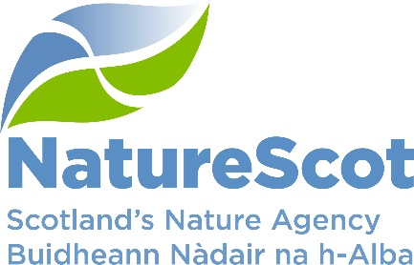

Title: 2022/23 Business Plan
Date: 3rd February 2022
Purpose: | Decision
How does this link with our corporate priorities of improving biodiversity or delivering nature-based solutions to climate change | This paper is a necessary step in the development of the NatureScot Business Plan 2022/23. Our Business Plan is a key part of Scottish Government’s framework of governance and accountability. The Year 1 Business Plan will be agreed by Board and submitted to our Minister. The Business Plan will set out our contribution to the 6 NPF indicators we report on and how we will deliver our Outcomes.
Summary: | Our Year One Business Plan for 2022/23, sets out how we plan to deliver the first year of our Corporate Plan: A Nature Rich Future. SLT and Board, through a process of action learning set exploration, have agreed our core offers over the coming four years with a focus on protecting, restoring and valuing nature.  The Business Plan focuses on our leadership ambition and the work we will do to position nature-based solutions in response to the climate emergency and the loss of biodiversity; moving us towards a nature-rich future. It reflects how our Core Offers will support Activity and Area teams to respond to this challenge and deliver our outcomes through their combined work.
Actions | Board to note the budget allocations following the settlement on 9th December and that the draft business plan is sufficiently robust to deliver our Outcomes.
Recommendations: | Board is asked to:  - Provide feedback on the draft Business Plan.  - Confirm they are content with the progress to confirm resourcing of the Year 1 Business Plan detailed in para 11.  - Note the budget position after the confirmed settlement on the 9th of December
Report Author(s):  Sponsor: | Author – Yvonne McIntosh  Sponsor – Stuart MacQuarrie
Appendices: | Annex A – Draft Business Plan  Annex B – Budget Settlement  Annex C – Resourcing the Year 1 Business Plan

Purpose
- This paper presents the Year One, draft NatureScot Business Plan for 2022/23. The plan sets out our intention to put in place a programme of work that focuses our twin strategic priorities of addressing the nature and climate change crisis. It positions us as Scotland’s nature agency with overall responsibility for leading on halting the loss of biodiversity, leading Scotland towards a nature-rich future.

Background
- This Business Plan is the next phase of our business planning approach after the core offers and direction for NatureScot were set out in the draft Corporate Plan. The steer these provided has been used to lead the project commissioning round and support preparation of the Activity and Area Summaries.
- This paper represents the latest draft of the business plan. It is almost fully developed but requires further work to finalise the overall narrative and the resources section that supports this. This will be complete by the BOARD meeting in February.

Budget Uncertainty and Resources
- Board considered the allocation of budgets in October and approved budget planning to continue based on the assumption of a flat cash settlement. Following the Scottish Government’s budget announcement we can now confirm that our core Grant-in-Aid will be £49.561m. This includes a £1.8m capital budget and budget for non-cash of £2.150m, making the resource allocation £45.611m. The table below shows an overall impact on our resource budget after inflation of 4.2% or £2.181m. Capital included a £1m uplift for GovTech during 2021/22.

Budget | 2021/22 | 2022/23 | Change (%) | Change (£m)
GiA | £50.209 | £49.561 | -1.3% | -£0.648
Ring-fenced | £1.000 | £0.750 | -25.0% | -£0.250
Total | £51.209 | £50.311 | -1.8% | -£0.898
Non-cash | £2.150 | £2.150 | 0.0% | £0.000
Capital | £2.450 | £1.800 | -26.5% | -£0.650
Ring-fenced | £1.000 | £0.750 | -25.0% | -£0.250
Operating | £45.609 | £45.611 | 0.0% | £0.002

2022/23 with RPI (3%) | Change (%) | Change (£m)
£51.72 | 4.2% | £2.15
£0.750 | 0 | £0.00
£52.465 | 4.1% | £2.15
£2.150 | 0.0% | £0.00
£2.52 | 28.7% | £0.72
£1.03 | 27.2% | £0.28
£47.792 | 4.6% | £2.181

- This is in line with our modelling and will result in an overall operating project budget of £12.961m, which represents a 1% reduction over 2021/22. A breakdown of the figures can be found in Annex B – Budget Settlement.
- We are still to review funding requests and allocate budget to any of next year’s projects. Projects will be approved following Board approval of the final Plan in March.

Risks & Issues
- The most significant risk to the Business Plan is that it lacks full alignment to our new Corporate Plan and/or our intent is not matched by required resource. Leaders and Team Managers will play a crucial role in helping staff to set their work objectives and priorities during their monthly performance management conversations. This year we will provide promotion of the Corporate Plan through the Winter Carnival sessions during Q4. This will cover the key aspects of the plan and how the work that we all do supports its delivery.
- Alongside strategic risks, there may be other threats in delivering each Activity’s contribution to the Business Plan. As such, all Activity Managers will be asked to review their Risk Registers to ensure these are being appropriately captured and subsequently managed.
- Measurement of the business plan is essential to be able to evidence progress towards our Corporate Plan. Currently, the measures stated in the business plan are still in development. The measures included in the business plan have been proposed in the Strategic Development paper and will be finalised based on feedback from Board received on that paper. The measures within the Business Plan will align directly to our new Corporate Plan. The Business Plan also presents a year-end summary of anticipated successes.

Resourcing the plan
- Resourcing of the Year 1 Business Plan is still in development with discussions ongoing with Scottish Government officials exploring options to deliver the Programme for Government. Resource demands are being collated and where possible networked teams will be used to utilise resource from within the organisation rather than recruiting new posts. Where this is unavoidable, a solution will be recommended by Resourcing Group in February.
- The current paybill figure forecast for 2022/23 includes an uplift of £0.500m to offset the impact of additional funding of these posts. With estimated savings of c£0.500m realised each year from the paybill, this provides cover of £1m. Any additional funding received to relieve staffing pressures will result in a potential release of funding to the project budget.
- There are 46.5 non-funded posts identified. 29.5 FTE Programme for Government resources and 17 FTE of expected visitor management pressures and priorities emerging from the new Scottish Biodiversity Strategy. These are Annex C – Resourcing Year 1 Business Plan provides details on resourcing pressures. This figure is still to be finalised and may shift slightly after submission of this paper. Decisions on funding will be taken during January after the ministerial meeting and potential savings to offset costs are being identified through the Corporate Plan paper.

Next Steps
- Feedback from Board will be incorporated into the draft Business Plan for the next SLT meeting in February.
- Sponsor will continue to be engaged over the implications of Business Plan priorities and resourcing. Discussions will help build a common understanding of resource pressures and capacity.
- Projects will be approved after the Board meeting, with the exception of fixed costs and those with prior approval.

Recommendations
- Board is asked to:
  - Provide feedback on the draft Business Plan.
  - Confirm they are content with the progress to confirm resourcing of the Year 1 Business Plan detailed in para 11.
  - Note the budget position after the confirmed settlement on the 9th of December

Annex A – Business Plan

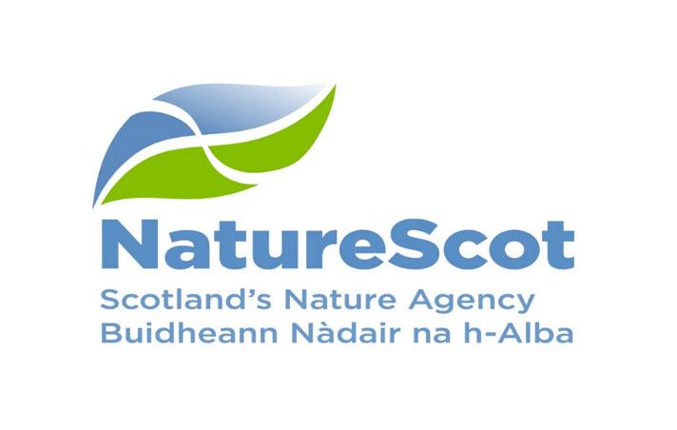
Business Plan 2022/23
Year One of a Nature Rich Future

Protect.Restore.Value

Introduction
NatureScot is Scotland’s nature agency. We work to improve nature in Scotland and inspire Scotland’s people to care more about it. This is the first annual business plan in support of A Nature Rich Future for All - our Corporate Plan for 2022-2026.
A lot has changed in the last 4 years. What has become clearer than ever though is that nature and the climate are in crisis. It is also clear that the link between the nature crisis and the climate emergency is so strong it makes no sense to tackle both separately. Big problems need big, bold actions. The Scottish people have laid down the challenge to get on with it. The Scottish Government along with nations around the world, is responding with new agreements, policies, investments and action. But, we need to urgently pick up the pace.
Our vision is clear. A nature-rich future is the only credible one for Scotland and it means radically changing how we use the land and sea to meet nature’s needs and to unleash the power of nature to solve our problems. Nature must be the first choice in helping people in Scotland to deal with the impacts of climate change and other problems in society. To achieve this we will focus on three priorities:
- Protecting Nature by expanding protected areas, regulating species management, and delivering effective planning advice on land and at sea
- Restoring Nature through a new biodiversity strategy, restoring peatlands, aiding nature’s recovery and transforming farming.
- Valuing Nature so that the many benefits it provides to society can in turn attract public, private and social enterprise expertise, support and financing for both protection and restoration.
We know that we cannot deliver a nature-rich future on our own. So, we want to work with partners across Scotland’s public sector. We also need to work with managers of the land and sea, local communities and businesses, and with the third sector towards a net zero nature-rich future.
We know that if we restore nature it can also contribute as much as 40% of the carbon emissions reductions needed to fuel Scotland’s drive for net zero carbon emissions by 2045. Overall management of the land and sea must be in line with limiting global warming to 1.5°C. Meanwhile, we must build our resilience and adapt to the warming that is already happening.
It’s important that no-one is worse off in the shift to a nature-rich, net zero Scotland. It is equally important that its benefits are shared equally. This means investment in nature needs to create good jobs, strengthen communities and support businesses.
That will lead to significant change. We won’t have a nature-rich future unless we value nature more. Human, social and economic capital are all necessary ingredients for our prosperity. Natural capital is now being added to that list. Decision makers and investors will do things differently if society, and its institutions, rules and regulations place more value on the benefits of nature.

2022/23 Focus

The Scottish Government’s Environmental Strategy for Scotland states that “We have a clearer picture than ever before of the crises in our climate and our natural world. Global assessments have highlighted the scale and urgency of action needed to avoid the worst impacts of climate change and to halt the loss of the Earth's biodiversity.” Our vision of a nature rich future for all aligns with the Strategy’s vision of ‘One Earth. One home. One shared future’.
With the Scottish Government, we lead on the development and delivery of the Scottish Biodiversity Strategy. The strategy is due to be launched in late 2022. It will guide our efforts to protect and restore nature in Scotland for the rest of this decade.
To deliver our work we promote nature-based solutions, which deliver multiple benefits and can help to fix societal problems. Working with nature will provide benefits for both human well-being and biodiversity.
Our Natural Capital are the elements of nature that provide benefits to people – species, habitats, soils and and seas and we use it to ensure that we account for all the benefits that nature provides. It also ensures that we can account for damage to nature.
Using the Just Transition principles we will support a net zero and climate resilient economy in a way that delivers benefits to all. And by applying a place based approach to our work will help achieve a thriving, healthy and safe Scotland where people are connected with, and benefiting from nature.
The Programme for Government (PfG) further supports this by committing to deliver a ‘Fairer, Greener Scotland’. We will respond to the commitments in the PfG through a range of activities:

- Promote land management practices which protect and enhance nature through the Agri-Environment Climate Scheme programme by improving water quality, managing flood risk and mitigate and adapt to climate change and improve public access.
- Delivering deer, grouse and wildlife management solutions to protect sites, species and support effective land management
- Protect 30x30 on land and sea with a further 10% highly protected in marine areas to safeguard our ecosystems
- Support the development of at least one new National Park which will preserve the natural environment
- Deliver a new £13m Nature Restoration Fund supporting projects that address the biodiversity and climate crisis by putting Scotland's species, woodlands, rivers and seas back on the road to recovery
- Steer the delivery of ScotWind developments to help promote Scotland as a world leader for offshore wind
- Further advance the Natural Capital Pilot Programme
- Lead peatland restoration to restore the millions of hectares of peatland in poor condition across Scotland
Our priorities focus on Protecting, Restoring and Valuing Nature. During 2022/23 we will focus on keys area of work to significantly progress us towards our Corporate Plan goals. All of our work is supported by the NatureScot Way approach, inspiring others and putting our expertise at the heart of Scotland’s future. To evidence delivery of our annual Business Plan, we have included key performance indicators which cover the areas of work. Our progress against these will be reported through our Annual Report and Accounts.
Protecting Nature
Strengthened protection of existing biodiversity
The degradation of nature threatens our society and the wellbeing of future generations. A nature-rich future starts with halting this decline by protecting what we have now.
During 2022/23 we will:
- Develop and publish of a framework for delivery of 30x30 on land and at least one new national park
- Deliver species management recommendations developing new deer management legislation and revised beaver, and white eagle management frameworks.
- Deliver an enabling and responsive licensing service including developing new licencing approaches for grouse moor management and muirburn.
- Deliver invasive non-native species controls and address the biodiversity impacts of established invasive non-native species
- Engage and influence the planning and other regulatory regimes including marine planning and fisheries management frameworks to ensure they deliver for nature and climate

What does success look like?
- More of Scotland is under additional legal protection and plans are being prepared to secure additional protection
- New frameworks to manage species conflicts are in place which secure species protection
- Greater protection for nature is secured through activities relating to development management, fisheries and marine management

Measures of success

- % area of land protected for nature
- Area (hectare) of woodlands restored
- % of licenses that comply with regulations
- Number of MPAs that we have monitored
Restoring Nature
Halt the loss of Biodiversity by 2030 and restore nature by 2045
Protecting the nature we have will not be enough to secure or maintain net zero, or to turn the corner into a nature positive future, for the sake of what it provides for us and its intrinsic value. We must also restore nature’s lost abundance and variety.
During 2022/23 we will:
- Co-lead the production of the new Scottish Biodiversity Strategy and develop targets to include in a new Natural Environment Bill
- Deliver an increase in the hectares of peatland put on the road to recovery
- Develop new approaches, with SG and other delivery bodies, to achieve a step-change in the scale of peatland restoration
- Deliver a major Nature Restoration Fund targeted at high impact nature recovery projects and drawing in greater investment from the private sector
- Trial agriculture transformation through Piloting Outcome Based Solutions scheme and a Farm Biodiversity Audit test programme and delivery of the Agri-Environmental Scheme

What does success look like?
- We have shaped a world leading strategy to restore Scotland’s biodiversity with an ambitious action plan and broad support for delivery
- More nature is on the road to restoration through delivering a range of existing and new financial incentives
- We have developed a natural capital assessment template and biodiversity audit that will enable all farmers to take action for nature.

Measures of success
- Area (hectares) of enhancements through Scottish Marine Environmental Enhancement Fund
- Hectares of land managed under plans (future measure (% of plans meeting targets)
- Area (hectares) improved for habitats and species through the nature restoration fund
- Area (hectares) of peatland restored

Valuing Nature
The value of nature is reflected throughout public and private sector policy, strategy and investment towards a wellbeing economy
We will come to value nature for what it does for people, as well as its intrinsic value, fully accounting for it in what we do. Doing so will create the conditions to do more to protect our natural capital and to secure wider investment in nature.
During 2022/23 we will:
- Help develop the new regulatory, policy, market and institutional infrastructure needed on Private Investment in Natural Capital and establish a programme of investment readiness support
- Develop a spatial investment prospectus for Scotland and pilot an initiative on our own land with a biodiversity metric to guide and verify natural capital public and private investment
- Lead in developing the skills and capacity needed to protect and restore nature and realise its role in addressing societal problems
- Refine, adapt and re-test the Land Holding Natural Capital Assessment Template and develop a Landscape Scale Natural Capital Assessment tool.
- Build the resilience of our National Nature Reserves to support visitor management pressures and ensure positive experiences for visitors

What does success look like?
- The need for nature based skills is widely recognised in support of a green recovery.
- We have a clear set of investment ready proposals for private investment
- Our people related activities strengthen engagement to protect and restore nature.

Measures of success
- Count of people employed in nature based jobs
- % of agricultural schemes that include natural capital approach
- Count of people visiting nature reserves

The NatureScot Way
Our passion, inspiration and expertise will put nature at the heart of Scotland’s future
Our Shared Values are the foundations we build everything on. Our Shared Experience is how we collectively realise our values and Our Shared Behaviours are how we live our values.
During 2022/23 we will:
- Develop and roll out tools to facilitate better collaboration including new intranet and more M365 functionality
- Pilot new ways of working through networked teams and job families to increase flexibility and agility, supporting staff with the development of new skills required to deliver our ambition and create a workforce fit for the future
- Take forward our estates strategy to ensure that our workplaces and how we use them are fit for purpose in a changed world and aligned with our net zero ambition
- Make better use of our corporate and environmental data to inform our decision making through a renewed focus on business intelligence
- Continue to increase the diversity of our workforce and those enjoying nature through partnership action and our programme for youth employment

What does success look like?
- Improved brand recognition
- Improved leadership capability across NatureScot
- Strengthened performance culture
- We deliver our 6% annual emission reduction target towards Net Zero by 2035.
- Successful Corporate Plan launch
- Progress on resourcing

Measures of success
- Workforce diversity
- Brand measure (TBC)
- % of emission reduction

Our Resources

Our funding comprises our Grant-in-Aid of £49.561m plus additional ring-fenced funding for a Nature Restoration Fund and Scotwind Licencing increase our total budget to £64.061m. We also have additional funding that we receive or administer to support and deliver our strategic priorities. Together this provides us with £75.361m to invest in nature.
This investment will contribute to a range of Government priorities, and deliver across all our Outcomes. Through our role in supporting the Agri-environmental Climate Scheme, and administering the European Regional Development Fund (ERDF), in 2022/23, we facilitate the distribution of a one-year commitment of around £4m in agriculture and rural development, and around £11.300m ERDF funding, providing investment in green infrastructure and tourism.

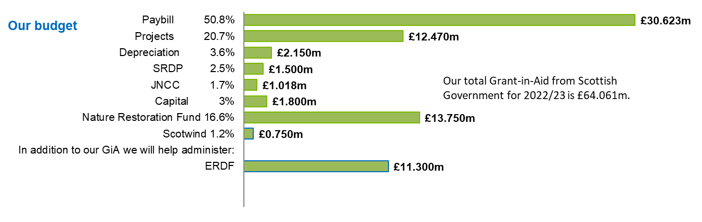
Resourcing our plan
Each year we set out to deliver the Outcomes from our Corporate Plan. To do this our resources are allocated through the activities we undertake. These activities provide an emphasis on flexible working across the organisation. The tables below shows the budget and resource allocation by these activities for 2022/23.
Protecting Nature | £m | FTE
Marine Ecosystems
Protected Areas
Supporting Good Development
Wildlife Management

Restoring Nature | £m | FTE
Biodiversity & Geodiversity
Sustainable Coasts and Seas
Natural Resource Management

Valuing Nature | £m | FTE
People and Places
National Nature Reserves
People and Places

NatureScot Way | £m | FTE
Workplace Facilities and Services
People and Organisational Development
Finance, Planning and Performance
Information and Cyber Security
Technology and Digital Services
Communications
Executive Governance

Total

Annex B – Budget Settlement

Budget | 2021/22 | 2022/23
GiA | £48.058 | £49.561
Scotwind Funding | £0.000 | £0.750
Nature Restoration Fund | £5.000 | £13.750
Biodiversity Challenge Fund (Ring-fenced) | £1.000 | £0.000
Total GiA | £54.058 | £64.061
PAYBILL
Gross | £31.944 | £33.755
Peatland contribution from SG | £0.000 | £2.032
Income and project funding | £3.549 | £1.100
Net Paybill Forecast | £28.395 | £30.623
Position
Total GiA | £54.058 | £64.061
Net Paybill Forecast | £28.395 | £30.623
Non-cash | £2.150 | £2.150
Capital | £2.450 | £1.800
JNCC (Ring-fenced) | £1.018 | £1.018
SRDP (Ring-fenced) | £1.500 | £1.500
Scotwind Funding | £0.000 | £0.750
Nature Restoration Fund | £5.000 | £13.750
Biodiversity Challenge Fund (Ring-fenced) | £1.000 | £0.000
Total Project Budget | £12.545 | £12.470
% reduction over 2021/22 |  | 1%
With 5% over-allocation | £13.172 | £13.094

Annex C – Resourcing the Year 1 Business Plan

Area | Description of work | Year 1 | Yr 1 £m
Nature Restoration Fund | Fund to deliver nature restoration | 5.0 | 13.0
Scotwind – fully funded | Funded delivering Scotwind leasing | 12.0 | 0.5
Natural Capital Pilot Programme | Funded by Scottish Government National Test Programme (ARE Directorate) | 4.0 | 4.0
Highly Protected Marine Areas | Identification of HPMA and engagement with stakeholders. | 2.0
Peatlands ACTION | Funded to deliver Peatland restoration (multi-year fund - will need to escalate during Corporate Plan Period) | 55.0 | 15.0
PfG Commitment - funded |  | 78.0 | 32.5
Wildlife Management | Delivering deer, grouse, protected species | 13.0 | 0.5
30x30 | 30x30 on land & local nature networks - detailed programmes of work still to be developed. | 5.0 | 0.0
Marine Protected Areas | MPA including management plans, stakeholder engagement + 30x30+Nature Networks | 10.0 | 0.0
National Park Commitment | National Park - confirmation of criteria; reviewing proposals; planning boundaries & community consultation | 1.5 | 0.1
Non funded PfG Commitment |  | 29.5 | 0.6
Visitor Management | Implementation of the Visitor strategy outwith 'our' NNRs (including BPF; projects and national SOAC communications) | 8.0 | 2.8
Visitor Management | Managing increased visitor pressure and building resilience on our NNRs - additional seasonal reserve officers and visitor facility/resilience works | 5.0 | 0.5
Biodiversity priorities including species management, INNS, rewilding, translocations and reintroductions | Work to support the emerging SBS priorities – INNS reversing degradation of ecosystem function, species prioritisation and enhancement. Rewilding including link to sustainable soil management, nature networks and green finance. | 4.0
Additional known pressures Year 1 - Non PfG unfunded |  | 17.0 | 3.3
Resourcing the Corporate Plan |  | 124.5 | 36.4

