Research Reports – sample report

Aerial surveys of seals in Scotland during the harbour seal moult, 2016-2019
Morris, C.D., Duck, C.D. and Thompson, D. (St Andrews University, Sea Mammal Research Unit)
This is a sample report showing how NatureScot research report in accessible format should look like. It is not the full report, but it shows main elements that we would expect to see in a report. Please use it together with our report template and accessibility guide which explains what is required under the accessibility legislation.
This report has been published on our website in accessible html format. It will give you an idea on how your report will look like once published.
For any questions on using our template or accessibility requirements please email research@nature.scot.

Keywords
harbour seal; Phoca vitulina; grey seal; Halichoerus grypus; population monitoring; seal distribution; regional trends; Special Area of Conservation

Background
Scotland holds around a quarter of all harbour seals (Phoca vitulina) found in Europe. Information on population size and distribution of harbour seals in Scotland is vital to inform species conservation and management, as well as to fulfil various surveillance and reporting requirements set out in legislation.
The Sea Mammal Research Unit (SMRU) has been undertaking surveys of harbour seals in Scotland for over 30 years, and currently aims to survey the entire Scottish coastline on a five-year cycle. Surveys are carried out during the August moult period, when the numbers of animals hauled out on shore are at their highest and provide a reliable index of harbour seal abundance. The seal count data can also be scaled-up to produce estimates of total harbour seal population. Grey seals (Halichoerus grypus) encountered during harbour seal moult surveys are also counted to provide information on their summer distribution.
Almost the entire Scottish coastline was surveyed by helicopter between 2016 and 2019 to provide the fifth full census of harbour seals in Scotland since the mid-1990s. This report presents these latest results in context of the long-term series of data, and provides an updated assessment of abundance and trends in harbour seals at national, regional, and local scales.

Main findings
- The latest total counts for the whole of Scotland suggest that both seal species are currently doing well on a national scale. During the most recent August surveys of all areas, 26,846 harbour seals and 25,412 grey seals were counted in Scotland. This is the second highest total ever recorded for harbour seals and the highest total recorded for grey seals. Using estimated haul-out probability from telemetry data to scale the most recent counts to population size (Lonergan et al., 2013; Russell et al., 2016), produced estimates of approximately 37,300 (95% CI: 30,500-49,700) harbour seals and 106,300 (95% CI: 88,800-132,400) grey seals.
- However, the latest counts also confirm starkly contrasting regional population trends in harbour seals. Harbour seal numbers are stable or increasing in most areas of western Scotland. Following substantial declines in the 2000s, numbers in northern and eastern Scotland appear to be stable overall, albeit at relatively low levels compared to the 1990s. Orkney has seen an 85% decline in harbour seal numbers since 1997. Although the most recent harbour seal count in Orkney was slightly higher than in 2016, this does not necessarily signify the end of the decline there.
- The latest counts show that more than three-quarters (78%) of all harbour seals in Scotland are currently found in western Scotland (including the Western Isles). This is a significant shift since the 1990s when Orkney and Shetland were proportionally the most important regions in Scotland for harbour seals. Whereas half of all harbour seals counted during the Scotland census in 1996-1997 were recorded in Orkney and Shetland, these regions now only contribute one sixth to the Scottish total.
- Harbour seal SACs are not always reliable indicators of wider populations. The total number of harbour seals counted within Special Areas of Conservation (SACs) has declined continuously since surveys began. There is no sign of harbour seal numbers recovering in those SACs that have seen the largest declines, namely Sanday SAC, Mousa SAC, Dornoch Firth and Morrich More SAC, and Firth of Tay and Eden Estuary SAC. The most recent counts for these SACs were 90-98% lower than the maximum counts recorded in the 1990s. In some cases, declines observed in SACs are balanced by significant increases in adjacent areas. The reason for this is unknown.
- Ongoing studies, funded by the Scottish Government, are attempting to identify the most likely driver(s) affecting the large regional declines observed in harbour seal populations. Among the possible causes being investigated are predation by orcas (Orcinus orca) and by grey seals, competition with grey seals, algal toxins, and diseases.
- The August counts suggest that grey seal numbers are stable overall. The high variability of grey seals hauled out at this time of year makes it difficult to identify clear trends. A significant increase has occurred in East Scotland, due to grey seal numbers hauling out at the Ythan River mouth, north of Aberdeen, making it the single largest haul-out site in Scotland.

Acknowledgements
Helicopter surveys around the whole of Scotland were primarily funded by NatureScot, with additional funding from Marine Scotland. Fixed-wing surveys in the Moray Firth and the Tay and Eden Estuaries were funded by the UK Natural Environment Research Council (National Capability Grant no. SMRU10001).
We are very grateful to PDG Aviation Services and their pilots and ground crew, engineers, and operations staff, who were all crucial in enabling us to conduct the surveys in a safe and efficient manner. Many thanks to Tim Whittome at Caledonian Air Surveys Ltd and Bill Giles of Giles Aviation for their help with the Moray Firth and Firth of Tay flights, as well as to Gordon Smith for piloting the survey of offshore islands.
We would also like to thank the TRAKKA team in Sweden, especially Danny Allen, for their help in getting our camera system up and running in time for the 2016 surveys, and for their efforts to further customise and improve the software ever since.
The Lismore boat survey counts were provided by Jane Dodd, NatureScot. We are grateful to John Baxter and Morven Carruthers at NatureScot for their support in management and administration of the survey agreement.
We are also very grateful to Debbie Russell for her valuable comments on this document.

Abbreviations
Natural Environment Research Council (NERC)
Oslo-Paris Convention for the Protection of the Marine Environment of the North-East Atlantic (OSPAR)
Special Area of Conservation (SAC)
Seal Management Area subdivision (SMAsd)
Sea Mammal Research Unit (SMRU)
Site of Special Scientific Interest (SSSI)

Table of contents
Keywords 2
Background 2
Main findings 2
Acknowledgements 3
Abbreviations 4
Table of contents 4
Introduction 5
Methods 5
Survey methods 5
Helicopter thermal-imaging surveys around Scotland 6
Fixed-wing surveys of sandy estuaries and offshore islands 6
Data analysis 7
Counting and mapping 7
Data presentation 7
Results 7
Harbour seals around Scotland 7
Summer distribution of grey seals in Scotland 8
Seal Management Areas (SMAs) 8
Southwest Scotland SMA 8
West Scotland SMA 8
Discussion 9
Harbour seals 9
Grey seals 9
Conclusion 9
References 10
Figures 13
Tables 20

Introduction
The Sea Mammal Research Unit’s seal count surveys play a central role in gathering knowledge on the size, distribution, and status of seal populations in the United Kingdom (UK). The Natural Environment Research Council (NERC) is obliged to submit this information to the Scottish Government and to the Department of the Environment, Food and Rural Affairs (Defra) under the Marine (Scotland) Act 2010 and the Conservation of Seals Act 1970 respectively. The most recent advice is available from St Andrews University Sea Mammal Research Unit. The surveys also provide information required to satisfy surveillance and reporting obligations under the Habitats Directive (and Habitats Regulations as amended in Scotland), including in relation to the conservation status of seals within Special Areas of Conservation (SACs), as well as requirements to assess the status of the marine environment through OSPAR and under the UK Marine Strategy.
During the introduction of the Marine (Scotland) Act 2010, the Scottish coast was divided into seven Seal Management Areas (SMAs), which are used for reporting numbers of seals counted and for calculating Potential Biological Removal (PBR) values at a regional level. The largest SMA, West Scotland, was split into three subdivisions, and North Coast & Orkney was split into two subdivisions (Figure 1). These SMAs were divided into smaller Subunits, generally containing several tens of kilometres of coastline, to facilitate the analyses of abundance and distributional changes at a more local scale (Figure 2).
This report presents the results from the most recent series of aerial surveys carried out around the whole of Scotland, from 2016 to 2019, in the context of previous findings at a national, regional, and local level. These data represent the fifth full Scotland census of harbour seals obtained over the last 25 years.
Figure 1
Figure 2

Methods

Survey methods
All surveys were limited to the August harbour seal moult period and followed the standard SMRU protocol. Survey windows were restricted to periods within two hours either side of low water occurring between approximately 12:00 and 19:00, when haul-out numbers are considered to be relatively high and consistent (Thompson and Harwood, 1990; Russell et al., 2015). The time-of-day rule needs to be relaxed occasionally to enable the surveying of haul-out sites that lie within restricted military Danger Areas, such as the outer parts of the Dornoch Firth and Morrich More SAC in the Moray Firth.
No flights were carried out during or following periods of heavy or prolonged rain, as very wet weather can affect the number of seals hauling out (Grellier et al., 1996). Standard survey altitude was around 300m for helicopter surveys and around 200m for fixed-wing surveys, which is usually sufficiently high to avoid significant disturbance of seals and other wildlife. High-resolution photographs were taken of all seals seen on shore. Cameras were either connected to a GPS unit directly producing geo-tagged imagery (during helicopter surveys) or time-synced to two Garmin Foretrex 401 units that recorded detailed tracks of all flights (during fixed-wing surveys).

Helicopter thermal-imaging surveys around Scotland
Scotland’s highly intricate coastline is over 18,000km long, including over 800 islands (Baxter et al., 2011). Seals are found in almost all Scottish coastal areas, and the only method currently available, to search the entire coast in an efficient manor, is by helicopter. All SMRU helicopter surveys were carried out with a Eurocopter AS350/AS355 Squirrel aircraft. The standard survey altitude was around 300m or lower and the aircraft generally remained a few hundred meters offshore where possible. Flying speed was over 100kts when scanning straight sections of coastline, but was reduced significantly when surveying more complex shorelines or areas with high concentrations of seals.
Rocky shores make up the vast majority of Scotland’s intertidal areas, and seals are often extremely well camouflaged when lying on rocks or seaweed. It would be impossible not to miss large numbers of hauled-out seals in this environment without using an infrared (IR) sensor. IR cameras use heat radiation to produce a thermal image, enabling the detection of warm bodies on a cooler background (Figure 5). Since 2016, SMRU has been using the multi-sensor camera gimbal SWE-400 by Trakka Systems, which has an integrated mapping and data recording system (Figure 6). The gyro-stabilised gimbal contains a thermal imaging video camera, a high-definition colour video camera, a Nikon D810 photo camera fitted with a 300mm lens, and a laser range finder. When conducting a survey both videos are recorded continuously. High-resolution photographs are taken of all seals detected with the thermal image. Time stamps and GPS coordinates are saved with all video and still image data. Breadcrumbs of the flight track and polygons of the areas covered by the sensors’ field of view (FoV) are saved in a metadata file.
Table 1

Fixed-wing surveys of sandy estuaries and offshore islands
In the annually surveyed areas in the Moray Firth and in the Firth of Tay and Eden Estuary SAC, the vast majority of seals haul out on sand. Because seals are much easier to see in this environment, and haul-out locations are well known, these areas are generally surveyed by fixed-wing aircraft using hand-held photography. A DSLR camera fitted with a 70-300mm zoom lens is used to take images of all seals encountered. The most commonly used aircrafts are a Cessna 172 and a Piper PA-23-250 Aztec. Surveys are carried out at an altitude of 200m or lower. Standard flying speeds vary between 70-100kts depending on aircraft type and wind conditions.
Figure 5
Figure 6

Data analysis

Counting and mapping
The video recordings were reviewed using the TM-100 software’s playback function, to ensure that no obvious seal groups were missed (i.e. not photographed) during the survey. The high-resolution photographs were scrutinised in conjunction with the thermal video to obtain precise counts of harbour seals and grey seals. All seals resting on land were counted, including partially submerged animals and potential pups of the year. Large groups of seals were counted in Photoshop using the in-built Count Tool or by using iTag, an open source software developed for counting seals on digital photographs (Viquerat, 2015). Counts were added to a GIS map showing the helicopter flight track and image locations (Figure 7).
Figure 7

Data presentation
The census totals were calculated by combining the most recent survey data available within each census period. The most recent survey coverage for the 2016-2019 census is shown in Figure 4. The census counts are presented in a table showing totals by SMA (subdivision). These data were also aggregated by 10km squares in order to visualise the Scotland-wide distribution.
Line graphs that help identify potential trends in the time series of SMA counts were created by plotting all years containing significant coverage of an SMA. If the SMA was not surveyed in its entirety in a given year, counts from the previous survey were included to represent the whole SMA. Indeed, the lines plotted for all seven SMAs contain data points made up of counts from more than one year. The larger a study area becomes, the more likely it is to require data collected in multiple different years to produce a total count. The vast West Scotland SMA has never been surveyed in a single year, so all plotted data points are based on surveys carried out over two or three years. Such amalgamation of counts over multiple years, although necessary, can potentially mask or delay detection of trends in abundance. Care should be taken when interpreting data presented in this way.

Results

Harbour seals around Scotland
The total number of harbour seals counted in Scotland was 26,846, based on data collected during the most recent surveys from August 2016-2019. This is 9% lower than the 1996-1997 census, but 6% higher than the previous count in 2011-2015, and it is the second highest Scotland total overall (Table 2). The August seal counts can be used as an index of total population size and are generally reported without converting them into absolute abundance estimates. In 2013, Lonergan et al. used ARGOS telemetry data from flipper tags to estimate the mean proportion of the population hauled out during the standard survey window (i.e. available to count). Using their results (0.72; 95% CI: 0.54-0.88) together with the latest count data produces a total population estimate for Scotland of approximately 37,300 (95% CI: 30,500-49,700) harbour seals.
The Scotland-wide distribution of harbour seals, based on the newest census data, is mapped by 10km squares in Figure 8. The highest density areas are now found in West Scotland, the Western Isles, and Shetland rather than in Orkney, where the highest concentrations were found in the 1990s (Figure 9). The West Scotland SMA and the North Coast & Orkney SMA both contributed 30% to the Scotland total in the 1996-1997 census, but since then the proportion of all harbour seals recorded in the former has doubled, while the proportion in the latter has dropped to 5% of the total (Figure 10).
Table 2

Summer distribution of grey seals in Scotland
In August, counts of harbour seals are relatively stable from day to day because they need to spend extended periods on land in order to moult efficiently (Paterson et al., 2012). Grey seals at this time of year, on the other hand, are only hauling out to rest between foraging trips, resulting in a higher variability in haul-out counts. In addition, because grey seals can haul out in much larger groups, containing several hundreds or even thousands of individuals, the counts made at a small number of potentially large haul-out sites can greatly affect the totals calculated for Subunits or SMAs. For these reasons, summer counts of grey seals should be interpreted with caution.

Seal Management Areas (SMAs)
The following pages present counts by Subunits within Seal Management Area (subdivisions) as shown in Figure 2. Relevant local changes indicated by the counts in the data tables are highlighted in the text.

Southwest Scotland SMA
Harbour seal counts by Subunits within the SMA are given in Table 4. The most recent survey in 2018 recorded the highest count of harbour seals for the SMA and was 40% higher than the previous maximum in 2015. Since surveys began, numbers found in the far south-west of Scotland, in Dumfries and Galloway (Subunits 1-4), have remained very low. Counts have been increasing in the Firth of Clyde, especially in northern and western areas such as in Loch Fyne and along the eastern shore of Kintyre (Figure 16).
Figure 16
Table 4

West Scotland SMA
Harbour seal counts by Subunits within the three SMA subdivisions are given in Table 6, Table 7 and Table 8. The large West Scotland SMA has contributed 50-60% to the total Scottish count of harbour seals since the mid-2000s (Figure 10). The count has increased significantly from around 8,800 in 1996-1997 to 15,600 in 2017-2018 (Table 2). Numbers found in the southern subdivision have always been high but quite variable (Figure 17) with no clear trend (range: ca. 5,650-7,650). Whereas 64% of West Scotland harbour seals were found in the southern subdivision during the first census, this proportion has gradually decreased to 45%, as numbers in the central subdivision have grown from 2,700 (31%) to ca. 7,400 (48%). Numbers counted in the southern region of the central subdivision have steadily increased since surveys began. In the north-eastern region of the central subdivision counts increased rapidly between 2005 and 2014. The greatest declines within the central subdivision were recorded in northern and western Skye between 2000 and 2007. The highest ever numbers were observed in all three of these central regions during the most recent surveys in 2017/2018 (Figure 18).

Discussion

Harbour seals
During their recent examination of the status of harbour seals in the UK, Thompson et al. (2019) used count data collected up until August 2017 to analyse harbour seal abundance trends within Scottish Seal Management Areas (SMAs) and Special Areas of Conservation (SACs). Additional data, from surveys conducted in 2018 and 2019 and described here, confirm findings by Thompson et al. that the current Scottish harbour seal population is similar to estimates from the late 1990s, but there have been significant declines in some subpopulations and increases in others.

Grey seals
The summer counts suggest that the grey seal population has increased over the last 20 years without any regional declines as observed for harbour seals. This is consistent with grey seal pup production estimates. Pup production in Scotland grew at an almost exponential rate through the 1980s up until the mid-1990s, when production in the Inner and Outer Hebrides, started levelling off (Russell et al., 2019). Production in the other main breeding region, Orkney, followed the same trend around five years later.

Conclusion
The increases in the whole of Scotland total counts of grey seals and harbour seals over recent years suggest that both seal species are currently doing well on a national level. However, there is a major difference between the two species in that there are starkly contrasting regional population trends for harbour seals. Eastern and northern areas, that have seen large declines in the numbers of harbour seals counted since ca. 2000, have shown no sign of recovery. Although it is not possible to calculate trends over short time periods using the approximately 5-yearly snapshots available for most areas, and sudden changes may not be identified very quickly, the duration of the long-term monitoring project allows us to identify overriding population trends. The time series of harbour seals counted within Special Areas of Conservation (SACs) compared with numbers found within 50km of an SAC show that it is not possible to use the existing SACs as indicator sites for the wider population. Seals are highly mobile, and comprehensive surveys are necessary in order to understand whether harbour seal populations are likely to be stable, increasing, or declining.

References
Arso Civil, M., Smout, S., Onoufriou, J., Thompson, D., Brownlow, A., Davison, N., Duck, C., Morris, C., Cummings, C., Pomeroy, P., McConnell, B. and Hall, A.J. 2019. Harbour Seal Decline – vital rates and drivers. Report to Scottish Government HSD2. Sea Mammal Research Unit, University of St Andrews, pp. 46.
Baxter, J.M., Boyd, I.L., Cox, M., Donald, A.E., Malcolm, S.J., Miles, H., Miller, B. and Moffat, C.F. eds, 2011. Scotland's Marine Atlas: Information for the national marine plan. Marine Scotland, Edinburgh.
Carroll, E.L., Hall, A., Olsen, M.T., Onoufriou, A.B., Gaggiotti, O.E. and Russell, D.J.F. 2020. Perturbation drives changing metapopulation dynamics in a top marine predator. Proceedings of the Royal Society B, 287.
Commission of the European Communities, 2003. Council directive 92/43/EEC of 21 May 1992 on the conservation of natural habitats and of wild fauna and flora. As amended by the Accession Act of Austria, Finland and Sweden (1995) and the Accession Act of the Czech Republic, the Republic of Estonia, the Republic of Cyprus, the Republic of Latvia, the Republic of Lithuania, the Republic of Hungary, the Republic of Malta, the Republic of Poland, the Republic of Slovenia and the Slovak Republic (2003). Official Journal of the European Union L 236 33 23.9.2003. Brussels. European Commission 1992/95/2003.
Cunningham, L., Baxter, J. and Boyd, I. 2010. Variation in Harbour Seal Counts Obtained Using Aerial Surveys. Journal of the Marine Biological Association of the United Kingdom, 90, 1659-1666.
Grellier, K., Thompson, P.M. and Corpe, H.M. 1996. The effect of weather conditions on harbour seal (Phoca vitulina) haulout behaviour in the Moray Firth, northeast Scotland. Canadian Journal of Zoology–Revue Canadienne De Zoologie, 74, 1806-1811.
Harvey, J.T. and Goley, D. 2011. Determining a correction factor for aerial surveys of harbor seals in California. Marine Mammal Science, 27, 719-735.
Lonergan, M., Duck, C., Thompson, D., Mackey, B., Cunningham, L. and Boyd, I. 2007. Using sparse survey data to investigate the declining abundance of British harbour seals. Journal of Zoology, 271, 261-269.
Lonergan, M., Duck, C., Thompson, D., Moss, S. and McConnell, B. 2011. British grey seal (Halichoerus grypus) abundance in 2008: an assessment based on aerial counts and satellite telemetry. ICES Journal of Marine Science, 68, 2201-2209.
Lonergan, M., Duck, C., Moss, S., Morris, C. and Thompson, D. 2013. Rescaling of aerial survey data with information from small numbers of telemetry tags to estimate the size of a declining harbour seal population. Aquatic Conservation: Marine and Freshwater Ecosystems, 23, 135-144.
McConnell, B., Fedak, M., Lovell, P. and Hammond, P. 1999. Movements and foraging areas of grey seals in the North Sea. Journal of Applied Ecology, 36, 573-590.
Olsen, M.T., Islas, V., Graves, J.A., Onoufriou, A., Vincent, C., Brasseur, S., Frie, A.K. and Hall, A.J. 2017. Genetic population structure of harbour seals in the United Kingdom and neighbouring waters. Aquatic Conservation: Marine and Freshwater Ecosystems, 27, 839– 845.
Onoufriou, J., Jones, E., Hastie, G. and Thompson, D. 2016. Investigations into the interactions between harbour seals (Phoca vitulina) and vessels in the inner Moray Firth. Scottish Marine and Freshwater Science, 7, 24.
Paterson, W., Sparling, C., Thompson, D., Pomeroy, P., Currie, J. and McCafferty, D. 2012. Seals like it hot: Changes in surface temperature of harbour seals (Phoca vitulina) from late pregnancy to moult. Journal of Thermal Biology, 37, 454-461.
Russell, D.J.F., McConnell, B., Thompson, D., Duck, C., Morris, C., Harwood, J. and Matthiopoulos, J. 2013. Uncovering the links between foraging and breeding regions in a highly mobile mammal. Journal of Applied Ecology, 50, 499-509.
Russell, D.J.F., McClintock, B.T., Matthiopoulos, J., Thompson, P.M., Thompson, D., Hammond, P.S., Jones, E.L., MacKenzie, M.L., Moss, S. and McConnell, B.J. 2015. Intrinsic and extrinsic drivers of activity budgets in sympatric grey and harbour seals. Oikos, 124, 1462-1472.
Russell, D.J.F., Duck, C., Morris, C. and Thompson, D. 2016. Independent estimates of grey seal population size: 2008 and 2014. SCOS Briefing paper 16/3, Sea Mammal Research Unit, University of St Andrews.
Russell, D.J.F., Morris, C.D., Duck, C.D., Thompson, D. and Hiby, L. 2019. Monitoring long‐term changes in UK grey seal pup production. Aquatic Conservation: Marine Freshwater Ecosystems, 29(S1), 24–39.
Special Committee on Seals, (SCOS). 2018. Scientific Advice on Matters Related to the Management of Seal Populations: 2018. Natural Environmental Research Council, Sea Mammal Research Unit, University of St Andrews.
Special Committee on Seals, (SCOS). 2019. Scientific Advice on Matters Related to the Management of Seal Populations: 2019. Natural Environmental Research Council, Sea Mammal Research Unit, University of St Andrews.
Simpkins, M.A., Withrow, D.E., Cesarone, J.C. and Boveng, P.L. 2003. Stability in The Proportion of Harbor Seals Hauled Out Under Locally Ideal Conditions. Marine Mammal Science, 19, 791-805.
Thomas, L. 2019. Estimating the size of the UK grey seal population between 1984 and 2018. NERC Special Committee on Seals Briefing Paper 19/01.
Thomas, L., Russell, D.J.F., Duck, C.D., Morris, C.D., Lonergan, M., Empacher, F., Thompson, D. and Harwood, J. 2019. Modelling the population size and dynamics of the British grey seal. Aquatic Conservation: Marine Freshwater Ecosystems, 29(S1), 6-23.
Thompson, P.M. and Harwood, J. 1990. Methods for estimating the population size of common seals, Phoca vitulina. Journal of Applied Ecology, 27, 924-938.
Thompson, D., Duck, C.D., Morris, C.D. and Russell, D.J.F. 2019. The status of harbour seals (Phoca vitulina) in the UK. Aquatic Conservation: Marine Freshwater Ecosystems, 29(S1), 40-60.
Thompson, P.M. and Rothery, P. 1987. Age and sex differences in the timing of moult in the common seal, Phoca vitulina. Journal of Zoology, 212, 597-603.
Viquerat, S. 2015. iTAG - An open source software facilitating the analysis of count data from still images.

Figures

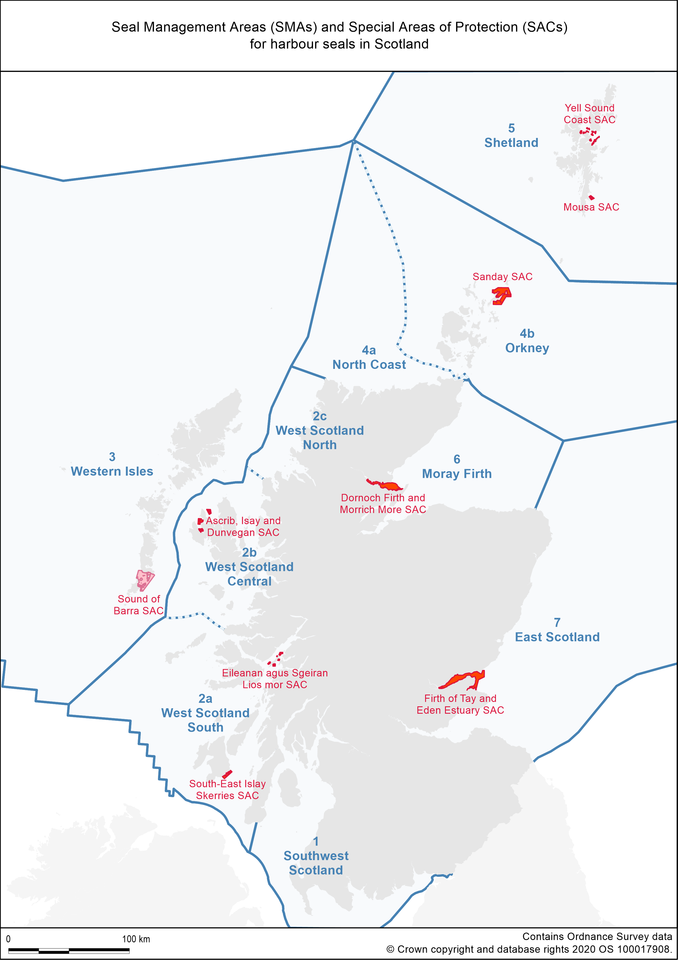

Figure 1
Caption
Figure 1. Map showing the seven Seal Management Areas (SMAs) in Scotland as well as the nine Special Areas of Conservation (SACs) for which Phoca vitulina is either a primary reason for site selection or a qualifying feature.
Alt text
Map of Scotland showing protected areas and management areas for seals
Long description
Subdivision lines for SMAs 2 and 4 are also shown.
Map of Scotland with Seal Management Areas (SMAs) delineated in blue:
1. Southwest Scotland
2a. West Scotland - South
2b. West Scotland - Central
2c. West Scotland - North
3. Western Isles
4a. North Coast
4b. Orkney
5. Shetland
6. Moray Firth
7. East Scotland
The boundaries of nine Special Areas of Conservation (SACs) designated for harbour seals are shown in red:
South-East Islay Skerries SAC
Eileanan agus Sgeiran Lios mor SAC
Ascrib, Isay and Dunvegan SAC
Sound of Barra SAC
Sanday SAC
Mousa SAC
Yell Sound Coast SAC
Dornoch Firth and Morrich More SAC
Firth of Tay and Eden Estuary SA

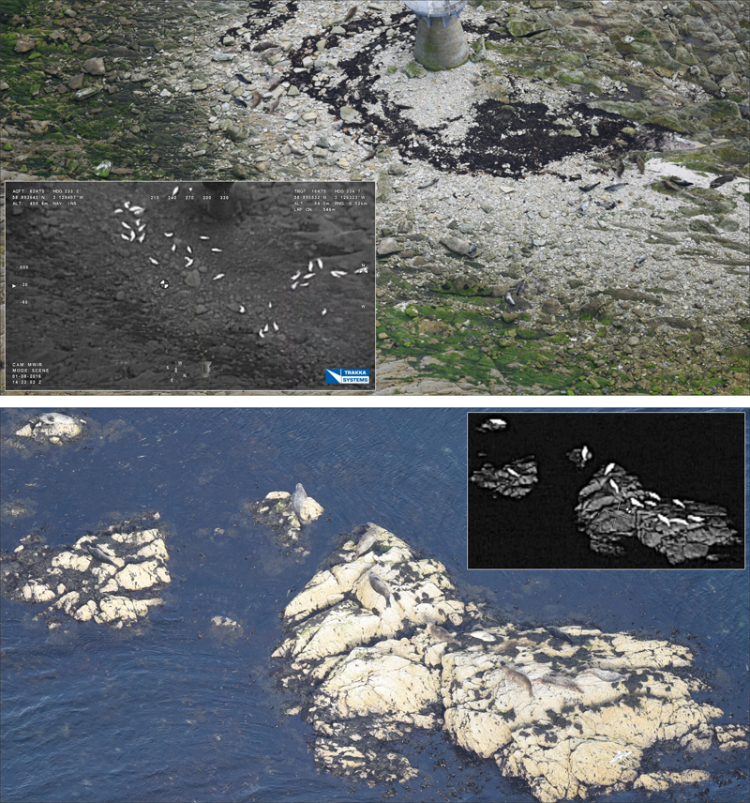

Figure 5
Caption
Figure 5. Examples of cropped digital still photographs with insets showing the same scene recorded by the thermal imaging camera.
Alt text
Seals lying on rocks
Long description
Images of seals on rocks. Seals are difficult to distinguish amongst rock and seaweed in the digital images, whereas they show up white against a dark background in the thermal images.

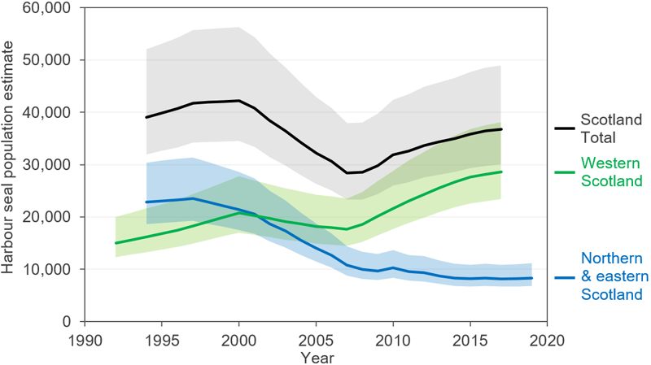

Figure 12
Caption
Figure 12. Harbour seal population estimates based on August haul-out counts and the proportion of the population hauled out during the survey window (Lonergan et al., 2013).
Alt text
Line graph displaying harbour seal population estimates
Long description
Shaded areas indicate 95% confidence intervals. Western Scotland includes SMAs 1-3, northern and eastern Scotland includes SMAs 4-7. Interpolated values were used for SMAs or SMA subdivisions that were not surveyed in a given year. Note that data points are not independent because the same count data are used in more than one point.
Line graph showing harbour seal population estimates, with year along the x axis and estimated population size on the y axis. Estimates along with shaded confidence intervals are provided for Scotland Total (black line), Western Scotland (green line) and Northern & eastern Scotland (blue line). The total Scotland estimate has fluctuated over the period between 1994 and 2017, but is currently similar to the estimate from the mid 1990s. The Western Scotland estimate has increased, while the Northern & eastern Scotland estimate has decreased over this same period.

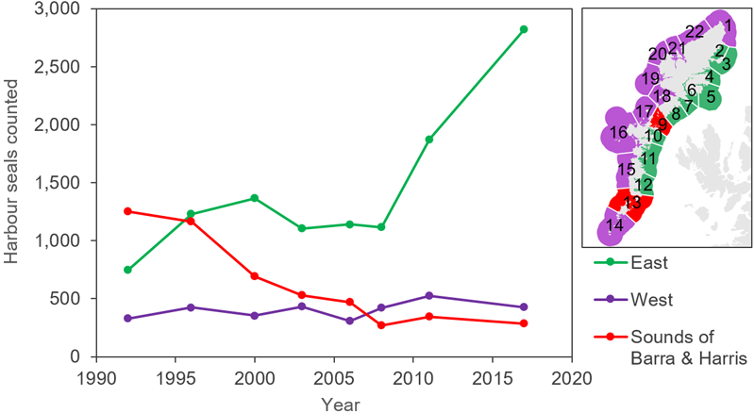

Figure 20
Caption
Figure 20. Regional trends in harbour seal counts within the Western Isles Seal Management Unit.
Alt text
Line graph displaying regional harbour seal counts
Long description
Line graph showing harbour seal counts within Western Isles SMA over the period 1992 - 2017. Counts are shown for three subdivisions within the SMA: East (green); West (purple); Sounds of Barra and Harris (red). Counts have increased on the east, remained relatively stable on the west and decreased in the Sounds of Barra and Harris.

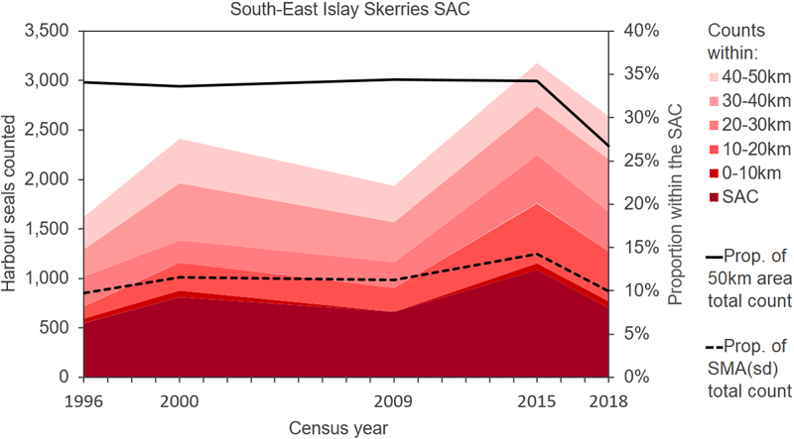

Figure 29
Caption
Figure 29. Harbour seal counts in the South-East Islay Skerries SAC and in 10km wide buffer areas extending up to 10, 20, 30, 40, and 50km from the SAC.
Alt text
Line graph displaying harbour seal counts in the South-East Islay Skerries SAC
Long description
The buffers are based on approximate swimming distances from intertidal areas within the SAC and are shown in Figure 28. The solid black line shows the SAC count as a proportion of the 50km buffer count. The dotted black line shows the SAC count as a proportion of the total count for West Scotland - South.
Line graph showing number of harbour seals counted within South-East Islay Skerries SAC between 1996 and 2018, and within the following buffer distances of the SAC: 0-10 km; 10-20 km; 20-30 km; 30-40 km; 40-50 km. Year is along the x axis, and there are two y axes, one for number of harbour seals counted, and the other for proportion of seals counted within the SAC. The area under the line showing numbers of seals counted within the SAC is shaded dark red, and shading is progressively lighter for counts within each buffered distance. Black and dashed black lines are used to show the proportion of harbour seals in the SAC relative to the 50 km buffer and to the wider Seal Management Area.

Tables

Table 1
Caption
Table 1. Different methods used to find, identify, count, and locate seals during helicopter surveys from 1988 to 2019.
Years | Finding seals | Identifying species | Counting animals | Locating site
1988-2005 | Live video image from hand-operated thermal imager (IR-18 through open side-window) | Thermal image video (few film photographs) | Thermal image video (few film photographs) | Marked paper maps, true colour video
2006-2009 | Live video image from hand-operated thermal imager (IR-18 through open side-window) | Hand-held digital photographs (8/10MP; 70-300mm lens) if available | Thermal image video & hand-held digital photographs (8/10MP; 70-300mm lens) | Marked paper maps, true colour video
2010-2015 | Live video image from hand-operated thermal imager (IR-18 through open side-window) | Hand-held digital photographs (8/10MP; 70-300mm lens) if available | Thermal image video & hand-held digital photographs (8/10MP; 70-300mm lens) | GPS flight tracks, marked paper maps, true colour video
2016-2019 | Live video image from thermal imager in gyro-stabilised SWE400 gimbal | Digital photographs taken with 38MP camera (300mm lens) in SWE400 | Thermal image video, digital photographs recorded with SWE400 | Geo-tagged imagery

Table 14
Caption
Table 14. August counts of harbour seals in the Seal Management Area subdivision ‘North Coast’ by Subunits. Subunit boundaries are shown in Figure 2.
Subunits within  SMAsd 4a - North Coast | 1991 | 1997 | 2005 | 2008 | 2013 | 2016
1 Cape Wrath to Faraid Head | 16 | 0 | 0 | 3 | 0 | 0
2 Faraid Head to Strathan | 147 | 32 | 39 | 0 | 0 | 4
3 Strathan to Strathy Pt | 48 | 92 | 34 | 26 | 14 | 24
4 Strathy Point to Thurso | 0 | 0 | 0 | 0 | 2 | 0
5 Thurso to Duncansby Head | 0 | 141 | 101 | 83 | 57 | 81
6 Sule Skerry & Sule Stack | - | - | 0 | 0 | 0 | 0
Total for SMAsd | 211 | 265 | 174 | 112 | 73 | 109

