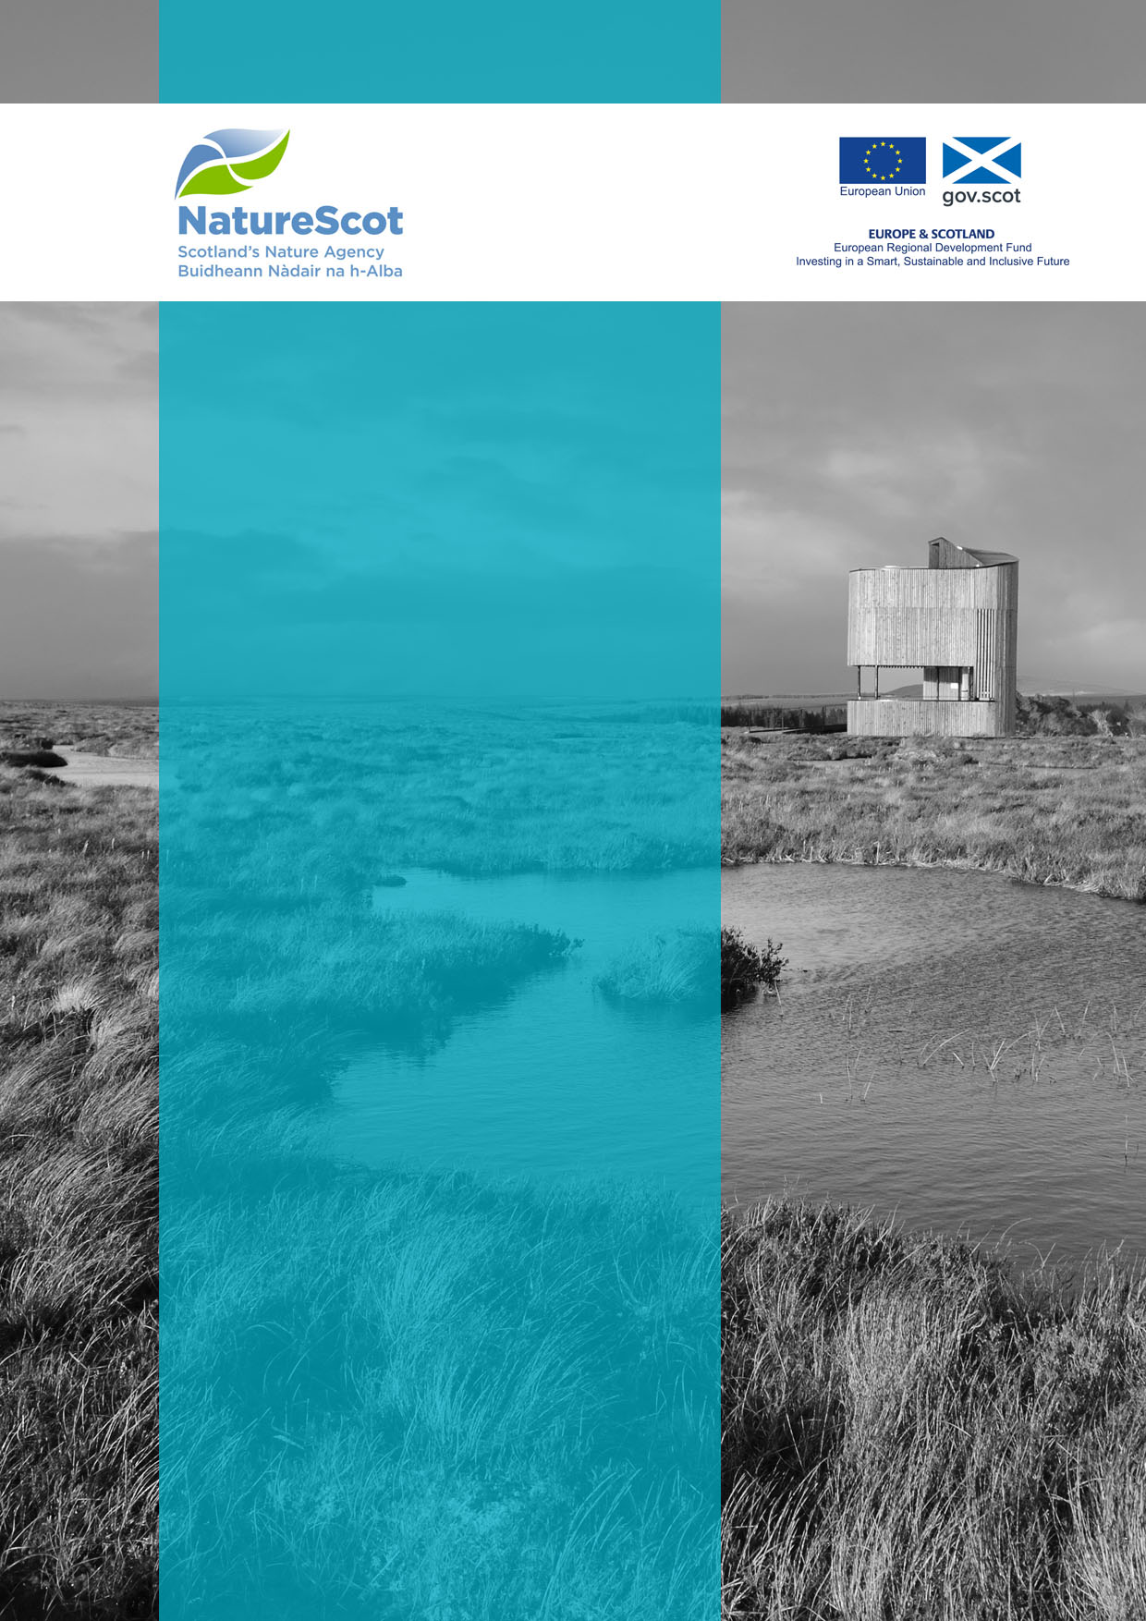

Natural and Cultural Heritage Fund

NCHF Monitoring and Evaluation Plan Template

NCHFAPP-XXX
(Name of Project)

September 2020

Contents
1. Overview of Framework 2
2. Plan 3
3. Timeline 1
4. Roles and Responsibilities 1
Annex 1: Monitoring Progress Report 2

Disclaimer
Scottish Natural Heritage (SNH) has changed its name to NatureScot as of the 24th August 2020. At the time of publishing, this document may still refer to Scottish Natural Heritage (SNH) and include the original branding. It may also contain broken links to the old domain.
If you have any issues accessing this document please contact nchf@nature.scot

Version Control
Date | Issue | Status | Author | Authorised by
24/01/19 | V1 | Draft | SW | EM 2 01 2019
15/09/20 | V2 | Final | EC | EM

- Overview of Framework
The purpose of this document is to provide a template for your Monitoring and Evaluation Plan and is designed to be completed using the Monitoring and Evaluation Guidance document, hereafter referred to as the ‘guidance document’.
This section is designed to give you a brief overview of the Monitoring and Evaluation Framework which is outlined in pages 5 – 8 of the guidance document.
The European Regional Development Fund (ERDF) is an outcomes and results-driven investment programme. It is designed to ensure that investment results in defined impacts for communities. The ERDF horizontal themes flow through the whole programme and should cross-cut across your outcomes. The three themes which should be reflected in your project are:
- Sustainable development
- Equal opportunities and non-discrimination
- Equality between men and women
Each NCHFSI project should also contribute towards our four outcomes and measure progress towards these outcomes through indicators and outcome measures. Monitoring activities will be recorded in the Quarterly Progress Reports. Table 1 below describes the indicators and measures reported on by NatureScot and the grantees.
Table 1 Overview of outcomes, indicators and outcome measures
NCHF Outcomes |  | Result Indicators | Outcome Measures
Heritage assets are more accessible and better promoted  The quality of visitor experience to the heritage assets is enhanced  New products, services and jobs based on heritage assets are sustained and/or created  There is co-ordinated promotion and interpretation of heritage assets across the region |  | Increase in employment in Sustainable Tourism  5% increase in baseline value of 26,200 jobs equivalent to a further 1,310 Full Time Equivalent roles.  Source data is ONS business Register and Employment Survey (BRES) | - Employment Generation  - Visitor experiences and perceptions are positive  - Increase in attendance at heritage events or places of culture or nature  - Increases in length of tourist season  - New products and services  - Increases in opportunities to spend, see and stay  - Improved perceptions of local people
 |  | Reported on by NatureScot | Reported on by Grantee

- Plan
NCHF Strategic Intervention Outcomes
NatureScot is responsible for monitoring progress of all Projects individually and collectively towards delivering the Strategic Intervention’s outcomes.
Project Monitoring and Evaluation plans should indicate progress towards fulfilling these outcomes:
Outcome 1 : Heritage assets are more accessible and better promoted : Awareness of the distinctive heritage assets of the region is increased, making them more accessible and better understood in ways which are consistent with their sensitive management and sustainable use.
Outcome 2 : The quality of visitor experience to the heritage assets is enhanced : The quality of the experience and products on offer to visitors to the region are enhanced through the provision of good quality, accessible facilities and/or information relating to heritage assets, in ways which fill gaps in provision, disperse benefits and encourage or attract visitors to discover and explore responsibly.
Outcome 3 : New products, services and jobs based on heritage assets are sustained and/or created : New products or services based on the region’s natural and cultural assets are developed, creating and/or maintaining jobs, helping to sustain local populations and benefitting local communities. Projects should contribute to sustainable social and economic growth based on sustainable environmental management and productive economic use of natural and cultural heritage assets.
Outcome 4 : There is co-ordinated promotion and interpretation of heritage assets across the region: Aspects of the distinctive natural and/or cultural heritage of the region (such as Gaelic and the region’s music or textiles) are promoted through innovative digital interpretation projects and interpretative media. This should be done in ways which protect the natural and/or cultural heritage assets being promoted, improve accessibility and information for visitors and expand visitor markets.
Horizontal Themes
Horizontal Themes have been set for the entire ERDF programme and all projects receiving ERDF funding must show how they will support each of the Themes. You may wish to refer to the application guidance when addressing these themes.
The Horizontal Themes are:
Sustainable Development
Equal opportunities and non-discrimination
Equality between men and women
Please ensure you address each of the horizontal themes throughout the delivery of your project.
Sustainable development
Sustainable development is described by the European Commission as “specific actions to take into account environmental protection requirements, resource efficiency, climate change mitigation and adaptation, disaster resilience and risk prevention and management”. Please tell us about the impact that your project may have on these, and identify potential mitigating actions which will be undertaken during the delivery of the project.
Equal Opportunities and Non-Discrimination
The European Commission describes Equal Opportunities and Non-Discrimination as taking ”appropriate steps to prevent any discrimination based on sex, racial or ethnic origin, religion or belief, disability, age or sexual orientation during the preparation and implementation of programmes. In particular, accessibility for persons with disabilities shall be taken into account throughout the preparation and implementation of programmes”.
Equality between men and women
The principle of Equality between Men and Women is outlined by the European Commission as ensuring that “…equality between men and women and the integration of gender perspective are taken into account and promoted throughout the preparation and implementation of programmes, including in relation to monitoring, reporting and evaluation.”

NCHFAPP-xxx name of project
Monitoring and Evaluation Plan
Checklist - Please indicate which outcome measures you will/will not measure against.
Table 2: Outcome measure checklist
No. | Measure Name | Y/N
Measure 1 | Employment generation - the number of jobs created in delivering your project and then sustained by it in the long term. This is to be measured by the number of full time equivalent jobs resulting from your project whether through direct employment or in sustaining jobs elsewhere in the community. . | Y – all projects
Measure 2 | Visitor experiences and perceptions are positive - measure of the number of people who have participated in a natural or cultural heritage experience as a result of your project and how they rated their experience.
Measure 3 | Increase in attendance at heritage events or places of culture or nature - measured by the number of adults who have attended or visited a heritage event or place as a result of your project.
Measure 4 | Increases in length of tourist season - the extent to which your project helps to extend the tourist season, expand markets, increase footfall or length of stay to one or more remote and rural area(s).
Measure 5 | New products and services - the extent to which your project offers new products or increases the availability of services to meet customer needs, demands or expectations.
Measure 6 | Increases in opportunities to spend, see and stay - the extent to which your project provides increased opportunity to spend, see and stay in remote and rural areas contributing to economic growth and social sustainability. This can be measured using visitor survey information on length of stay in the area and estimates of spend.
Measure 7 | Improved perceptions of local people - benefits perceived by local people who live in your project’s area such as: the percentage of adults who rate that it is a very good place to live and/or has been improved by your project and the extent to which they have been able to contribute to local decisions.

Example – monitoring and evaluation plan, projects may use this template or their own format
Medium to long term outcomes and measure | Short to medium term outcomes | What are you going to measure? |  | Data Collected |  | Method of data collection |  | Frequency of data collection | Who is going to collect this data?
Project outcome: Visitor experience is improved  NCHF Outcome 1 : Heritage assets are more accessible and better promoted  NCHF Outcome 2 : The quality of visitor experience to the heritage assets is enhanced  Measure 2 : Visitor experiences and perceptions are positive  Measure 3 : Increase in attendance at heritage events or places of culture or nature | More people visiting/engaging with the project | 1. Increased numbers of visitors to project and other local attractions  2. More diverse range of visitors to project and other local attractions (e.g. local/domestic/ overseas/; individuals/groups; people with protected characteristics)  3. Increased visitor satisfaction/propensity to recommend  4. Extended season/opening hours  5.Users of App
 | Wider range of activities on offer | 6. Activity Plan
Project outcome:  Increase in local employment  NCHF Outcome 3 New products, services and jobs based on heritage assets are sustained and/or created  Measure1:  Employment generation | Increase in number of local jobs | 7. Number of visitors staying longer resulting in increased employment in the local area
Project outcome:

NCHF Outcomes:

Measures:
Project outcome:

NCHF Outcomes:

Measures:

Additional lines as required
ERDF Horizontal themes
Sustainable development Demonstrate best practice | Ensure all materials used in the project are sustainably sourced | Environmental impact analysis of product options | Travel miles |  |  |  |  |  | Project officer
Equal Opportunities and non- discrimination  Address social problems and potential inequalities | Target groups which could benefit;  Ensure equality of opportunity for staff employed in the project. | Impact of project on people with protected characteristics | No of people involved in or benefiting from project with protected characteristics  Opportunities for people to meet and interact socially  Engagement with ‘hard to reach groups’ |  | • Visitor Survey  • Project staff review |  | For quarterly reports – staff; per event and by annual visitor survey. |  | Project officer
Equality between men and women  Reduction of gender stereotyping | Ensure equality of opportunities between men and women | Number of men and women involved in the project and project activities | Gender of people involved in or benefiting from project |  | • Visitor Survey  • Project staff review |  | For quarterly reports – staff; per event and by annual visitor survey. |  | Project officer

- Timeline
This section requires you to create a timeline for the monitoring and evaluation activities outlined in the plan produced in section 2. The timeline does not need to go into great detail but must provide clear indication of when monitoring activities will start and finish, this includes activity beyond the end of the project.
The table below is an example.
Please include your timeline as an annex to this document.
 | 2019 |  |  |  | 2020 |  |  |  | 2021
 | Q1 | Q2 | Q3 | Q4 | Q1 | Q2 | Q3 | Q4 | Q1 | Q2 | Q3 | Q4
Baseline data collection
M&E 1
M&E 2
M&E 3
Evaluation Report

- Roles and Responsibilities
Please tell us who will be responsible for collecting, analysing and reporting on data.
Name | Role | Description of Responsibilities
John Smith | Project Officer | Collecting and analysing data on visitors, events and activities

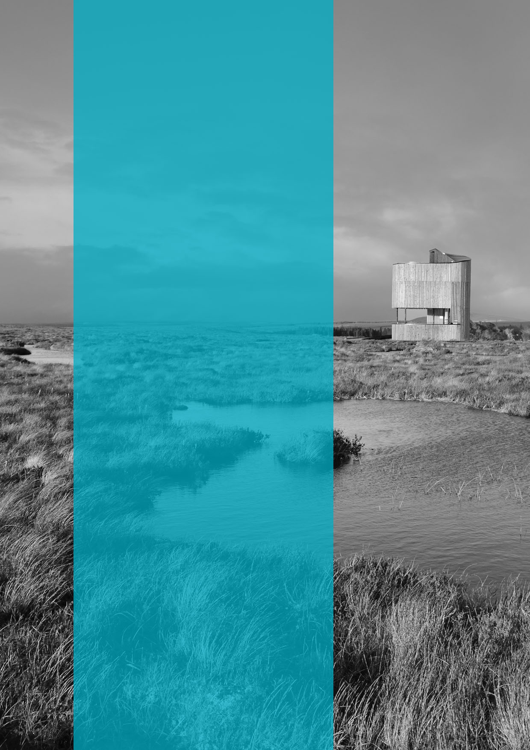

  - Published: September 2020

  - NatureScot
  - Great Glen House
  - Leachkin Road
  - Inverness IV3 8NW

  - 01463 725000

  - www.nature.scot

