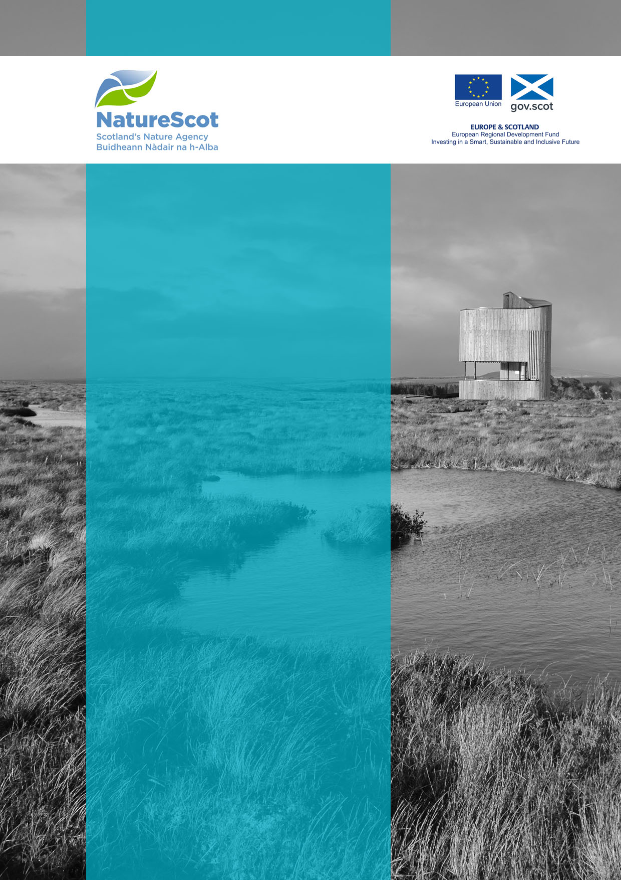

Natural and Cultural Heritage Fund

Equalities Impact Assessment
Template

September 2020

Septembe2019

Version Control
Date | Issue | Status | Author | Authorised by
25/06/19 | V1 | Draft | FS | IR
15/09/2020 | V2 | Final | LC | EM

Equalities Impact Assessment Template

- Application number and name

- Who is the project likely to impact on and how? Does the project have the potential to impact on groups with protected characteristics? Please provide a brief description including any evidence.

- Think about the impact the project/policy will have on eliminating discrimination, promoting equality of opportunity and fostering good relations between different groups. Please also consider whether there is potential for discrimination.
Protected characteristic | What do you know about this group in the context of the project/policy? | What is the potential impact (positive, neutral or negative) on people who share the characteristic? | What could you do to reduce any negative impacts and maximise positive impacts?
Age
Disability
Gender reassignment
Marriage and civil partnership
Pregnancy and maternity
Race
Religion or belief
Sex
Sexual orientation

- Who will be consulted internally or externally on this EqIA?

- Equalities Action Plan - What actions will be taken to ensure any issues identified are addressed during the project?
Issue | Action | Outcome | Monitoring and Evaluation
What is the issue we want to address | What needs to be done? | What will be achieved by undertaking the outline actions? | How will we know we’ve been successful?

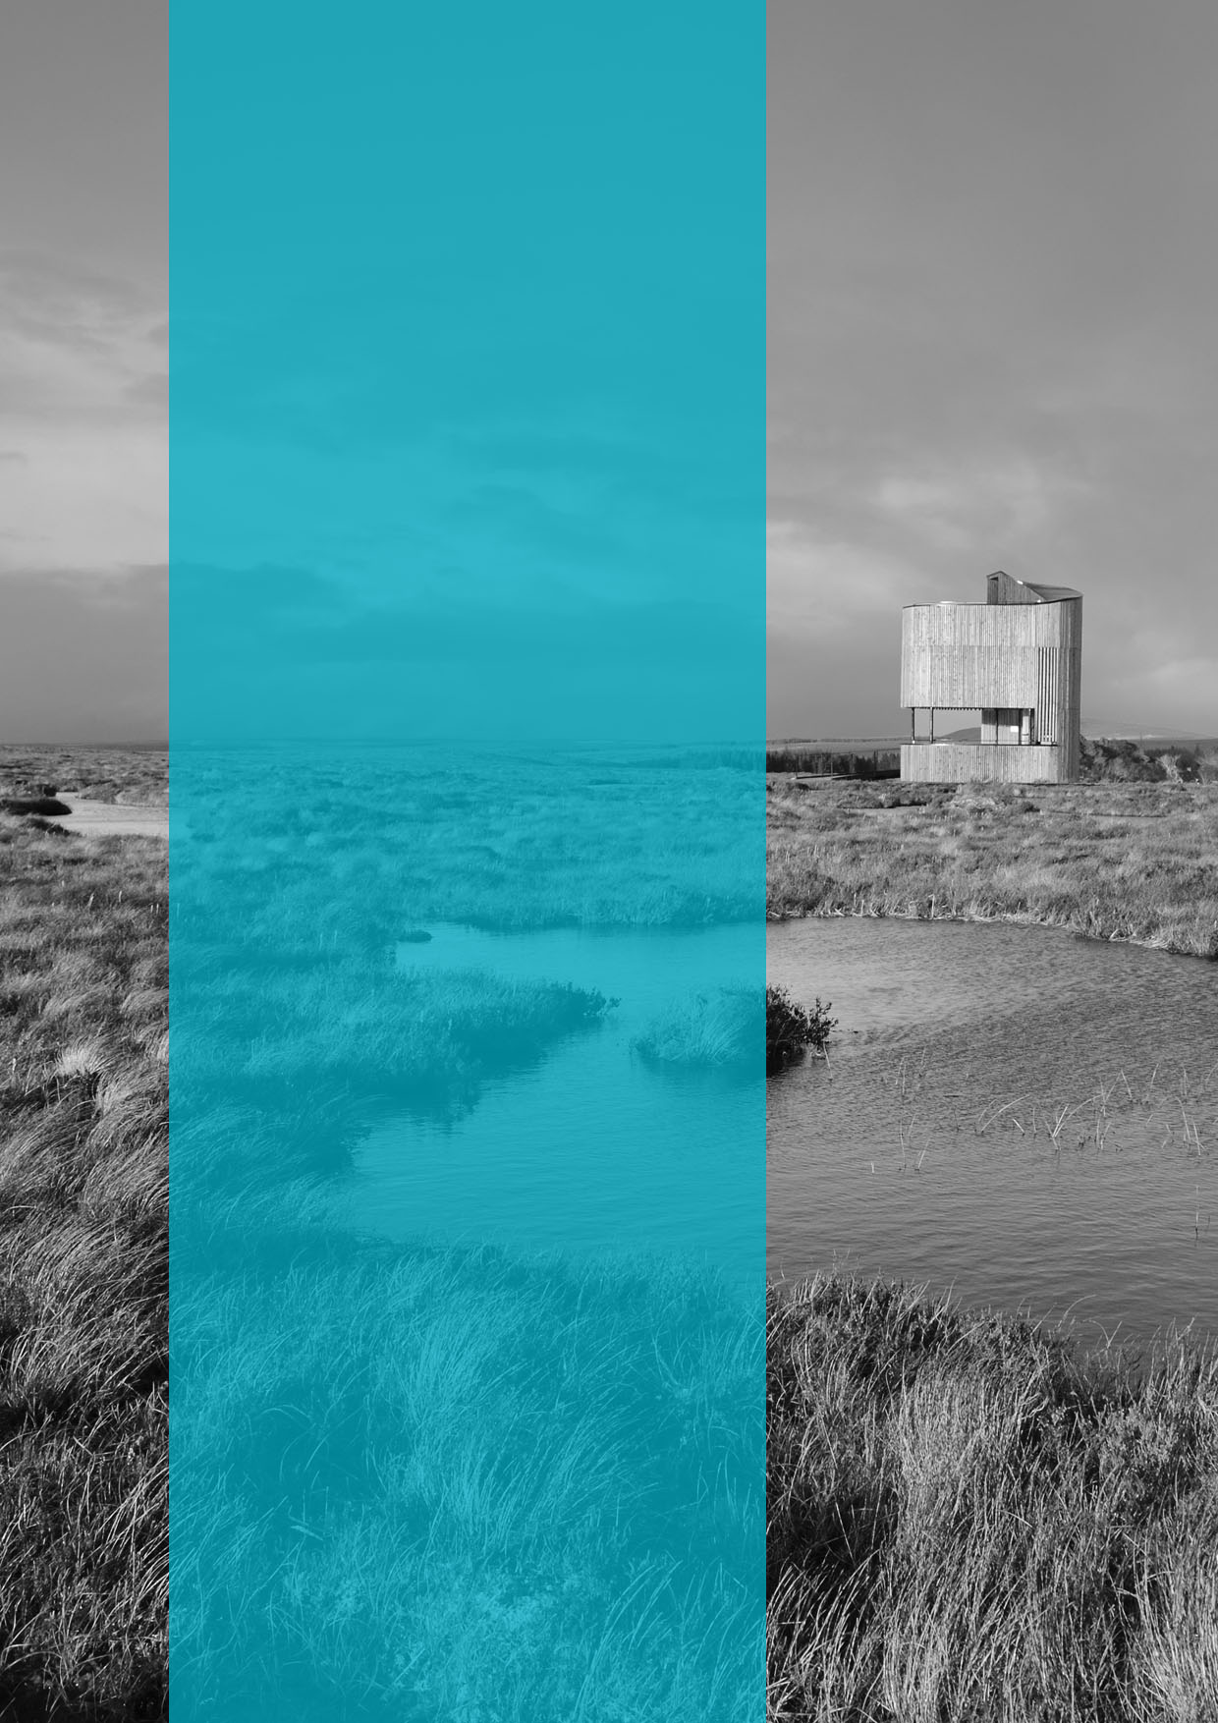
  - Published: September 2020

  - NatureScot
  - Great Glen House
  - Leachkin Road
  - Inverness IV3 8NW

  - 01463 725000

  - www.nature.scot

