Natural and Cultural Heritage Fund

Quarterly Progress Report
Report No. 1

Insert date; e.g.
1st April – 30 June 2020

NCHFAPP-
Project Name:
Grantee:

September 2020

Disclaimer
Scottish Natural Heritage (SNH) has changed its name to NatureScot as of the 24th August 2020. If you have any issues accessing any links within this document please contact nchf@nature.scot

Version Control
Date | Issue | Status | Author | Authorised by
10/09/2019 | V1 | Final | EM | AR
04/03/2020 | V2 | Draft | EM
16/09/2020 | V3 | Final | LC | EM
10/05/2021 | V4 | Final | LC | EM/LL

Lead Partner Details
Lead Partner Details
Strategic Intervention Title | Natural and Cultural Heritage Fund
Strategic Intervention Lead Partner | NatureScot
Name of SI Manager that the Project will report to | Arthur Keller

Grantee Details
Grantee Details
Grantee Organisation Name
Project Manager Name
Project Manager Address
Project Manager Email Address
Project Manager Telephone Number

Submission Details
Report No. | Calendar Year | Period Covered | Date Submitted | Submitted By
1 | 2020 | 01/01/2020 – 31/03/2020
2 | 2020 | 01/04/2020 – 30/06/2020
3 | 2020 | 01/07/2020 – 30/09/2020
4 | 2020 | 01/10/2020 – 31/12/2020
5 | 2021 | 01/01/2021 – 31/03/2021
6 | 2021 | 01/04/2021 – 30/06/2021
7 | 2021 | 01/07/2021 – 30/09/2021
8 | 2021 | 01/10/2021 – 31/12/2021
9 | 2022 | 01/01/2022 – 31/03/2022
10 | 2022 | 01/04/2022 – 30/06/2022
11 | 2022 | 01/07/2022 – 30/09/2022
12 | 2022 | 01/10/2022 – 31/12/2022
13 | 2023 | 01/01/20233 - 31/03/2023
14 | 2023 | 01/04/2023 - 30/06/2023

Introduction
This Progress Report is a key component of the Natural and Cultural Heritage Fund’s Monitoring and Evaluation Framework and forms part of the quarterly claim and reporting cycle. It is a condition of the Delivery Contract that these are completed.
The Progress Report enables the capture of project information which will enable the Lead Partner (NatureScot) to effectively manage the performance of the fund and enable informed reporting to the Managing Authority through EUMIS and inform Mid-Term Reviews and Annual Reporting.
Fund performance reporting will include the monitoring of project progress and includes both qualitative and quantitative information ranging from up-to-date financial projections and claims to progress against outputs which contribute to the Outcomes and Horizontal Themes of the Fund.
Please see the Monitoring and Evaluation Guidance on the NCHF webpages on the NatureScot website and in your share file:
NCHF Monitoring & Evaluation Guidance
The Progress Report and supporting documents will be subject to audit from bodies ranging from the European Commission and European Court of Auditors to the Scottish Government Audit Authority and Managing Authority.
The Managing Authority will perform their own verification checks on EUMIS through the claim process and until these checks are satisfied, claims will not be paid.
The Lead Partner will also undertake site visits and perform compliance checks during the quarterly claim and reporting cycle.
The calendar year quarterly reporting cycles are as follows:
Period | Months
Quarter 1 | Jan – Mar
Quarter 2 | Apr – Jun
Quarter 3 | Jul – Sep
Quarter 4 | Oct - Dec

An end of project report will be required when the project’s physical works have been completed then annually for three years after submission of the project’s end of project report. This monitoring will focus on the outcomes of the project and a different format of report is provided for this.

The Progress Report and Associated Annexes are structured as follows:
Document | Name | Source
Annex 0 | Progress Report | Template to be provided by NatureScot.
Annex 1 | Claim Form | Template to be provided by NatureScot.
Annex 2 | Expenditure Evidence | Grantee Document(s).
Annex 3 | Match Funding Evidence | Grantee Document(s).
Annex 4 | Revised Financial Forecast | Template to be provided by NatureScot.
Annex 5 | Updated Risk Register | Grantee Document(s).
Annex 6 | Updated Milestones / Project Activity Plan | Grantee Document (s) / Template provided by NatureScot on request.
Annex 7 | Updated Communications Plan | Grantee Document(s).
Annex 8 | Updated Community Engagement Plan | Grantee Document(s).
Annex 9 | Photographic Records | Grantee Document(s).
Annex 10 | Updated Monitoring and Evaluation Plan | Template to be provided by NatureScot.

Templates provided by NatureScot can be downloaded from your share file

When uploading files through Objective Connect, please use the following file naming convention:
Claim Number - NCHFAPP-000-00 – Grantee Name - Project Name – Quarter Calendar Year – Annex No – Annex Name – Date of Upload
Examples as follows for a series of files for the same reporting period:
Claim Number - NCHFAPP-076-02 - Grantee Name - Project Name - Qtr3 – 2019 – Annex 0 – Quarterly Progress Report – 30 September 2019
Claim Number - NCHFAPP-076-02 - Grantee Name - Project Name - Qtr3 – 2019 – Annex 1 - Claim Form – 30 September 2019
Claim Number - NCHFAPP-076-02 - Grantee Name - Project Name - Qtr3 – 2019 - Annex 2 - Expenditure Evidence – 30 September 2019

Reporting files should be uploaded onto Objective Connect. Participant Guidance link below:
eRDMS Participants Guide

Progress Report

1 – Project Progress Overview
Highlights
Supporting documents required:

- Annex 9 - Photographic Records

2 - ERDF Claim
Highlights – Expenditure Claim & Budget Variances
Please enter the amount you are claiming and if this is different from the amount forecasted, please tell us why.
Supporting documents required:

- Annex 1- Completed & Approved Claim Form
- Annex 2- Claim Expenditure Evidence – Direct Staff Cost & Flat Rate & Procurement
- Annex 3 - Match Funder(s) - Letters & Receipts

3 - Match Funding Status
Funder | Per Application  £’s | Received To-Date  £’s | Date of  Match Funding | Profile – Qtrly, Monthly, Annually | Period Funding Relates | Comments

- - Summary of Change Requests
List Any Previous or Current Change Requests Here

Change No. | Description of Change | Status / Date Approved

5 –Delivery Contract Conditions
Please provide an update on any conditions specified in your contract that are still to be met.
 | Condition | Status | Comments
1
2
3

6 – Project Risks
Please tell us about any significant changes in your risk register since your last progress report, particularly any high rated risks.
Highlights - Risk Movements & High rated Risks
Supporting documents required:

- Annex 5 – Updated Risk Register

7 – Project Milestones
Highlights - Milestone Progress
Please tell us about any significant changes in delivery of milestones, including slippages.
Supporting documents required:

- Annex 6 - Project Activity Plan with Milestones

8 – Project Outputs
Please report on progress towards delivery of your project outputs as listed in your NCHF application form. Example given below:
Progress on Outputs
 | Activity / Deliverable | Start  Date | End  Date | Outputs | Cumul  Progress | Qtrly  Progress
1 | Encourage sustainable transport | 01/05/2020 | 31/07/2020 | 6 Bike racks installed to parking area | Bike Rack Design Contract tendered and awarded  Planning consent given, detailed planning for construction tender ongoing  Design contractor preparing design and detailed drawings Contract awarded | Volunteer based cycling group now full established. Additional works include signage to link to local path network and visitor centre from nearby places / local villages and communities to approach paths. Brown tourist road signs now installed to promote and direct visitors to the visitor centre.
2 | Increasing capacity for more visitors by  expanding size of visitor centre and car park | 01/02/2020 | 01/03/2020 | Expanded visitor centre  with external corridor on the south side of the building into the interior and removing internal walls.  External decked seating area constructed.  Car park expanded to accommodate more visitors | Contract tendered and awarded.  Planning consent given.  Design contractor preparing design and detailed drawings | Detailed planning for construction tender ongoing

9.1 – Monitoring and Evaluation
Please use this section to give an update on the Monitoring and Evaluation activities you have set out in your Monitoring and Evaluation plan.
It is not mandatory to report on every outcome measure each quarter (unless agreed otherwise).
Outcome Measure | Progress
- Employment generation
- Visitor experiences and perceptions are positive
- Increase in attendance at heritage events or places of culture or nature
- Increases in length of tourist season
- New products and services
- Increases in opportunities to spend, see and stay
- Improved perceptions of local people
Supporting documents required:

- Annex 10 – Updated monitoring and evaluation plan

9.2 – Horizontal Themes
Please tell us how your project is delivering towards the Horizontal Themes to date.
Progress on Horizontal Themes
 | Horizontal Theme | Progress
1 | Sustainable Development
2 | Equal Opportunities and non-discrimination
3 | Equality between Men and Women

10 – Communications & Publicity
Highlights / Progress / Acknowledgement of ERDF
Please tell us what communications and publicity activity you have undertaken and provide evidence that NCHF communications requirements have been followed as per the NCHF Communications Guidance
Supporting documents required:

- Annex 7 – Updated Communications Plan

11 – Community Engagement
Highlights / Progress
Please tell us how you have been working with the community/ies that your project will benefit.
Supporting documents required:

- Annex 8 – Updated Community Engagement Plan

12 – Grantee Declaration
Please confirm if the information you have supplied on this form including the supporting documentation is regarded as commercial in confidence. | Yes / No
Please confirm that you have read and understood the ERDF National Rules and Fund Guidance before submitting this Progress Report. | Yes / No

Name
Position

Signature

Date

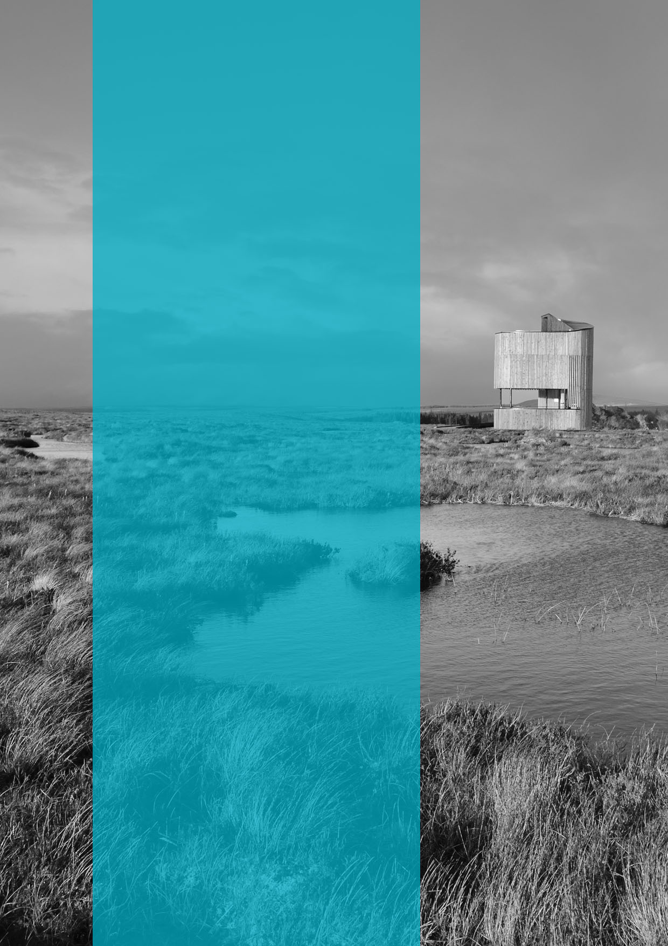

  - Published: September 2020
Updated May 2021

  - NatureScot
  - Great Glen House
  - Leachkin Road
  - Inverness IV3 8NW

  - 01463 725000

  - www.nature.scot

