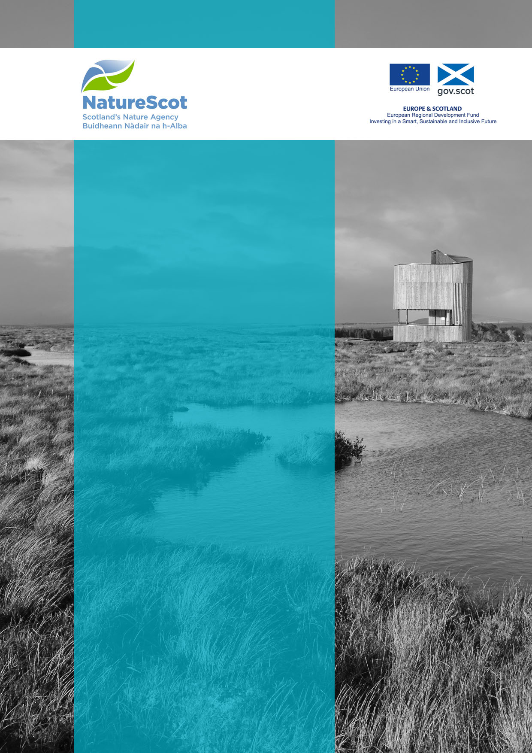
Natural and Cultural Heritage Fund

Annual Post-Project Report

[Insert Date]

NCHFAPP-
Project Name:
Grantee:

Version Control
Date | Issue | Status | Author | Authorised by
31/03/2021 | V1 | Final | LC | EM

Lead Partner Details
Lead Partner Details
Strategic Intervention Title | Natural and Cultural Heritage Fund
Strategic Intervention Lead Partner | NatureScot
Name of SI Manager that the Project will report to | Arthur Keller

Grantee Details
Grantee Details
Grantee Organisation Name
Project Manager Name
Project Manager Address
Project Manager Email Address
Project Manager Telephone Number

Introduction
The Annual Post-Project Report is a key component of the Natural and Cultural Heritage Fund Monitoring and Evaluation Guidance and it is a condition of the Delivery Contract that it is completed.

The Annual Post-Project Report will allow us to continue to capture the legacy of the project and will enable NatureScot, as Lead Partner, to comprehensively report on the cumulative impact of NCHF funded projects to the Managing Authority. It must be completed each year after project completion, starting 1 year after submission of the final report and finishing in December 2024. This approach recognises that that not all results will be instantaneous and will allow projects to demonstrate fully that outcomes have been achieved.

The Natural and Cultural Heritage Fund Annual Post-Project report is similar in format to the Progress Reports and Final Report that grantees will have completed during the delivery of their project. There are no mandatory annexes but please supply any relevant evidence that supports the information you provide in the report.

Grantees must be able to keep detailed records, suitable for local, national and EU audits, up to 31st December 2030 or as otherwise directed.

The Annual Post-Project Report and supporting documents will be subject to audit from bodies ranging from the European Commission and European Court of Auditors to the Scottish Government Audit Authority and Managing Authority.

The Final Report and Associated Annexes are structured as follows:

Document | Name | Source
Final Report | Final Report | Template to be provided by NatureScot.
Annexes (optional) | e.g. photographic records/press articles/other relevant evidence | Grantee Document(s).

When uploading files through Objective Connect, please use the following file naming convention:

NCHFAPP-000 – Grantee Name – Project Name –Quarter – Calendar Year – Annex No – Annex Name – Date

Examples as follows for a series of files for the same reporting period:

- NCHFAPP-040 - Grantee Name - Project Name - Q3 2019 - Annual Post-Project Report – 30 September 2020
- NCHFAPP-040- Grantee Name - Project Name - Q3 2019- Annex 1 - Case Study – 30 September 2020
- NCHFAPP-040 - Grantee Name - Project Name - Q3 2019 - Annex 2 – image – XXXX - 30 September 2019

Reporting files should be uploaded onto Objective Connect. Participant Guidance link below:
eRDMS Participants Guide

Annual Post-Project Report
- Project (Impact) Summary
Highlights / Milestones Achieved - Summarise the key impacts of your project, in relation to agreed outputs, milestones and outcomes. Use annex to demonstrate before/after impact.

Supporting documents required:
- N/A

- Ongoing Monitoring
Monitoring and Evaluation – Please provide an update, referring back to the plans for ongoing Monitoring and Evaluation you included in your Monitoring and Evaluation Plan

Supporting documents required:

Annex 3 – Monitoring and Evaluation Plan

- Post-Project evidence for Impact on Outcomes
Project Impact on Outcomes – Describe the evidence gathered for each Outcome Measure, as stated in your Monitoring and Evaluation Plan. Please provide proof of data collection in the annex.
EXAMPLE  - Improved access to better promoted heritage assets | We increased access to heritage assets by creating new paths and enhancing existing paths. At the beginning of the project there was 60m of paths. At the end of the project (April 2022) there are now 200m of accessible pathways.  Using a people counter to monitor visitors we observed a steady increase in visitors accessing more of the site and staying for longer. The baseline number of visitors was around 70 per day. At the end of the project we counted on average 500 visitors per day. Annex 2 shows the visitor increases graphically from March 2019- March 2020 and since April 2021-April 2022.
Supporting Documents Required:

Annex 2 – Data sheet - evidence of impact (quantitative data, graphs, tables, qualitative data)

Note: The purpose of the data sheet is for the grantee to collate all data gathered for the project in one document. The data should be summarised and presented by outcome in the document (preferably in an Excel spreadsheet).

Project Impact on Horizontal Themes – Please tell us about the continued impact of your project activities on the Horizontal Themes

- Post-Project Impact on Horizontal Themes
 | Outcome | Impact
1 | Sustainable Development  (previously Environmental Sustainability)
2 | Equal Opportunities and non-discrimination  (previously Social Inclusion)
3 | Equality between Men and Women  (previously Equal Opportunities)

- Grantee Declaration
Please confirm if the information you have supplied on this form including the supporting documentation is regarded as commercial in confidence. | Yes / No
Please confirm that you have read and understood the ERDF National Rules and Natural and Cultural Heritage Fund Guidance before submitting this Final Report. | Yes / No
Please confirm that your project continues to not constitute State Aid. For further information on the 4 key tests see:  www.gov.scot/publications/state-aid-guidance/pages/determining-whether-it-is-state-aid/ | Yes / No

Name
Position

Signature

Date

Checklist of Supporting Documents

Annex 1 | Photographic records | Y/N
Annex 2 | Data sheet | Y/N
Annex 3 | Monitoring and Evaluation Plan | Y/N
Annex 4 | Case study – please refer to Monitoring and Evaluation Guidance Document for more information | Y/N
Annex 5 | Video – please refer to Monitoring and Evaluation Guidance Document for more information | Y/N

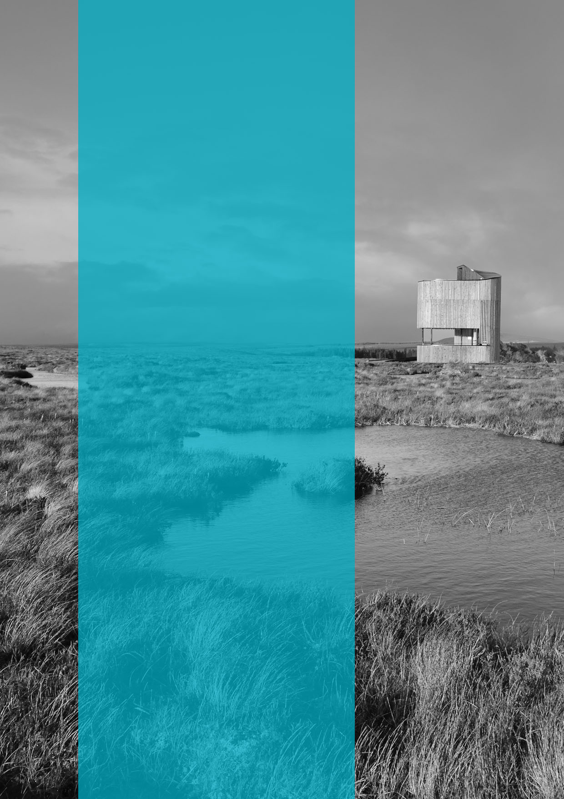

  - Published: March 2021

  - NatureScot
  - Great Glen House
  - Leachkin Road
  - Inverness IV3 8NW

  - 01463 725000

  - www.nature.scot

