Natural and Cultural Heritage Fund

Change Request Form

September 2020

Introduction
This form is to be used by grantees in receipt of a Natural and Cultural Heritage Fund grant to request material changes to your project after you have been awarded a grant and in the case that you need to change what has been approved in your original application and agreed in your Delivery Contract.
We understand that change is inevitable and the process relating to change is described in the Change guidance and process overview for applicants.
Please note that you must use this form to inform us of any changes and get our approval before implementing the change.
In addition, please also refer to the Monitoring and Evaluation Guidance in the share folder.

Disclaimer
Scottish Natural Heritage (SNH) has changed its name to NatureScot as of the 24th August 2020. At the time of publishing, this document may still refer to Scottish Natural Heritage (SNH) and include the original branding. It may also contain broken links to the old domain.
If you have any issues accessing this document please contact nchf@nature.scot.

Version Control
Date | Issue | Status | Author | Authorised by
25/09/19 | V1 | Draft | LL | EM 26/09/2019
15/09/202 | V2 | Final | LC | EM

Change Request Form
Please complete this form as completely as possible.

Grantee Details
Grantee Details

Grantee Organisation Name

Project Name

Project Unique Reference

Project Manager Name

Project Manager Address

Project Manager Email Address

Project Manager Telephone Number

Current change requested
Change Request No. | Date Submitted | Submitted By | Change type
Examples:

Time
Cost
Deliverables
External Driver

Previous change requests
(Please list all changes and their status. If none, please add ‘None’ to the Change No. column.)
Change No. | Description of Change | Status / Date Approved

Description of requested change
Description of Change

What is the reason for the requested change?
Reason for Change

What alternative solutions have you considered?
Evaluation of options

How will the change affect the delivery of your project?
Changes affecting delivery

How will this change affect the project’s risks?
Description of changes to risks

What resources and costs are needed to implement this change?
Description of resources and costs required

What impact will the change have?
Summary of Impacts | Yes / No
Is there a change to milestones?

Will there be a change to the expenditure budget?

Will there be an increase in the overall expenditure budget?

Will there be a decrease in the overall expenditure budget?

Will there be a reduction in the expenditure timeline?

Will there be an increase in the expenditure timeline?

Will there be a change to the funding profile within the approved timeline?

Will there be any changes to the match funding package?

Will there be an increase in ERDF and match funding?

Will there be a decrease in ERDF and match funding?

Will there be any other impacts? If yes, please list:

Does the change affect any other aspects of your project?
Description of other affected aspects

Grantee Declaration
Please confirm that the changes will not stop your project from achieving the agreed outcomes. | Yes / No
Please confirm if the information you have supplied on this form including the supporting documentation is regarded as commercial in confidence. | Yes / No
Please confirm that you have read and understood the ERDF National Rules and Natural and Cultural Fund Guidance before submitting this Change Request. | Yes / No

Name
Position

Signature

Date

FOR NATURESCOT USE ONLY

Date Received:

APPROVE | REJECT | DEFER
Change Request Decision Form ERDMS Reference:

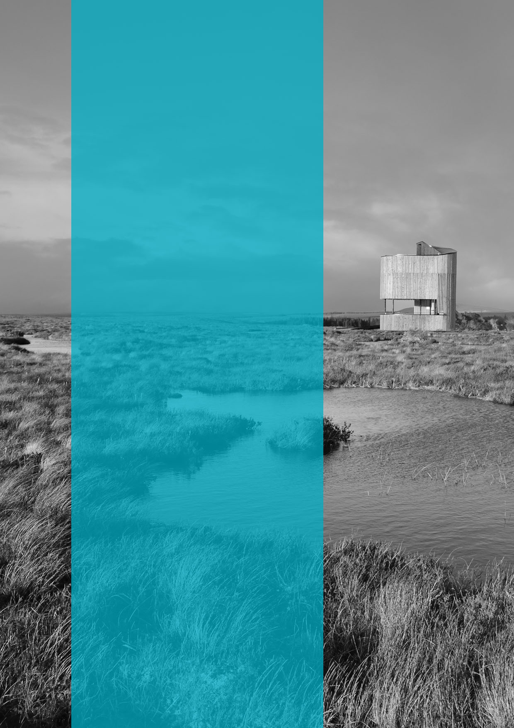

  - Published: September 2020

  - NatureScot
  - Great Glen House
  - Leachkin Road
  - Inverness IV3 8NW

  - 01463 725000

  - www.nature.scot

