July 2020

Green Infrastructure Fund & Community Engagement
Fund

Change Request Form

Introduction
This form is to be used by grantees in receipt of a Green Infrastructure Fund or Community Engagement Fund grant to request material changes to your project after you have been awarded a grant and in the case that you need to change what has been approved in your original application and agreed in your Delivery Contract.
We understand that change is inevitable and the process relating to change is described in the Change guidance and process overview for applicants.
Please note that you must use this form to inform us of any changes and get our approval before implementing the change.
In addition, please also refer to the Monitoring and Evaluation Guidance on the Green Infrastructure website.

Version Control
Date | Issue | Status | Author | Authorised by
01/09/17 | V1 | Final | LS | DP
07/06/19 | V2 | Final | LS | DP
24/06/20 | V3 | Final | LS | DP

Change Request Form

FOR NatureScot USE ONLY  To be completed by NatureScot (P&FO) | Confirmation that Change Request Form has been fully completed by Grantee and is ready for decision-making
Name of NatureScot P&FO

Date passed to PM for decision-making process

Form for Completion by Grantee – please complete this form as fully as possible.

Grantee Details
Grantee Details

Grantee Organisation Name

Project Name

Project Unique Reference

Project Manager Name

Project Manager Address

Project Manager Email Address

Project Manager Telephone Number

Current change requested
Change Request No. | Date Submitted | Submitted By | Change type
Examples:

Time
Cost
Deliverables
External Driver

Previous formal change requests
(Please list all changes and their status. If none, please add ‘None’ to the Change No. column.)
Change No. | Description of Change | Status / Date Approved

Description of requested change
Description of Change

What is the reason for the requested change?
Reason for Change

What alternative solutions have you considered?
Evaluation of options

How will the change affect the delivery of your project?
Changes affecting delivery

How will this change affect the project’s risks?
Description of changes to risks

What resources and costs are needed to implement this change?
Description of resources and costs required

What impact will the change have?
Summary of Impacts | Yes / No
Is there a change to milestones?

Will there be a change to the expenditure budget?

Will there be an increase in the overall expenditure budget?

Will there be a decrease in the overall expenditure budget?

Will there be a reduction in the expenditure timeline?

Will there be an increase in the expenditure timeline?

Will there be a change to the funding profile within the approved timeline?

Will there be any changes to the match funding package?

Will there be an increase in ERDF and match funding?

Will there be a decrease in ERDF and match funding?

Will there be any other impacts? If yes, please list:

Does the change affect any other aspects of your project?
Description of other affected aspects

Time and Financial Overview
Delivery dates overview | Date
What is the project end date agreed in your Delivery contract?

Have any previous approved Change Requests changed this date?
(If yes, please add approved revised date.
If no, please add the date agreed in your Delivery Contract.)

What will the revised project end date be if this Change request is approved?
(If there is no change, please add the date agreed in your Delivery Contract or previously approved revised date.)

ERDF Grant Award overview | £
What is the amount of your ERDF grant award agreed in your Delivery contract? | £
Have any previous approved Change Requests changed this amount of grant?  (If yes, please add approved revised amount of your ERDF grant.  If no, please add the amount of your ERDF grant agreed in your Delivery Contract.) | £
What will the amount of your ERDF grant be if this Change request is approved? | £

Grantee Declaration
Please confirm that the changes will not stop your project from achieving the agreed outcomes. | Yes / No
Please confirm if the information you have supplied on this form including the supporting documentation is regarded as commercial in confidence. | Yes / No
Please confirm that you have read and understood the ERDF National Rules and Green Infrastructure Fund Guidance before submitting this Change Request. | Yes / No

Name
Position

Signature

Date

FOR NatureScot USE ONLY |  | To be completed by NatureScot (PM)
Date Received from P&FO:

APPROVE | REJECT |  | DEFER
Change Request Decision Form ERDMS Reference:

Published: July 2020

NatureScot
Great Glen House
Leachkin Road
Inverness
IV3 8NW

01463 725000

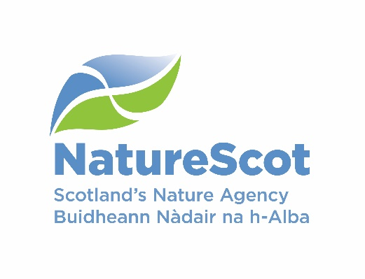
www.nature.scot

