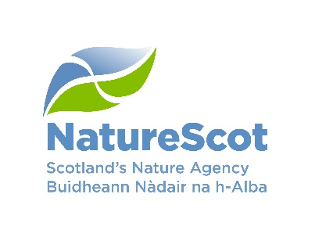 | SEA EAGLE MANAGEMENT SCHEME (SEMS)  MANAGEMENT AGREEMENT APPLICATION FORM |  |  | 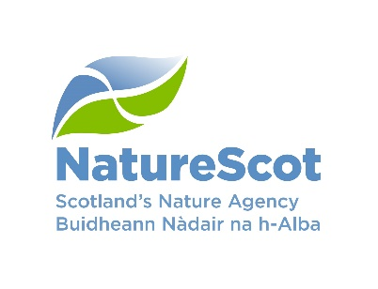
About You
It is important you answer the questions as instructed on this application form and that you provide supporting information where we ask for it.
If you need extra help to fill in the form or advice on any part of the form itself, please contact your local NatureScot office—see contact details in the Scheme Booklet. Forms with insufficient information will be returned to you and may not be assessed or may only qualify for a basic level of funding (£500).

Name of applicant:

Payee details if different from above:

Status: (e.g. sole trader, partner)

Address: (for all correspondence) |  | Post Code:
Phone:

e-mail:

Business name:

Name (s) of common grazing (if applicable)
Main Location Code (Farm Code): |  |  | Business Reference Number (BRN):

If application is being prepared by an agent on behalf of the land manager

Name of Agent:

Address: | Post Code:
Phone:

e-mail:
Other Public Funding

Are you taking part in any other publicly-funded land management scheme on the same land? Please tick one box.  If YES, please select from the following (tick box) |  |  |  | YES | NO
NatureScot Management Agreement |  |  | Details:  Expiry date:
SRDP – Rural Priorities |  |  | Case no:  Expiry date:
SRDP – Agri-Environment and Climate Scheme |  |  | Case no:  Expiry date:
SRDP – Land managers Options |  |  | Details:  Expiry date:
Other (Scheme Name) |  |  | Details:  Expiry date
If you are applying for sheep measures - does your current contract involve any sheep management measures?  If YES, please give brief details below |  |  |  | YES | NO

Tenure
Please tick all boxes that apply
Owner-occupier | Tenant | Common grazier | Sheep Stock Club | Other: Details

Information About Sea Eagles On Your Land

Please provide details of any action you have taken so far (including details of any previous Management Agreement with NatureScot)

Total Area of holding | (Ha)
% share of Common Grazings (if applicable) | %
Total Area of common grazing share | (Ha)
Total Area used for sheep management | (Ha)
Are you managing common grazing land on behalf of other shareholders?  (Ha)  If YES, please give area  If YES, please list other shareholders below: |  |  | YES | NO

Explain the standard and/or enhanced or capital measures you propose to carry out (include details of locations, timing and how the works will reduce impacts/interactions of Sea Eagles on your livestock) - please continue on separate sheet if necessary and supply map on a separate sheet showing landholding and indicating management. Details of costs will be requested on pages 4 and 5. Please provide sufficient detail and justification to allow assessment of your Application. Forms with insufficient information will be returned to you and may not be assessed or may only qualify for a basic level of funding (£500).

Standard sheep management measures to reduce impacts of sea eagles on livestock:

Enhanced measures to reduce eagle interaction with livestock:

Capital measures to reduce eagle interaction with livestock: (Please include any quotes you have received for proposed works with your Application)

Standard Sheep Management Measures: | Payment Rates | Per Annum costs
Additional labour and shepherding costs at key times (e.g. lambing). | £8.18/hour
Treatment of tick and fluke to improve sheep health. Possible communal use of mobile dosing/dipping infrastructure. | £4.50/ewe
Supplementary feeding and nutrition/mineral blocks. | £4.00/ewe
Scanning of ewes for separation of those with twins. | £0.80/ewe
Enhanced Measures:

Additional Shepherding (Monitoring and Reporting) | £12.80/hour
Away wintering of sheep (Ewes will be prioritised for support unless serious issues with hogg predation) see Supporting Annex for Info | £20.67/per head
Other—Management necessary to manage sheep around Sea Eagles ** | Contribution to actual cost
Total Cost

** These items do not have a standard rate. Payments will be based on actual costs and applications must be discussed in advance with NatureScot.

Your Management Proposals
Capital Measures
NOTE: Include detailed description of Capital Measure and show locations on a map.

Description of Capital Measure: | Total cost:
Improving fertility of the ground through lime/slag application in order to enhance condition of stock and reduce the vulnerability of lambs to predation. Only semi-improved
land will be eligible. No unimproved ground can be incorporated into this measure.
Please indicate if you will be doing this work using your own machinery/labour:
Yes
No
Re-seeding of core hay/silage/grazing fields in order to enhance condition of stock and reduce the vulnerability of lambs to predation. (Specific fields to be agreed with scheme administrators).
Please indicate if you will be doing this work using your own machinery/labour:
Yes
No
Stock Fencing – Actual Cost Quotes (only erection of new fencing is eligible)

Stock Fencing – Standard cost £5.50 per metre (only erection of new fencing is eligible)

Hillpark – creation

Development of lambing sheds or shelters and/or polytunnels
Purchase of scaring/deterrent devices

Other— management necessary to manage sheep around Sea Eagles
Total

Declaration
You or your agent (if appropriate) must sign this section
Signature:
Of applicant or agent

Date:

Information for applicants

- If you need to speak to an NatureScot advisor, please call 0300 244 9360 and you will be directed to an appropriate advisor or call your local NatureScot office https://www.nature.scot/about-naturescot/contact-us
- This form can be completed in Gaelic.
- If there is not enough space on the form for any of your answers, please continue on a separate sheet and attach it to the form.
- A map detailing the holding boundary, the common grazing boundary (if applicable) and any management measure must be submitted with this application.
- Please continue to keep records of flock management and sea eagle interactions as, should your application be successful, they will be required as part of any management agreement claim on an annual basis.

Please return the completed form, along with maps, either
by post to: NatureScot, Cameron House, Oban, Argyll, PA34 4AE or by e-mail to: seaeaglescheme@nature.scot.

Additional information
Please use this page for any additional information that you consider will support your application

