INSTRUCTIONS FOR AUTHORS OF NATURESCOT RESEARCH REPORTS

Guidance on using this template

To ensure that a consistent format is followed, all research reports should be written using this template.

How to insert text

Each section to be completed has square brackets around it. To enter text highlight bracketed areas, delete and type in text as required. Please complete all sections, except where reserved for ‘NatureScot only’.

Using styles

The template uses predetermined Styles in MS Word designed to ensure that the report is written using the correct format and fonts. Typing in the required areas automatically generates the correct style. You can select styles from the ‘Styles’ menu on the ‘Home’ tab or by right-clicking your mouse and selecting ‘Styles’. The headings and sub-headings are also ‘tagged’, which means that you can automatically generate the Table of Contents.

Styles and Table of Contents

To generate the ‘Table of Contents’ hover over the table, right click the mouse, and select ‘Update field’ and then ‘Update entire table’. Repeat regularly to ensure the headings and page numbers match.

Confidential header

The header is a safeguard against publishing confidential information and is for NatureScot use only. Please do not edit.

Reducing rework

Please proof read and spell check before submitting the final draft to NatureScot. Please check the format meets the Instructions for authors supplied to you when the contract was awarded. If you did not receive it, please contact the Project Manager at NatureScot.

If you have any questions about using this template, please contact research@nature.scot.

Please remember to delete these instructions (2 pages) before submitting your report to NatureScot.

Further information on the research reports house style for additional items

- FOOTNOTES: Footnotes should be typed in Arial 10 point and should be separated from the main text by a short, left justified line (see below).

- To insert a footnote go to ‘References’ and select ’Insert Footnote’. The line will be automatically generated and numbered, and footnote text can be entered and edited. Repeat for further footnotes, each time a sequential number is generated.

- HEADING SPACING: Style automatically inserts line between heading and paragraph.

- LINE SPACING: Single spaced and fully justified.

- MARGINS: All margins in the document are set for 2.54cm.

- PAGE NUMBERING: Automatically generated, centred, at foot of page, and starts from first chapter which is generally the Introduction. Roman numerals are used for the preceding pages, e.g. Summary, Contents and Acknowledgements.

- PARAGRAPH NUMBERING: None.

- PARAGRAPH SPACING: Insert single line between paragraphs.

- QUOTES: Choose 'Quote' from the ‘Styles’ menu on the ‘Home’ tab, or by right-clicking your mouse and selecting ‘Styles’, and insert text where appropriate in the report. The Style ‘Quote’ will automatically indent the text in the correct way.

- REFERENCES: Should be listed in the Harvard style. Examples are shown in the References section. Please delete the text and examples when finalising your report.

- SUB-HEADINGS: Please attempt to use no more than three sub-headings and ideally two.

- LOGO: the NatureScot logo is sized according to brand guidelines (do not edit). Company/organisation logos should not be added, unless agreed with NatureScot.

To start go to next page, highlight report title with your mouse, delete and type in title, then move between sections, following the instructions shown and ignoring any 'NatureScot use only' sections.

RESEARCH REPORT

Research Report No. – NatureScot use only
[Insert report title here]

For further information on this report please contact:

Name of Project Manager
NatureScot
Great Glen House
Leachkin Road
INVERNESS
IV3 8NW
Telephone:
E-mail: firstname.lastname@nature.scot

This report should be quoted as:

[Insert name of author(s). Insert year. Insert report title]. NatureScot Research Report No. – NatureScot use only.

This report, or any part of it, should not be reproduced without the permission of NatureScot. This permission will not be withheld unreasonably. The views expressed by the author(s) of this report should not be taken as the views and policies of NatureScot.
© NatureScot 2020.
RESEARCH REPORT
Summary

Insert report title here

Research Report No. – NatureScot use only
Project No: – NatureScot use only
Contractor: [Insert contractor's name here]
Year of publication: [Insert year here]

Keywords
[Enter 6-8 keywords here separated by a semi-colon.]

Background
[Enter background here - two paragraphs max. NatureScot reserves the right to edit as required.]

Main findings
- [Summarise recommendations here in bulleted list. Press return key to go to next bullet point.]

For further information on this project contact:
Name of Project Manager - NatureScot use only
Telephone and email of Project Manager - NatureScot use only
For further information on our research programme contact:
Research Coordinator, NatureScot, Great Glen House, Leachkin Road, Inverness, IV3 8NW.
Tel: 01463 725000 or research@nature.scot

Table of Contents Page

1. [INSERT HEADING TITLE, EG. introduction] 1
1.1 [Insert heading text. Please delete if not applicable when finalising] 1
1.1.1 [Insert heading text. Please delete if not applicable when finalising.] 1
2. [INSERT HEADING TITLE, EG. methods] 2
2.1 [Insert heading text. Please delete if not applicable when finalising] 2
2.1.1 [Insert heading text. Please delete if not applicable when finalising.] 2
3. [INSERT HEADING TITLE, EG. results] 3
3.1 [Insert heading text. Please delete if not applicable when finalising.] 3
3.1.1 [Insert heading text. Please delete if not applicable when finalising.] 3
4. [INSERT HEADING TITLE, EG. discussion] 4
4.1 [Insert heading text. Please delete if not applicable when finalising.] 4
4.1.1 [Insert heading text. Please delete if not applicable when finalising.] 4
5. [INSERT HEADING TITLE, EG. CONCLUSIONS] 5
5.1 [Insert heading text. Please delete if not applicable when finalising.] 5
5.1.1 [Insert heading text. Please delete if not applicable when finalising.] 5
6. REFERENCES 6
ANNEX 1: [TITLE] 7
ANNEX 2: [TITLE] 7
ANNEX 3: [TITLE] 7

Acknowledgements

[Insert acknowledgements here.]

[INSERT HEADING TITLE, EG. introduction]
[Insert text. Number headings and sub-headings only, not paragraphs.]

[Insert heading text. Please delete if not applicable when finalising]
[Insert text. Number headings and sub-headings only, not paragraphs.]

[Insert heading text. Please delete if not applicable when finalising.]
[Insert text. Number headings and sub-headings only, not paragraphs.]

[Insert heading text. Please delete if not applicable when finalising.]
[Insert text. Number headings and sub-headings only, not paragraphs.]

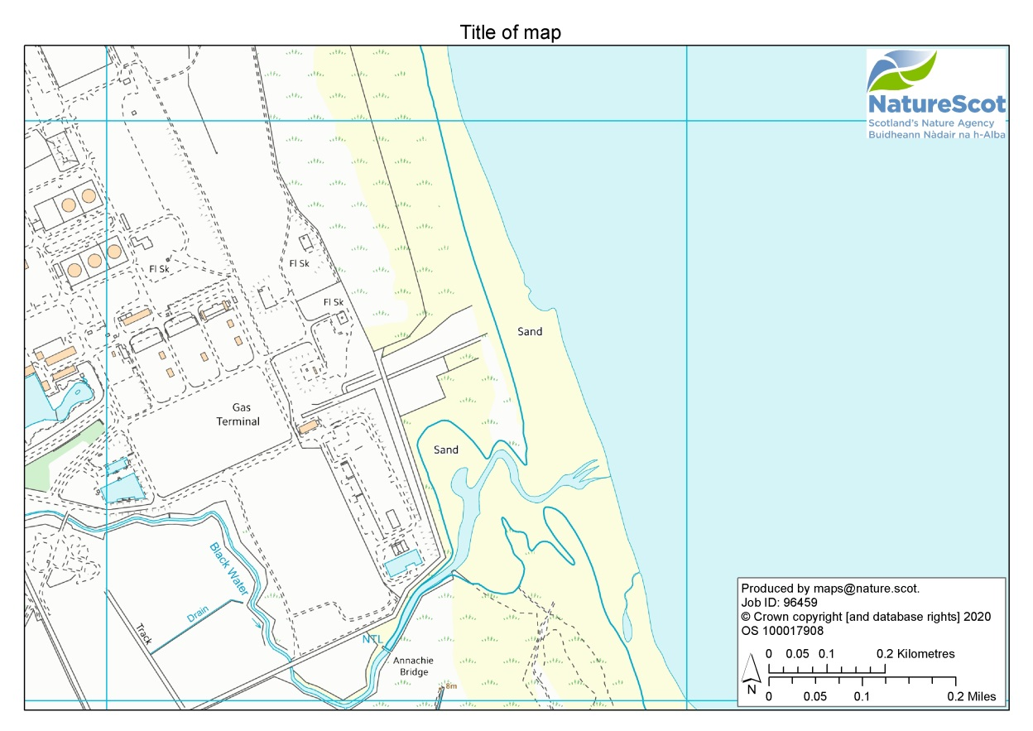
Figure 1. Insert caption below the figure. Use appropriate copyright statement depending on the source material for any maps involved (see Instructions for authors). Copyright statement should either be within the map or retyped in this caption. For example, for OS base map use © Crown copyright [and database rights] 2020 OS 100017908.

[INSERT HEADING TITLE, EG. methods]
[Insert text. Number headings and sub-headings only, not paragraphs.]

Table 1. Insert caption above the table.
 | Number in
Year | Scotland | England | Wales
2005 | 14 | 56 | 23
2006 | 28 | 67 | 24
2007 | 40 | 68 | 22

[Insert heading text. Please delete if not applicable when finalising]
[Insert text. Number headings and sub-headings only, not paragraphs.]

[Insert heading text. Please delete if not applicable when finalising.]
[Insert text. Number headings and sub-headings only, not paragraphs.]

[Insert heading text. Please delete if not applicable when finalising.]
[Insert text. Number headings and sub-headings only, not paragraphs.]

[INSERT HEADING TITLE, EG. results]
[Insert text. Number headings and sub-headings only, not paragraphs.]

[Insert heading text. Please delete if not applicable when finalising.]
[Insert text. Number headings and sub-headings only, not paragraphs.

[Insert heading text. Please delete if not applicable when finalising.]
[Insert text. Number headings and sub-headings only, not paragraphs.]

[Insert heading text. Please delete if not applicable when finalising.]
[Insert text. Number headings and sub-headings only, not paragraphs.]

[INSERT HEADING TITLE, EG. discussion]
[Insert text. Number headings and sub-headings only, not paragraphs.]

[Insert heading text. Please delete if not applicable when finalising.]
[Insert text. Number headings and sub-headings only, not paragraphs.]

[Insert heading text. Please delete if not applicable when finalising.]
[Insert text. Number headings and sub-headings only, not paragraphs.]

[Insert heading text. Please delete if not applicable when finalising.]
[Insert text. Number headings and sub-headings only, not paragraphs.]

[INSERT HEADING TITLE, EG. CONCLUSIONS]
[Insert text. Number headings and sub-headings only, not paragraphs.]

[Insert heading text. Please delete if not applicable when finalising.]
[Insert text. Number headings and sub-headings only, not paragraphs.]

[Insert heading text. Please delete if not applicable when finalising.]
[Insert text. Number headings and sub-headings only, not paragraphs.]

[Insert heading text. Please delete if not applicable when finalising.]
[Insert text. Number headings and sub-headings only, not paragraphs.]

REFERENCES
Please list references in the Harvard style, as per examples shown below.

Begon, M., Harper, J.L. & Townsend, C.R. 1996. Ecology: Individuals, Populations and Communities. 3rd ed. Oxford: Blackwell Science.

McArthur, W.M. 1993. History of landscape development. In: Hobbs, R.J. & Saunders, D.A. eds. Reintegrating Fragmented Landscapes. Berlin: Springer Verlag, pp. 10-22.

Newton, I., Davis, P.E. & Moss, D. 1996. Distribution and breeding of red kites Milvus milvus in relation to afforestation and other land-use in Wales. Journal of Applied Ecology, 33, 210-224.

Rosell, F., Parker, H. & Steifetten, Ø. 2006. Use of dawn and dusk sight observations to determine colony size and family composition in Eurasian beaver Castor fiber. Acta Theriologica, 51, 107-112.

Strachan, R.S. & Moorhouse, T.P. 2006. The Water Vole Conservation Handbook. Wildlife Conservation Research Unit & The Environment Agency.

Please delete this text and examples when finalising your report.

ANNEX 1: [TITLE]
[Insert text here.]

ANNEX 2: [TITLE]
[Insert text here.]

ANNEX 3: [TITLE]
[Insert text here.]

Please use this section to list Annexes included in the report. If none, please leave blank. Please delete this text and any unused examples when finalising.

They should be cross-referenced in the text using consecutive numbers throughout the report. They should be in super-script at the appropriate point.
See section on Footnote creation.
http://libweb.anglia.ac.uk/referencing/harvard.htm

