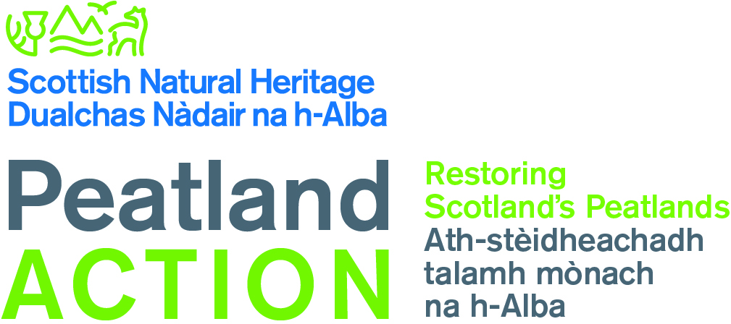

Peatland Action Fund - RESTORATION PROJECT

Expression of Interest (EoI)

The application round for 2019 has now passed. In limited circumstances we may consider further applications where delivery of all on-site activity before 28 February 2020 can be assured.

Please use this form to tell us about your proposed project. We will review your Expression of Interest as soon as we receive it, after which we may invite you to submit a full application. We will aim to let you know our decision within 10 working days of receiving your Expression of Interest form - a member of SNH staff may contact you during that time to discuss your Expression of Interest further.

If we are interested in receiving a full application, we will send you an application form directly at which point we will discuss an appropriate submission deadline.

Submitting a full application does not mean that it will be successful.

Name: |  | Phone Nº:
Email:
Organisation:

I have read the ‘Information for Applicants’ guidance and assess that this proposal meets the project and eligibility criteria (check box) | ☐

If we invite a full application then a decision from SNH may take up to 6 weeks. If you have an urgent deadline, please give details of when and why.

Project Title

Project Start Date Estimated Completion Date
Please note that where possible, we want projects to complete by 31 December 2019 to avoid the significant impacts of winter weather. All approved site-based restoration activities must be completed by 28 February 2020 at the latest.

Six figure National Grid Reference (s) and area of site(s):

Project Description:
Please describe your project clearly in 300 words or fewer (1/2 page A4). You should tell us about the site-based restoration activities you propose to carry out including the distinct stages of the project, expected access routes and any access issues, methods & techniques, equipment/ plant/ machinery, any risks to delivery in timescales etc.

Area to be restored (Hectares):

Value of funds being sought and potential match funding/in kind contribution:

Are the costs you are submitting to us:
☐ an outline estimate ☐ a firm quotation ☐ a full tender
☐ a single tender (accompanied with a justification)

Please email your completed Expression of Interest form to PEATLANDACTIONGRANT@nature.scot with the subject heading ‘Peatland Action – Expression of Interest’. Thank you.

We will only be accepting Expression of Interests until 23:59 Sunday 13 October 2019.

SNH will collect and hold your contact details. We will use your details to help us assess your grant application. Please see our website for our Privacy Notice.

