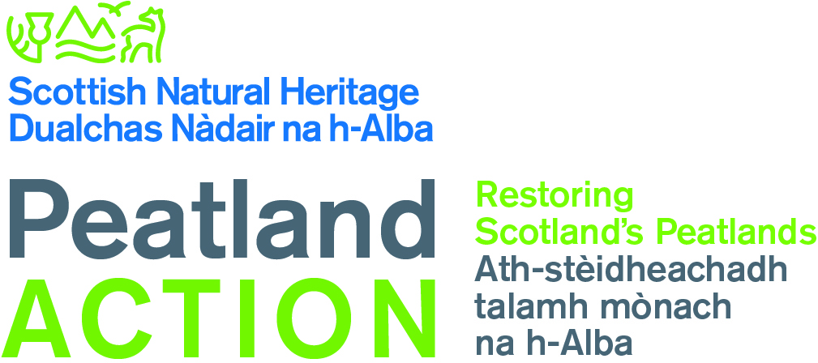

Geospatial Metadata template
Update 23 July 2019, Version V1.2

Metadata elements based on UK GEMINI standards v2.3

Please complete this metadata form with the information about your dataset, and submit this together with your data. For more information check the descriptions for the UK GEMINI standards: https://www.agi.org.uk/agi-groups/standardscommittee/uk-gemini/40-gemini/1062-gemini-datasets-and-data-series

Element name | Description | Please complete for your data:  (suggestions have been provided for some fields)
Title | Name of your project
Dataset language | What language were the data recorded in?
Abstract | Short description
Topic | What is your data about? | Peatlands
Keywords | Search terms | Peatlands, Peatland Action, restoration, Scotland , bog
Temporal extent | Time range of your data
Dataset reference date | Date data were submitted
Lineage | How did you produce the data? | e.g. field surveys, OS maps, aerial imagery
Extent | Where the data come from? | Scotland
Spatial reference system | Coordinate reference system used | e.g. British National Grid
Data format | GIS package, shapefiles, spreadsheet, images
Responsible organisation | Responsible for the establishment, management, maintenance and distribution of the data resource | Scottish Natural Heritage
Limitations on public access | Is there any sensitivity around these data? | No restriction on public access, with the exception of personal data.
Metadata date | When this metadata form was completed
Metadata point of contact | Who can be contacted for information about this metadata
Additional information

