**Investment Ready Nature in Scotland**

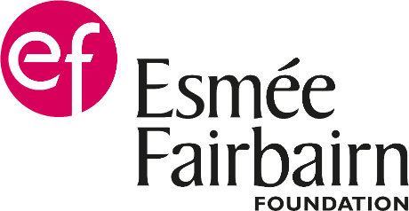 

**Application Form**

Thank you for your interest in Investment Ready Nature Scotland. Please complete this application form as best you can. Bullet point lists are acceptable, and you may attach short appendices including tables, data sheets, maps, graphics and illustrations.

**Scoring**

Each group of questions (A.4 and B.1-B.5) informs an assessment based on between 1 and 6 criteria. Each selection criterion will be graded from 0 to 3 as follows:

0: Does not show any evidence of meeting criteria

1: Shows only weak evidence of meeting criteria

2: Shows acceptable evidence of meeting criteria and any negative evidence is outweighed by good evidence

3: Shows strong evidence of meeting criteria.

Each group of questions will be awarded a final score amounting to the average of these scores. The project will then receive a total score that will be the sum of final scores of each group of questions.

In answering all questions keep in mind that the assessment process is designed to favour projects that are most strongly aligned with the [Scottish Government’s Interim Principles for Responsible Investment in Natural Capital](https://www.gov.scot/publications/interim-principles-for-responsible-investment-in-natural-capital/) and is not solely based on the ability of a project to generate revenues from ecosystem services or value for private investors. The use of approximations and potential numbers is acceptable as the purpose of this application form is to provide a sense of the scale and impact of the project.

**How to submit your application**

Your completed application form should be submitted by 23:59 on 16th September 2022 to [Patrick.Jean-Martel@nature.scot](mailto:Patrick.Jean-Martel@nature.scot)

## Section A - About you

1. **Your details**

|  |  |
| --- | --- |
| Applicant name |  |
| Name of Organisation (if applicable) |  |
| Position in Organisation (if applicable) |  |
| Address |  |
| Postcode |  |
|  |  |
| Landline phone number |  |
| Mobile phone number |  |
| Email |  |
|  |  |
| Charity or business number (if applicable) |  |
| VAT registration number (if applicable) |  |

1. **Is your organisation*:* (please check box)**

Public  Private  Voluntary  Private Individual

1. **Are you applying on behalf of a partnership or as lead partner in a consortium?**

Yes  No

If yes, please list the other partners who will be involved in delivering and managing the project.

|  |
| --- |
|  |

1. **Please provide a summary of the organisation/partnership’s history – its origin, major delivery milestones, and experience of working strategically, innovating and influencing.**

Selection Criteria:

* Strength of the organisation/partnership in terms of past experience in delivering similar projects or experience of its current members in that field

|  |
| --- |
| [500 words max] |

## Section B - Your project

1. **The project**

**Please describe the project that you are ultimately seeking to raise investment for.**

|  |  |
| --- | --- |
| Project Title |  |
| General description |  |

* **Where is it?** (ideally a map showing its location and area)

|  |
| --- |
|  |

* **What are the particular environmental problems your project will address? (**the answer must be short and concise, it will be used general information purposes only and will not be part of the assessment)

|  |
| --- |
|  |

* **What are the environmental activities and interventions that will take place on the site and how will these lead to the desired environmental outcomes?** (the answer must be short and concise, it will be used general information purposes only and will not be part of the assessment)

|  |
| --- |
|  |

1. **The innovation and the business model:**

**Please describe:**

* **How the project will help realise and monetise the benefits provided by natural capital and how the model will be scalable and replicable.**
* **Who are the stakeholders and who have you identified as potential buyers of the ecosystem services delivered, and how confident are you that they will be interested?**
* **What are your expectations of private investment to fund the natural capital restoration (i.e. at what stage of the project, how will revenue streams be used to repay them, what scale of private finance could be mobilised through the proposed intervention).**
* **Does the project integrate Environmental, Social and Governance (ESG) criteria to attract buyers or investors? (i.e. providing ESG metrics/data to buyers or investors)**

Selection Criteria:

* The proposal demonstrates clear thinking about the future business model
* The proposal considers positive and negative impacts across all four capitals (natural, social, economic, human)
* Does the project explicitly promote ESG integration as per the UN [Principles for Responsible Investment](https://www.unpri.org/about-us/what-are-the-principles-for-responsible-investment)?
* The proposal demonstrates clear and practical thinking about the buyers of ecosystem services
* The business model is replicable and scalable
* The targeted market in terms of buyer of ecosystem services is large (national vs regional vs local)

|  |
| --- |
| [500 words max] |

1. **Environmental Impact:**

**Please:**

* **Demonstrate how your project will have a direct positive environmental impact, and explain any potential additional indirect benefits.**
* **What indicators will you be using to monitor this impact? Describe any potential trade-offs and how these will be managed.**

Selection Criteria:

* There is a holistic assessment of the environmental impact (i.e. not focussing or measuring solely carbon, but also biodiversity and other benefits) and the project aims at maximising it
* Is the project protecting or restoring a habitat that is widespread in Scotland and in a state that would allow the project to be replicated/scaled up easily?
* Does the proposal recognise potential trade-offs and present options to manage them?

|  |
| --- |
| [500 words max] |

1. **Monitoring and impact:**

**Please tell us:**

* **What project management methods will be applied, how will you measure the progress of IRNS funded work and what milestones and KPIs will you use to measure progress and success?**
* **In terms of green washing what are the risks that you foresee and how do you plan on mitigating these?**
* **What are the main other risks you have identified and how will you manage these?**

Selection Criteria:

* The IRNS-funded work will have an effective project management plan
* The selected milestones and KPIs are appropriate and take a multi-capital approach to measuring impact and success
* The project will rely on recognised codes (i.e. Woodland Carbon Code, Peatland Code, Gold Standard…) or make us of approved frameworks or scientifically backed methodologies to measure impact
* Is the risk of green washing clearly identified and appropriate measures will be taken to minimise it?
* How relevant are the risks identified and how adapted are the envisioned mitigation measures?

|  |
| --- |
| [500 words max] |

1. **Engagement and just transition:**

**Please tell us:**

* **How the project takes into account communities’ interests, involvement and share benefits with them (economic, environmental, and social). For instance what level of engagement will you seek from stakeholders and partners (co-design, participation, involvement, consultation)? Is the project supported by any other organisation, community, public body, Agency, University, NGO …?**

Selection Criteria:

* The proposal has identified all of the relevant stakeholders (including public bodies, local communities, NGOs, etc…)
* Is the project well supported by other organisations?
* Does the project actively involve local communities, including tenants, and give them opportunities to influence decisions about land and land use change, in line with the Scottish Government’s Guidance on Engaging Communities in Decisions Relating to Land?
* Is there practical consideration of how to share benefits between public, private and community interests e.g. shared ownership, sharing future increases in land and ecosystem services values, business opportunities, Community Wealth Building?
* The proposal recognises and responds to local circumstances, acknowledging the suitability of land for particular uses and seeks to protect and enhance existing natural capital
* Has the applicant considered whether ownership of land is necessary or if management agreements or other forms of collaboration/partnership with communities can deliver the required outcomes and wider social and economic benefit?

|  |
| --- |
| [500 words max] |

1. **Value for money:**

**Please tell us:**

* **How the IRNS grant will help you move to investment readiness. (Consider the Green Finance Institute pathway).**

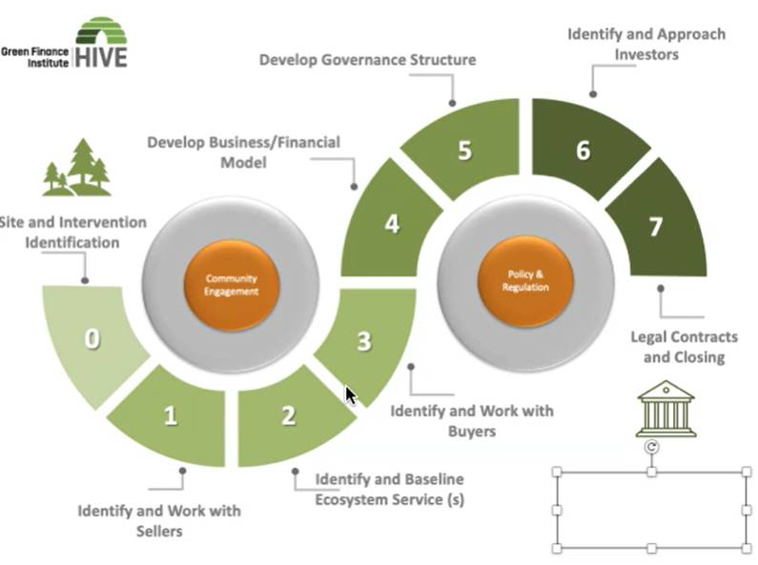

* **What inputs (hiring, training, and contracting) are you buying? How will they help you to progress?**
* **Will the project be able to credibly demonstrate investor returns and how likely is it that the project will secure private investment?**
* **Will the project have a transformational impact and directly enable or support the development of other natural capital projects in Scotland?**
* **Would the project require additional funding support to leverage in private finance?**

Selection Criteria:

* Does the project bring good value for public money in terms of delivering high quality and relevant outputs, costs savings, and environmental impact?
* Will the project enable to leverage a substantial amount of private funding in relation to the potential public funding required?
* Will the project support the natural capital project pipeline in Scotland?

|  |
| --- |
| [500 words max] |

|  |  |  |  |
| --- | --- | --- | --- |
| **6a. Project start date** |  | **6b. Estimated completion date** |  |

Please remember that all projects must ideally be completed within 12 months or at the latest by 29 March 2024.

## Section C – Project finances

1. **Provide details of the overall cost of the project and how much you are applying for from IRNS. Please provide a breakdown of project costs, providing as much detail as possible.**

* Grants awarded will be between £30,000 and £100,000 and up to 100% of eligible costs, which can include internal organisational capacity, specialist consultancy and technical advice.
* For ineligible costs, please see the list at the end of this form[1].
* Please add extra rows to the table below as required.

|  |  |  |  |  |  |  |
| --- | --- | --- | --- | --- | --- | --- |
|  | FY 1st April- 31st March 2023 | | FY 1st April- 31st March 2023 | |  |  |
| Item | Cost | Grant Requested | Cost | Grant Requested | Total Cost | Total Grant Requested |
|  |  |  |  |  |  |  |
|  |  |  |  |  |  |  |
|  |  |  |  |  |  |  |
|  |  |  |  |  |  |  |
|  |  |  |  |  |  |  |
|  |  |  |  |  |  |  |
|  |  |  |  |  |  |  |
|  |  |  |  |  |  |  |
|  |  |  |  |  |  |  |
| Total |  |  |  |  |  |  |

1. **Ineligible costs: The grant cannot pay for:**

   * capital spending, such as physical works, buying or leasing land or equipment
   * costs already covered through other funding
   * costs incurred before you’re awarded the grant
   * meeting your own legal obligations (except related to designing and structuring an investment model)
   * paid-for lobbying, which means using the grant to fund lobbying (through an external firm or in-house staff) to influence Parliament, government or political activity, or trying to influence legislative or regulatory action
   * using the grant to directly allow one part of government to challenge another on topics unrelated to the agreed purpose of the grant
   * expenses, such as for gifts or entertaining, specifically aimed at influencing government policy or investors
   * input VAT reclaimable by the grant recipient from HMRC
   * fines, charges or dividends
   * payments for activities of a political or wholly religious nature
   * contingency – if you encounter unexpected costs, there will be a process in place to assess this.

  